**ISYS 637 602 DATA WAREHOUSING**

**GROUP # 10**

**GROUP PROJECT - REPORT 4**



|  |  |
| --- | --- |
| FULL NAME | EMAIL ID |
| Fathima Benazir Ghouse Mohideen | [fathima_benazir@tamu.edu](mailto:fathima_benazir@tamu.edu) |
| Thenmozhi Singaravel | [thensingar@tamu.edu](mailto:thensingar@tamu.edu) |
| Santosh Kumar Sriram | [santosh.sriram@tamu.edu](mailto:santosh.sriram@tamu.edu) |

**Staging Area:**

Group10_602-Staging_area

**Data warehouse Area:**

Group10_602-DW-area

**Analysis Services:**

Group10Section602_BQ1

Group10_Section_602_BQ3

Group10Section602_BQ5

**Report Server:**

<http://infodata.tamu.edu/ReportServer>

Report 1: Group10_Section602_BQ1_Report >Coupon Sales

Report 2: Group10_Section602_BQ2 > BQ2

Report 3: Group10_Section602_BQ3_Report > Frozen Food

Sales

**Login credentials:**

User ID: sr6354

Password: Mays6354

**Contents**

**Introduction** 2

**a.** **Details about the data** 2

**b.** **Entity Relationship Diagram** 2

**Business Questions** 2

**Independent Data marts Design using Kimball’s Approach** 2

**a.** **Fact Table Design** 2

**b.** **Dimension Table Design** 2

**c.** **Data Mart Schemas** 2

**Data Integration** 2

**Data Quality Issues** 2

**ETL Plan** 2

**ETL Implementation Evidences and Screen Shots** 2

**Data Loading to the Data Warehouse** 2

**BI Reporting** 2

**Data Warehouse Infrastructure Justification** 2

**References** 2

## **Introduction**

DFF was a retail grocery business founded by Dominick DiMatteo in Chicago. The company was purchased by Fisher Foods of Cleveland, Ohio in 1968, when it had grown to a chain of 18 stores. During the mid-1970s, the Dominick's chain employed about 6,000 Chicago-area residents. In 1981, when there were 71 stores in the chain, the DiMatteo family bought it back for $80 million. The market share of DFF, the retail grocery market in Chicago grew from about 13 percent in 1984 to about 25 percent by 1993. In 1995, Oak Brook–based Dominick's was purchased by the Yucaipa Cos., a grocery company based in Los Angeles; three years later, it was acquired by Safeway Inc. At the end of the century, the Safeway-owned Dominick's remained a leading grocery chain in the Chicago area and was still one of the area's top employers [1].

Chicago Booth and DFF entered into a partnership for store-level research into shelf management and pricing. Many random experiments were conducted in this 100 store chain in various categories and data of over nine years of sales and used for academic purposes [2].

The objective of this project is to develop a data warehouse for the DFF retail store chain. This report documents the analysis of the DFF data and formulation of questions from a business perspective to enable the design and implementation of the data warehouse.

### **Details about the data**

The DFF data contains the store level scanner data collected over a period of more than seven years.

The database consists of two kinds of files- general files which carry data that span over all categories and category specific files which deal with the data pertaining to a specific category.

The data from the CCount, demographics, movement and UPC files was analysed for the kind of data present in each file, organization, categorization and granularity of the data. CCount files primarily consisted data about the everyday sales traffic in the various DFF stores- the number of customers buying each product, whether coupons were used for a purchase, the revenue generated from the sales, and the date of a particular week on which the sales was recorded. The demographics data consists of the type of population- singles, families, number of people in a household, the kind of shoppers, households with cars and phones , level of education of the population, ethnicity, work profiles of women the in the area where each DFF store is located. The UPC files contain the product information of each UPC. Movement files have data pertaining to each UPC, number of units sold together, profit grossed from the sale, and granularity of data is on a weekly basis. Pivot tables and pivot charts were used to study the various trends in data in these files. This analysis coupled with the domain understanding of the retail industry enabled the formulation of business questions for the design of the data warehouse.

### **Entity Relationship Diagram**

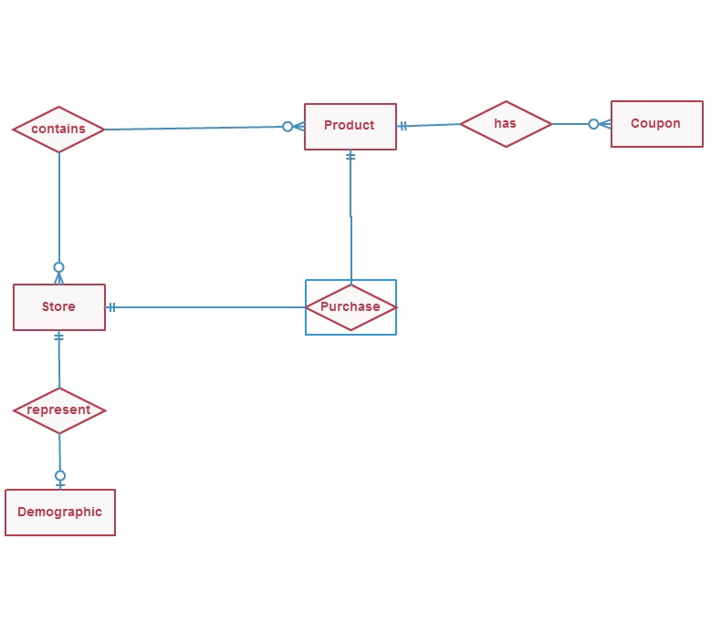

Figure 1 : Entity relationship diagram

## **Business Questions**

|  |  |
| --- | --- |
| Question # | 1 |
| Business Question | Which of the following coupons are effectively redeemed in each DFF store?  Meat Coupons  Grocery Coupons  Fish Coupons |
| Team Benefited | Marketing Team |
| Question Justification | The marketing team needs to evaluate the effectiveness of coupon usage and redemption. This benefits the marketing team in budgeting for coupons. There is always a direct relation with effective redemption of coupons and increase in product’s sale.  The marketing team would be interested in coupon redemption of similar products. This would branch into effective business decisions of specific product advertising and also specific coupon printing.  We have considered 3 similar products for this study. The products are – Meat, Fish and Grocery. |
| Data Availability | The Customer Count File contains specific information of store wise, date wise, total dollar sales and total coupon redeemed figures for every product category. We have used the Customer Count File to choose the coupon data of Meat, Fish and Groceries |

|  |  |
| --- | --- |
| Question # | 2 |
| Business Question | How does age of the customers and demography affect the pharmacy sales? |
| Team Benefited | Procurement team, Franchisee |
| Question Justification | The procurement team would be interested in pharmacy sales in different stores for procurement of pharmacy items. This would also be useful in enhancing the sale and profit in the stores where there is demand for pharmacy items. The franchisees can also expand their pharmacy. It is expected that the stores where the percentage of customers older than 60 is higher will have higher pharmacy sales. |
| Data Availability | The Customer Count File contains store wise information of pharmacy sales. The age of the customers is stored in the Demo file. |

|  |  |
| --- | --- |
| Question # | 3 |
| Business Question | Which type of frozen food that is in high demand in the whole of DFF? |
| Team Benefited | Franchisee, procurement team |
| Question Justification | The procurement team would be interested in the different kinds of frozen food sales for procurement. This would also be useful in enhancing the profit for the frozen food items with high movement. Some products and brands of frozen food are highly grossing compared to the others. This will help in increasing the stock of the specific frozen food products. |
| Data Availability | The frozen food product details, the corresponding movement and profit are obtained from the Movement file for frozen food. |

|  |  |
| --- | --- |
| Question # | 4 |
| Business Question | How are beer sales in regions where single living population are high? Do these regions reflect higher profit for DFF?  Do beer sales result in higher profit in demographic distribution of single family? |
| Team Benefited | Sales Team, Production Team and Franchisee |
| Question Justification | Beer sales are perennial sales. Franchisee have to rely on previous year sales trend to decide on procurement decisions.  We are helping sales strategy and procurement planning for the sales team, procurement team and franchisee. We are comparing the sales of beer sales during the entire span of 8 years. |
| Data Availability | The Customer Count File contains specific information of store wise, date wise, total dollar sales and total coupon redeemed figures for every product category. We have used the Customer Count File to choose sale data of beer sales.  The demographics file consists of the store- specific demographic data and we use this file to retrieve the single family concentration data.  The distribution file of the beer sales are maintained in the movement files.  We use these 3 files to draw this direct relation Sales. |

|  |  |
| --- | --- |
| Question # | 5 |
| Business Question | Which among Wine or Spirits is sold more during holiday season? Which is better gifted during Halloween, Thanksgiving or Christmas – Wine or Spirits? |
| Team Benefited | Production team, Sales Team |
| Question Justification | Holiday Season are both high sales yielding tenure and also a highly strategic period. Many a times we have seen companies flaw their holiday sale strategy and failing to make the most out of holiday market.  The following data and the respective graph considers 2 frequently gifted products during Christmas, Halloween and Thanksgiving season – Wine and Spirit. We compare the Wine and Spirits sales during the mentioned season to provide DFF with better production strategies for a similar season. |
| Data Availability | The Customer Count File contains specific information of store wise, date wise, total dollar sales and total coupon redeemed figures for every product category. We have used the Customer Count File to choose sale data of Spirits and Wine. For the holidays to be chosen we use the Week file.  The week file contains week number and the respective dates. |

## **Independent Data marts Design using Kimball’s Approach**

After obtaining the requirements or the business questions, the next step to build the schema would be to create a matrix for the same. This would help us determine the dimensions that are required for each requirement. Three data marts namely Coupon Redemption, Sales and Movement have been designed to answer the five business questions. There are some dimensions that are common among some data marts. These would act as conformable data marts. After detailed analysis, three dimensions were identified- Time dimension to store the various granularities of time, Store dimension to maintain the necessary details of the store and Product dimension to store the essential details of the product, to answer the business questions.

Table 1 : Data marts and dimension Mapping

|  |  |  |  |
| --- | --- | --- | --- |
| Data Mart | Time | Store | Product |
| Coupon Redemption | **x** | **x** |  |
| Sales | **x** | **x** |  |
| Movement | **x** |  | **x** |

### **Fact Table Design**

|  |  |
| --- | --- |
| Question # | 1 |
| Business Question | Which of the following coupons are effectively redeemed in each DFF store?  Meat Coupons  Grocery Coupons  Fish Coupons |
| Fact Table | Figure 2 : FactCoupon  The fact table that is a part of this data mart is named as FactCoupon and tracks the details of the sales made via the coupons. Three different coupons are being analysed in this data mart - meat, fish and grocery coupons. The WeeklyMeatCoup, WeeklyFishCoup and WeeklyGrocCoup in the fact table depict the weekly sales made by the coupons. The ratio of sales of these coupons indicates their relative redemption. This helps the business identify how a particular coupon fairs against the other coupons and which is the highest grossing coupon. The fact table makes use of two dimensions StoreDim and TimeDim to analyse these facts in all stores at weekly, monthly, yearly and quarterly levels. This is signified by the surrogate key – StoreKey and TimeKey. |

|  |  |
| --- | --- |
| Question# | 2 |
| Business Question | How does age of the customers and demography affect the pharmacy sales? |
| Fact Table | Figure 3: FactSales  The fact table that is a part of this data mart is named as FactSales and tracks the details of weekly pharmacy sales made. The FactSales is used by multiple data marts and hence we have combined values to signify the same. We calculate the pharmacy sales for every store and week. The fact table makes use of two dimensions StoreDim and TimeDim to analyse these facts in all stores at weekly, monthly, yearly and quarterly levels. This is signified by the surrogate key – StoreKey and TimeKey |

|  |  |
| --- | --- |
| Question# | 3 |
| Business Question | Which type of frozen food that is in high demand in the whole of DFF? |
| Fact Table | Figure 4: FactMovement  The fact table that is a part of this data mart is named as FactMovement and tracks the details of the movement of various products and the profit grossed from their sales. These key facts determine which frozen food that has earned the highest profit among all the frozen foods. The fact table makes use of two dimensions ProductDim and TimeDim to analyse these facts in all products (UPCs) at weekly, monthly, yearly and quarterly levels. This is signified by the surrogate key – ProductKey and TimeKey. |

|  |  |
| --- | --- |
| Question # | 4 |
| Business Question | How are beer sales in regions where single living population are high? Do these regions reflect higher profit for DFF?  Do beer sales result in higher profit in demographic distribution of single family? |
| Fact Table | Figure 5: FactSales  The fact table that is a part of this data mart is named as FactSales and tracks the details of weekly beer sales and profit information. The fact sales is used by multiple data marts and hence we have combined values to signify the same. We calculate the beer sales and profits for every store and week. The fact table makes use of two dimensions StoreDim and TimeDim to analyse these facts in all stores at weekly, monthly, yearly and quarterly levels. This is signified by the surrogate key – StoreKey and TimeKey. |

|  |  |
| --- | --- |
| Question# | 5 |
| Business Question | Which among Wine or Spirits is sold more during holiday season? Which is better gifted during Halloween, Thanksgiving or Christmas – Wine or Spirits? |
| Fact Table | Figure 6: FactSales  The fact table that is a part of this data mart is named as FactSales and tracks the details of weekly wine and spirits sales made. The fact sales is used by multiple data marts and hence we have combined values to signify the same. We calculate the sales information and the corresponding ratios for every store and week. The fact table makes use of two dimensions StoreDim and TimeDim to analyse these facts in all stores at weekly, monthly, yearly and quarterly levels. This is signified by the surrogate key – StoreKey and TimeKey |

### **Dimension Table Design**

|  |  |
| --- | --- |
| Question # | 1 |
| Business Question | Which of the following coupons are effectively redeemed in each DFF store?  Meat Coupons  Grocery Coupons  Fish Coupons |
| Dimension Table | Figure 7: Store and Time Dimension  Dimension Hierarchy  Time dimension: All data are tracked on a weekly basis which could be rolled up to Month, Quarter and Yearly data.  Week 🡪 Month 🡪 Quarter 🡪 Year  Store dimension: There are no hierarchy on the store dimension to roll up as each individual store of DFF is represented in a dimensional record.  From the business point of view, the question should answer when the sales were made and through which store, so as to help the marketing team achieve greater results. The time dimension tracks the time of the sales in different granularity levels. The store dimension tracks the important details of the store. The fact table contains the keys of the dimension tables and thus the weekly sales amount from the coupons, the time and the stores at which the sales were made can be identified. The coupon that is most effective in generating the revenue among fish coupons, grocery coupons, meat coupons can be recognized. This will in turn help the marketing team to decide on whether they need to continue certain coupons or promote any other coupons. |

|  |  |
| --- | --- |
| Question# | 2 |
| Business Question | How does age of the customers and demography affect the pharmacy sales? |
| Dimension Table | Figure 8: STORE AND TIME DIMENSION  Dimension Hierarchy  Time dimension: All data are tracked on a weekly basis which could be rolled up to Month, Quarter and Yearly data.  Week 🡪 Month 🡪 Quarter 🡪 Year  Store dimension: There are no hierarchy on the store dimension to roll up as each individual store of DFF is represented in a dimensional record.  From the business point of view, the question should answer when the sales were made and through which store, so as to help the procurement team and franchisee to achieve greater results. The time dimension tracks the time of the sales in different granularity levels. The store dimension tracks the important details of the store. The fact table contains the keys of the dimension tables and thus the weekly sales amount from the coupons, the time and the stores at which the sales were made can be identified. The store dimension also contains the necessary demographic information the percentage of population with age above 60 to identify the effect of Age60 population on the pharmacy sales. |

|  |  |
| --- | --- |
| Question# | 3 |
| Business Question | Which type of frozen food that is in high demand in the whole of DFF? |
| Dimension Table | Figure 9: PRODUCT AND TIME DIMENSION  Dimension Hierarchy  Time dimension: All data are tracked on a weekly basis which could be rolled up to Month, Quarter and Yearly data.  Week 🡪 Month 🡪 Quarter 🡪 Year  Product dimension: There are no hierarchy on the product dimension to roll up as each individual product of DFF is represented in a dimensional record.  This data mart makes use of two dimensions. This question needs to answer as to which frozen food has the highest demand at any point of time. This necessitates a product dimension which stores the details of all the frozen foods at DFF like UPC, price and description. And we need a time dimension to derive at this result on a week/month/quarter granularity. Hence the fact table uses these two dimensions to compute the frozen food with highest demand at the whole retailer level. |

|  |  |
| --- | --- |
| Question # | 4 |
| Business Question | How are beer sales in regions where single living population are high? Do these regions reflect higher profit for DFF?  Do beer sales result in higher profit in demographic distribution of single family? |
| Dimension Tables | Figure 10: STORE AND TIME DIMENSION  Dimension Hierarchy  Time dimension: All data are tracked on a weekly basis which could be rolled up to Month, Quarter and Yearly data.  Week 🡪 Month 🡪 Quarter 🡪 Year  Store dimension: There are no hierarchy on the store dimension to roll up as each individual store of DFF is represented in a dimensional record.  From the business point of view, the question should answer what was sold, when the sales were made and through which store, so as to help the sales, production teams and franchisee achieve greater results. The time dimension tracks the time of the sales in different granularity levels. The store dimension tracks the important details of the store. We can also get the details about the percentage of the single people purchasing from that particular store. |

|  |  |
| --- | --- |
| Question # | 5 |
| Business Question | Which among Wine or Spirits is sold more during holiday season? Which is better gifted during Halloween, Thanksgiving or Christmas – Wine or Spirits? |
| Dimension Table | Figure 11: STORE AND TIME DIMENSION  Dimension Hierarchy  Time dimension: All data are tracked on a weekly basis which could be rolled up to Month, Quarter and Yearly data.  Week 🡪 Month 🡪 Quarter 🡪 Year  Store dimension: There are no hierarchy on the store dimension to roll up as each individual store of DFF is represented in a dimensional record.  From the business point of view, the question should answer when the sales were made and through which store, so as to help the marketing team achieve greater results. The time dimension tracks the time of the sales in different granularity levels. The store dimension tracks the important details of the store. The fact table contains the keys of the dimension tables and thus the weekly sales amount, the time and the stores at which the sales were made can be identified. The sales increase/dip for Wine and Spirits changes when a holiday season passes by. This will help the production team and the sales team in ensuring that wine and spirits are available on stock in all DFF stores to accommodate the demands of holiday season. |

### **Data Mart Schemas**

**Coupon Redemption Data mart:**

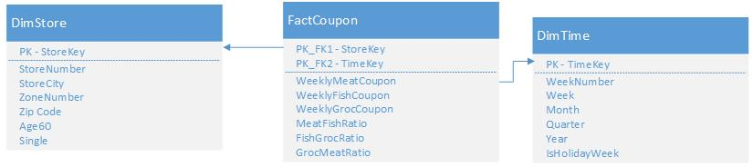

Figure 12: Coupon Redemption Data mart

**Movement Data mart:**

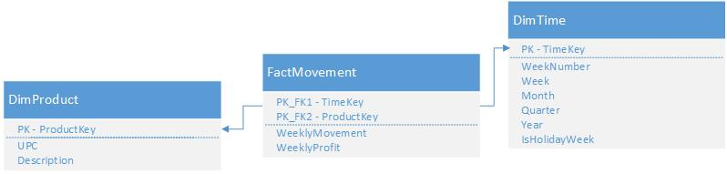

Figure 13: Movement Data mart

**Sales Data mart:**

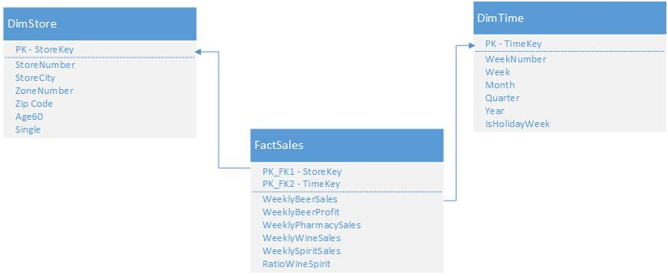

Figure 14: Sales Data mart

## **Data Integration**

**Data Quality Issues**

Data quality refers to the fitness of the data for use. The readily available data may not be fit for processing and hence various transformation rules are applied on it to make it suitable for the intended purposes. Data warehousing helps the business in making informed decisions and it is necessary for the business to trust the data which leads to the decisions.

The data is of high quality when it is complete, it is of the right data type, consistent, has right amount of redundancy, should have structure definiteness, absence of anomalies and should satisfy domain integrity.

The DFF data provided for this project had the following data problems- inconsistent values, incorrect values, violated domain integrity, the format of the values for a field was inconsistent and some values were invalid. Such data was transformed and cleaned to ensure that data was consistent in the warehouse.

**Procedures followed to ensure data quality in our data warehouse:**

1. Referential constraints were applied while creating tables.
2. Domain integrity was enforced.
3. Primary keys were created while designing the staging tables and surrogate keys were created while designing the data warehouse tables.
4. Invalid week numbers were removed from the data.
5. Extra spaces and special characters were removed.
6. Null values were replaced by meaningful values.
7. Only the details of stores whose store numbers were present in the manual were extracted.

**ETL Plan**

**Extraction**

The data necessary for the data warehouse needs to be extracted from the various CSV files and manual of DFF. This was done using SSIS and the extraction was a one-time process. New data can be extracted on a daily or a monthly basis as the organization requires it. The ETL process used in this data warehouse extracts data from CSV files. The source files are restricted to the CSV files and the DFF manual provided by DFF. The data taken from the manual was converted to CSV format and then extracted to the pre-staging tables in the staging area. The files necessary for the three data marts were the only files extracted. Extracted data was used to populate the pre-staging tables- Week, Store, Ccount, Demographics, Product_Final, WBER_Staging, WFRD_Staging created in the staging area.

|  |  |  |  |  |  |
| --- | --- | --- | --- | --- | --- |
| **E - Extract Functionalities** | | | | | |
| **Source Type** | **Data Source** | **Data Source Column Headers** | **Mapping** | **Prestaging Table Column Header** | **Prestaging Table Name** |
| From DFF manual | Week.xlsx | Week# | Copy | WeekNum | Week |
| StartDate | Copy | StartDate |
| EndDate | Copy | EndDate |
| SpecialEvents | Copy | SpecialEvents |
| From DFF manual | Store.xlsx | Name | Copy | StoreNumber | Store |
| City | Copy | StoreCity |
| Zip | Copy | ZipCode |
| Zone | Copy | ZoneNumber |
| DFF CSV Files | Ccount.csv | Store | Copy | StoreNumber | Ccount |
| GrocCoup | Copy | GrocCoup |
| MeatCoup | Copy | MeatCoup |
| FishCoup | Copy | FishCoup |
| Pharmacy | Copy | PharmacySales |
| Beer | Copy | BeerSales |
| Wine | Copy | WineSales |
| Spirits | Copy | SpiritSales |
| Week | Copy | WeekNumber |
| <<ignore>> |  | CCountNum |
| DFF CSV Files | Demo.csv | Store | Copy | StoreNumber | Demographics |
| Age60 | Copy | Age60 |
| HHSingle | Copy | HHSingle |
| <<ignore>> |  | DemoNumber |
| DFF CSV Files | Ffood.xlsx | UPC | Copy | UPC | Product_Final |
| Description | Copy | Description |
| <<ignore>> |  | ProductNumber |
| DFF CSV Files | DONE-WBER.csv | Store | Copy | StoreNumber | WBER_Staging |
| Profit | Copy | Profit |
| Week | Copy | WeekNumber |
| <<ignore>> |  | WBERNumber |
| DFF CSV Files | WFRD.csv | Store | Copy | StoreNumber | WFRD_Staging |
| UPC | Copy | UPCNumber |
| Week | Copy | WeekNumber |
| Move | Copy | Move |
| Profit | Copy | Profit |
| <<ignore>> |  | WFRDNumber |

**Data Transformation and cleansing:**

The data extracted to the pre- staging tables in the staging area need to be cleansed and transformed before the staging tables can be populated. Since the data extracted had a lot of inconsistencies and extra junk characters, invalid dates, invalid week numbers, null values , it had to be cleansed and transformed to load only consistent and usable data to the warehouse. Some of the cleansing and transformations performed are as follows:

**DEMO.CSV**

The StoreNumber, Age60 and HHSingle columns of this file are used in the data marts.

The store manual has a list of DFF stores and their details. These store numbers range from 1-138. Hence only the details for these stores were extracted. Some of the values in this column had white spaces appended to the ends which were trimmed off before using them.

Age60 and HHSingle columns were used to extract the percentage of population above Age60 and households with singles. These columns had ‘.’ characters as junk values. These were removed before being populated in the staging tables.

**CCOUNT.CSV**

The StoreNumber, GrocCoup, MeatCoup, FishCoup, PharmacySales, BeerSales, WineSales, SpiritSales and WeekNumber columns of this file are used in the data marts.

The store manual has a list of DFF stores and their details. These store numbers range from 1-138. Hence only the details for these stores were extracted.

GrocCoup, MeatCoup, FishCoup, PharmacySales, BeerSales, WineSales, SpiritSales columns had some negative values. These were assumed as data entry errors and the absolute values were taken and populated.

CCount file consisted entries for week numbers less than 1. Since the week numbers in the DFF manual ranged from 1-400, any data which had week numbers not within this range were not considered.

**WEEK**

The week information from the DFF manual has the start date, end date of the week, if the week was a holiday week. This information was used to find the week of the year, month of the year, year and the quarter to which the week belongs using the DATEPART (), MONTH (), YEAR () function.

The special event type was also populated for the weeks. The weeks which did not have associated special event had null values in the pre-staging table “week”. REPLACENULL () as used to replace these null values with “no”.

This detail was used to populate the IsHolidayWeek attribute of the staging table Time_Final. The IsHolidayWeek attribute had 1 if the Special events column had an event associated with it and 0 if the special events column had a “no”.

**WFRD.CSV**

The store number, move and profit columns of this file were used to populate the pre-staging table “WFRD_Staging”.

The store manual has a list of DFF stores and their details. These store numbers range from 1-138. Hence only the details for these stores were extracted.

The “Move” and “profit” columns from the file were cleansed of the junk value ‘.’, nulls were replaced and values were aggregated by the UPC number, store number and the week number.

**DONE-WBER.CSV**

The store number and profit columns of this file were used to populate the pre-staging table “WBER_Staging”.

The store manual has a list of DFF stores and their details. These store numbers range from 1-138. Hence only the details for these stores were extracted.

The “profit” column from this table was cleansed of the junk value ‘.’, nulls were replaced and values were aggregated by the store number and the week number.

CCount_Temp table is created as an intermediate table to perform aggregations to populate the staging table which will be used to populate the data warehouse fact table.

|  |  |  |  |  |  |
| --- | --- | --- | --- | --- | --- |
| **T - Transform Functionalities** | | | | | |
| **Pre-Staging Table Name** | **Pre-Staging Table Column Header** | **Transformation Logic** | **Mapping** | **Staging Table Column Header** | **Staging Table Name** |
| Demographics | StoreNumber | TRIM(StoreNumber) | Copy | StoreNumber | Store_Final |
| Age60 | Age60 != "." | Copy | Age60 |
| HHSingle | HHSingle != "." | Copy | Single |
| Store | StoreNumber |  | N/A |  |
| StoreCity | Copy | StoreCity |
| ZoneNumber | Copy | ZoneNumber |
| ZipCode | Copy | ZipCode |
| Week | WeekNum |  | Copy | WeekNumber | Time_Final |
| StartDate | N/A |  |
| EndDate | N/A |  |
| SpecialEvents | REPLACENULL(SpecialEvents,"no") | N/A |  |
|  | DATEPART("ww",StartDate) | Copy | Week |
| MONTH(StartDate) | Copy | Month |
| YEAR(StartDate) | Copy | Year |
| DATEPART("qq",StartDate) | Copy | Quarter |
| ((SpecialEvents == "Halloween" || SpecialEvents == "Thanksgiving" || SpecialEvents == "Christmas") ? 1 : 0) | Copy | IsHolidayWeek |
| WBER_Staging | StoreNumber | StoreNumber < 138 | Copy | StoreNumber | Beer_Final |
| Profit | Aggregrated by StoreNumber ,WeekNumber | Copy | ProfitByWeek |
| WeekNumber |  | Copy | WeekNumber |
| WFRD_Staging | StoreNumber | StoreNumber < 138 | N/A |  | FrozenFood_Final |
| UPCNumber |  | Copy | UPC |
| WeekNumber | Copy | WeekNumber |
| Move | 1. Move != "."  2. REPLACENULL(TRIM(Move),0) 3. Aggregrated by UPCNumber ,WeekNumber | Copy | MovementByWeek |
| Profit | 1. Profit != "." 2. REPLACENULL(TRIM(Profit),0) 3. Aggregrated by UPCNumber ,WeekNumber | Copy | ProfitByWeek |
| Ccount | StoreNumber | StoreNumber < 138 | Copy | StoreNumber | Ccount_Temp |
| GrocCoup | ABS([Copy of GrocCoup]) | Copy | GrocCoup |
| MeatCoup | ABS([Copy of MeatCoup]) | Copy | MeatCoup |
| FishCoup | ABS([Copy of FishCoup]) | Copy | FishCoup |
| PharmacySales | ABS([Copy of PharmacySales]) | Copy | PharmacySales |
| BeerSales | ABS([Copy of BeerSales]) | Copy | BeerSales |
| WineSales | ABS([Copy of WineSales]) | Copy | WineSales |
| SpiritSales | ABS([Copy of SpiritSales]) | Copy | SpiritSales |
| WeekNumber | WeekNumber > 0 | Copy | WeekNumber |
| Ccount_Temp | StoreNumber |  | Copy | StoreNumber | CCount_Final |
| GrocCoup | Aggregrated by StoreNumber ,WeekNumber | Copy | GrocCoupByWeek |
| MeatCoup | Aggregrated by StoreNumber ,WeekNumber | Copy | MeatCoupByWeek |
| FishCoup | Aggregrated by StoreNumber ,WeekNumber | Copy | FishCoupByWeek |
| PharmacySales | Aggregrated by StoreNumber ,WeekNumber | Copy | PharmacySalesByWeek |
| BeerSales | Aggregrated by StoreNumber ,WeekNumber | Copy | BeerSalesByWeek |
| WineSales | Aggregrated by StoreNumber ,WeekNumber | Copy | WineSalesByWeek |
| SpiritSales | Aggregrated by StoreNumber ,WeekNumber | Copy | SpiritSalesByWeek |
| WeekNumber |  | Copy | WeekNumber |

**Loading:**

The staging tables are used to load the dimension and fact tables of the data warehouse. The dimension tables DimProduct, Dim Time and Dim Store are directly loaded from the staging tables Product Final, Time Final, Store Final respectively.The primary keys for these tables are auto-generated.

For the fact table, FactSales, the data is loaded from the staging tables CCount_Final and Beer_Final. TimeKey and StoreKey are surrogate keys. The RatioWineSpirit is calculated for the rows where SpiritSalesByWeek is not equal to zero.

For the fact table, FactCoupon, the data is loaded from the staging table CCount_Final. TimeKey and StoreKey are surrogate keys. MeatFishRatio, FishGrocRatio and GrocMeatRatio are calculated and populated.

For the fact table, FactMovement, the data is loaded from FrozenFood_Final. TimeKey and ProductKey are surrogate keys.

|  |  |  |  |  |
| --- | --- | --- | --- | --- |
| **L - Loading Functionalities** | | | | |
| **Staging Table Column Header** | **Staging Table Name** | **Mapping** | **DW Area Table Column Header** | **DW Area Table Name** |
| Product_Final | UPC | Copy | UPC | DimProduct |
| Description | Copy | Description |
|  | Autogenerated Key | ProductKey |
| Time_Final | WeekNumber | Copy | WeekNumber | DimTime |
| Week | Copy | Week |
| Month | Copy | Month |
| Year | Copy | Year |
| Quarter | Copy | Quarter |
| IsHolidayWeek | Copy | IsHolidayWeek |
|  | Autogenerated Key | TimeKey |
| Store_Final | StoreNumber | Copy | StoreNumber | DimStore |
| Age60 | Copy | Age60 |
| Single | Copy | Single |
| StoreCity | Copy | StoreCity |
| ZoneNumber | Copy | ZoneNumber |
| ZipCode | Copy | ZipCode |
|  | Autogenerated Key | StoreKey |
| CCount_Final | StoreNumber | N/A |  | FactSales |
| PharmacySalesByWeek | Copy | WeeklyPharmacySales |
| BeerSalesByWeek | Copy | WeeklyBeerSales |
| WineSalesByWeek | Copy | WeeklyWineSales |
| SpiritSalesByWeek | Copy | WeeklySpiritSales |
| WeekNumber | N/A |  |
|  | (SpiritSalesByWeek != 0 ? (WineSalesByWeek / SpiritSalesByWeek) : 0) | RatioWineSpirit |
| Surrogate Key | TimeKey |
| Surrogate Key | StoreKey |
| Beer_Final | ProfitByWeek | Copy | WeeklyBeerProfit |
| WeekNumber | N/A |  |
| StoreNumber | N/A |
| CCount_Final | WeeklyMeatCoup | Copy | WeeklyMeatCoup | FactCoupon |
| WeeklyFishCoup | Copy | WeeklyFishCoup |
| WeeklyGrocCoup | Copy | WeeklyGrocCoup |
| WeekNumber | N/A |  |
| StoreNumber | N/A |
|  | Surrogate Key | StoreKey |
| Surrogate Key | TimeKey |
| (FishCoupByWeek != 0 ? (MeatCoupByWeek / FishCoupByWeek) : 0) | MeatFishRatio |
| (GrocCoupByWeek != 0 ? (FishCoupByWeek / GrocCoupByWeek) : 0) | FishGrocRatio |
| (MeatCoupByWeek != 0 ? (GrocCoupByWeek / MeatCoupByWeek) : 0) | GrocMeatRatio |
| FrozenFood_Final | UPC | N/A |  | FactMovement |
| WeekNumber | N/A |
| MovementByWeek | Copy | WeeklyMovement |
| ProfitByWeek | Copy | WeeklyFrdProfit |
|  | Surrogate Key | ProductKey |
| Surrogate Key | TimeKey |

### **SQL Scripts**

* 1. **Pre-Staging Scripts**
     1. **Dropping table data**

USE [Group10_602-Staging-area]

GO

IF EXISTS ( SELECT TOP 1 * FROM [dbo].[Week])

DELETE FROM [dbo].[Week]

IF EXISTS ( SELECT TOP 1 * FROM [dbo].[Store])

DELETE FROM [dbo].[Store]

IF EXISTS ( SELECT TOP 1 * FROM [dbo].[CCount])

DELETE FROM [dbo].[CCount]

IF EXISTS ( SELECT TOP 1 * FROM [dbo].[Demographics])

DELETE FROM [dbo].[Demographics]

IF EXISTS ( SELECT TOP 1 * FROM [dbo].[Product_Final])

DELETE FROM [dbo].[Product_Final]

IF EXISTS ( SELECT TOP 1 * FROM [dbo].[WBER_Staging])

DELETE FROM [dbo].[WBER_Staging]

IF EXISTS ( SELECT TOP 1 * FROM [dbo].[WFRD_Staging])

DELETE FROM [dbo].[WFRD_Staging]

* + 1. **Creating pre-staging tables**

CREATE TABLE [dbo].[CCount](

[CCountNum] [int] IDENTITY(1,1) NOT NULL,

[WeekNumber] [varchar](10) NULL,

[MeatCoup] [varchar](10) NULL CONSTRAINT [DF_CCount_MeatCoup_1] DEFAULT ((0.00)),

[FishCoup] [varchar](10) NULL CONSTRAINT [DF_CCount_FishCoup_1] DEFAULT ((0.00)),

[GrocCoup] [varchar](10) NULL CONSTRAINT [DF_CCount_GrocCoup_1] DEFAULT ((0.00)),

[BeerSales] [varchar](10) NULL CONSTRAINT [DF_CCount_BeerSales_1] DEFAULT ((0.00)),

[WineSales] [varchar](10) NULL CONSTRAINT [DF_CCount_WineSales_1] DEFAULT ((0.00)),

[SpiritSales] [varchar](10) NULL CONSTRAINT [DF_CCount_SpiritSales_1] DEFAULT ((0.00)),

[PharmacySales] [varchar](10) NULL CONSTRAINT [DF_CCount_PharmacySales_1] DEFAULT ((0.00)),

[StoreNumber] [varchar](10) NOT NULL,

CONSTRAINT [PK_CCount] PRIMARY KEY CLUSTERED

(

[CCountNum] ASC

)WITH (PAD_INDEX = OFF, STATISTICS_NORECOMPUTE = OFF, IGNORE_DUP_KEY = OFF, ALLOW_ROW_LOCKS = ON, ALLOW_PAGE_LOCKS = ON) ON [PRIMARY]

) ON [PRIMARY]

GO

CREATE TABLE [dbo].[CCount_Temp](

[WeekNumber] [numeric](18, 0) NOT NULL,

[MeatCoup] [decimal](10, 2) NULL,

[FishCoup] [decimal](10, 2) NULL,

[GrocCoup] [decimal](10, 2) NULL,

[BeerSales] [decimal](10, 2) NULL,

[WineSales] [decimal](10, 2) NULL,

[SpiritSales] [decimal](10, 2) NULL,

[PharmacySales] [decimal](10, 2) NULL,

[StoreNumber] [int] NOT NULL

) ON [PRIMARY]

GO

CREATE TABLE [dbo].[Demographics](

[DemoNumber] [int] IDENTITY(1,1) NOT NULL,

[Age60] [varchar](30) NULL CONSTRAINT [DF_Demographics_Age60] DEFAULT ((0.00)),

[HHSingle] [varchar](30) NULL CONSTRAINT [DF_Demographics_HHSingle] DEFAULT ((0.00)),

[StoreNumber] [varchar](10) NULL,

CONSTRAINT [PK_Demographics] PRIMARY KEY CLUSTERED

(

[DemoNumber] ASC

)WITH (PAD_INDEX = OFF, STATISTICS_NORECOMPUTE = OFF, IGNORE_DUP_KEY = OFF, ALLOW_ROW_LOCKS = ON, ALLOW_PAGE_LOCKS = ON) ON [PRIMARY]

) ON [PRIMARY]

GO

CREATE TABLE [dbo].[Store](

[StoreNumber] [int] NOT NULL,

[StoreCity] [varchar](50) NOT NULL,

[ZoneNumber] [int] NULL,

[ZipCode] [int] NULL,

CONSTRAINT [PK_Store] PRIMARY KEY CLUSTERED

(

[StoreNumber] ASC

)WITH (PAD_INDEX = OFF, STATISTICS_NORECOMPUTE = OFF, IGNORE_DUP_KEY = OFF, ALLOW_ROW_LOCKS = ON, ALLOW_PAGE_LOCKS = ON) ON [PRIMARY]

) ON [PRIMARY]

GO

CREATE TABLE [dbo].[WBER_Staging](

[WBERNumber] [int] IDENTITY(1,1) NOT NULL,

[StoreNumber] [int] NOT NULL,

[WeekNumber] [int] NOT NULL,

[Profit] [numeric](18, 2) NULL,

CONSTRAINT [PK_WBER_Staging] PRIMARY KEY CLUSTERED

(

[WBERNumber] ASC

)WITH (PAD_INDEX = OFF, STATISTICS_NORECOMPUTE = OFF, IGNORE_DUP_KEY = OFF, ALLOW_ROW_LOCKS = ON, ALLOW_PAGE_LOCKS = ON) ON [PRIMARY]

) ON [PRIMARY]

GO

CREATE TABLE [dbo].[Week](

[WeekNum] [int] NOT NULL,

[StartDate] [date] NOT NULL,

[EndDate] [date] NOT NULL,

[SpecialEvents] [varchar](50) NULL,

CONSTRAINT [PK_Week] PRIMARY KEY CLUSTERED

(

[WeekNum] ASC

)WITH (PAD_INDEX = OFF, STATISTICS_NORECOMPUTE = OFF, IGNORE_DUP_KEY = OFF, ALLOW_ROW_LOCKS = ON, ALLOW_PAGE_LOCKS = ON) ON [PRIMARY]

) ON [PRIMARY]

GO

CREATE TABLE [dbo].[WFRD_Staging](

[WFRDNumber] [int] IDENTITY(1,1) NOT NULL,

[StoreNumber] [int] NOT NULL,

[UPCNumber] [bigint] NOT NULL,

[WeekNumber] [int] NOT NULL,

[Move] [varchar](20) NULL CONSTRAINT [DF_WFRD_Staging_Move] DEFAULT ((0.00)),

[Profit] [varchar](20) NULL,

CONSTRAINT [PK_WFRD_Staging] PRIMARY KEY CLUSTERED

(

[WFRDNumber] ASC

)WITH (PAD_INDEX = OFF, STATISTICS_NORECOMPUTE = OFF, IGNORE_DUP_KEY = OFF, ALLOW_ROW_LOCKS = ON, ALLOW_PAGE_LOCKS = ON) ON [PRIMARY]

) ON [PRIMARY]

GO

* 1. **Staging Scripts**
     1. **Dropping all Final table data**

USE [Group10_602-Staging-area]

GO

IF EXISTS ( SELECT TOP 1 * FROM [dbo].[Ccount_final])

DELETE FROM [dbo].[Ccount_final]

IF EXISTS ( SELECT TOP 1 * FROM [dbo].[CCount_Temp])

DELETE FROM [dbo].[CCount_Temp]

IF EXISTS ( SELECT TOP 1 * FROM [dbo].[FrozenFood_Final])

DELETE FROM [dbo].[FrozenFood_Final]

IF EXISTS ( SELECT TOP 1 * FROM [dbo].[Beer_Final])

DELETE FROM [dbo].[Beer_Final]

IF EXISTS ( SELECT TOP 1 * FROM [dbo].[Product_Final])

DELETE FROM [dbo].[Product_Final]

IF EXISTS ( SELECT TOP 1 * FROM [dbo].[Store_Final])

DELETE FROM [dbo].[Store_Final]

IF EXISTS ( SELECT TOP 1 * FROM [dbo].[Time_Final])

DELETE FROM [dbo].[Time_Final]

* + 1. **Creating Staging tables**

CREATE TABLE [dbo].[Beer_Final](

[BeerNumber] [int] IDENTITY(1,1) NOT NULL,

[WeekNumber] [int] NULL,

[StoreNumber] [int] NULL,

[ProfitByWeek] [decimal](8, 2) NULL,

CONSTRAINT [PK_Beer_Final] PRIMARY KEY CLUSTERED

(

[BeerNumber] ASC

)WITH (PAD_INDEX = OFF, STATISTICS_NORECOMPUTE = OFF, IGNORE_DUP_KEY = OFF, ALLOW_ROW_LOCKS = ON, ALLOW_PAGE_LOCKS = ON) ON [PRIMARY]

) ON [PRIMARY]

GO

ALTER TABLE [dbo].[Beer_Final] WITH CHECK ADD CONSTRAINT [FK_Beer_Week] FOREIGN KEY([WeekNumber])

REFERENCES [dbo].[Time_Final] ([WeekNumber])

GO

ALTER TABLE [dbo].[Beer_Final] CHECK CONSTRAINT [FK_Beer_Week]

GO

CREATE TABLE [dbo].[Ccount_final](

[CCountNum] [int] IDENTITY(1,1) NOT NULL,

[WeekNumber] [int] NULL,

[MeatCoupByWeek] [decimal](10, 2) NULL,

[FishCoupByWeek] [decimal](10, 2) NULL,

[GrocCoupByWeek] [decimal](10, 2) NULL,

[BeerSalesByWeek] [decimal](10, 2) NULL,

[WineSalesByWeek] [decimal](10, 2) NULL,

[SpiritSalesByWeek] [decimal](10, 2) NULL,

[PharmacySalesByWeek] [decimal](10, 2) NULL,

[StoreNumber] [int] NULL,

CONSTRAINT [PK_Ccount_final] PRIMARY KEY CLUSTERED

(

[CCountNum] ASC

)WITH (PAD_INDEX = OFF, STATISTICS_NORECOMPUTE = OFF, IGNORE_DUP_KEY = OFF, ALLOW_ROW_LOCKS = ON, ALLOW_PAGE_LOCKS = ON) ON [PRIMARY]

) ON [PRIMARY]

GO

ALTER TABLE [dbo].[Ccount_final] WITH CHECK ADD CONSTRAINT [FK_Ccount_final_Store_Final] FOREIGN KEY([StoreNumber])

REFERENCES [dbo].[Store_Final] ([StoreNumber])

GO

ALTER TABLE [dbo].[Ccount_final] CHECK CONSTRAINT [FK_Ccount_final_Store_Final]

GO

ALTER TABLE [dbo].[Ccount_final] WITH CHECK ADD CONSTRAINT [FK_Ccount_final_Time_Final] FOREIGN KEY([WeekNumber])

REFERENCES [dbo].[Time_Final] ([WeekNumber])

GO

ALTER TABLE [dbo].[Ccount_final] CHECK CONSTRAINT [FK_Ccount_final_Time_Final]

GO

CREATE TABLE [dbo].[FrozenFood_Final](

[UPC] [bigint] NOT NULL,

[MovementByWeek] [int] NOT NULL,

[ProfitByWeek] [decimal](8, 2) NOT NULL,

[WeekNumber] [int] NOT NULL

) ON [PRIMARY]

GO

ALTER TABLE [dbo].[FrozenFood_Final] WITH CHECK ADD CONSTRAINT [FK_FrozenFood_Product_Final] FOREIGN KEY([UPC])

REFERENCES [dbo].[Product_Final] ([UPC])

GO

ALTER TABLE [dbo].[FrozenFood_Final] CHECK CONSTRAINT [FK_FrozenFood_Product_Final]

GO

ALTER TABLE [dbo].[FrozenFood_Final] WITH CHECK ADD CONSTRAINT [FK_FrozenFood_Time_Final] FOREIGN KEY([WeekNumber])

REFERENCES [dbo].[Time_Final] ([WeekNumber])

GO

ALTER TABLE [dbo].[FrozenFood_Final] CHECK CONSTRAINT [FK_FrozenFood_Time_Final]

GO

CREATE TABLE [dbo].[Product_Final](

[ProductNumber] [int] IDENTITY(1,1) NOT NULL,

[UPC] [bigint] NOT NULL,

[Description] [varchar](100) NULL,

CONSTRAINT [PK_Product_Final] PRIMARY KEY CLUSTERED

(

[UPC] ASC

)WITH (PAD_INDEX = OFF, STATISTICS_NORECOMPUTE = OFF, IGNORE_DUP_KEY = OFF, ALLOW_ROW_LOCKS = ON, ALLOW_PAGE_LOCKS = ON) ON [PRIMARY]

) ON [PRIMARY]

GO

CREATE TABLE [dbo].[Store_Final](

[StoreNumber] [int] NOT NULL,

[StoreCity] [varchar](50) NULL,

[ZoneNumber] [int] NULL,

[ZipCode] [int] NULL,

[Age60] [decimal](12, 10) NULL CONSTRAINT [DF_Store_Final_Age60] DEFAULT ((0.00)),

[Single] [decimal](12, 10) NULL CONSTRAINT [DF_Store_Final_Single] DEFAULT ((0.00)),

CONSTRAINT [PK_Store_Final] PRIMARY KEY CLUSTERED

(

[StoreNumber] ASC

)WITH (PAD_INDEX = OFF, STATISTICS_NORECOMPUTE = OFF, IGNORE_DUP_KEY = OFF, ALLOW_ROW_LOCKS = ON, ALLOW_PAGE_LOCKS = ON) ON [PRIMARY]

) ON [PRIMARY]

GO

CREATE TABLE [dbo].[Time_Final](

[WeekNumber] [int] NOT NULL,

[Week] [int] NULL,

[Month] [int] NULL,

[Year] [int] NULL,

[Quarter] [int] NULL,

[IsHolidayWeek] [int] NULL CONSTRAINT [DF_Time_Final_IsHolidayWeek] DEFAULT ((0)),

CONSTRAINT [PK_Time_Final] PRIMARY KEY CLUSTERED

(

[WeekNumber] ASC

)WITH (PAD_INDEX = OFF, STATISTICS_NORECOMPUTE = OFF, IGNORE_DUP_KEY = OFF, ALLOW_ROW_LOCKS = ON, ALLOW_PAGE_LOCKS = ON) ON [PRIMARY]

) ON [PRIMARY]

GO

ALTER TABLE [dbo].[Time_Final] WITH CHECK ADD CONSTRAINT [CK_Time_Final] CHECK (([Month]<=(12)))

GO

ALTER TABLE [dbo].[Time_Final] CHECK CONSTRAINT [CK_Time_Final]

GO

ALTER TABLE [dbo].[Time_Final] WITH CHECK ADD CONSTRAINT [CK_Time_Final_2] CHECK (([Year]>=(1989) AND [Year]<=(1997)))

GO

ALTER TABLE [dbo].[Time_Final] CHECK CONSTRAINT [CK_Time_Final_2]

GO

* 1. **Data warehouse scripts**
     1. **Full Refresh SQL**

USE[Group10_602-DW-area]

GO

IF EXISTS ( SELECT TOP 1 * FROM [dbo].[DimProduct])

DELETE FROM [dbo].[DimProduct]

IF EXISTS ( SELECT TOP 1 * FROM [dbo].[DimStore])

DELETE FROM [dbo].[DimStore]

IF EXISTS ( SELECT TOP 1 * FROM [dbo].[DimTime])

DELETE FROM [dbo].[DimTime]

IF EXISTS ( SELECT TOP 1 * FROM [dbo].[FactSales])

DELETE FROM [dbo].[FactSales]

IF EXISTS ( SELECT TOP 1 * FROM [dbo].[FactMovement])

DELETE FROM [dbo].[FactMovement]

IF EXISTS ( SELECT TOP 1 * FROM [dbo].[FactCoupon])

DELETE FROM [dbo].[FactCoupon]

* + 1. **Creating Dimensions and Fact tables**

CREATE TABLE [dbo].[DimProduct](

[ProductKey] [int] IDENTITY(1,1) NOT NULL,

[UPC] [bigint] NOT NULL,

[Description] [varchar](100) NULL,

CONSTRAINT [PK_DimProduct] PRIMARY KEY CLUSTERED

(

[ProductKey] ASC

)WITH (PAD_INDEX = OFF, STATISTICS_NORECOMPUTE = OFF, IGNORE_DUP_KEY = OFF, ALLOW_ROW_LOCKS = ON, ALLOW_PAGE_LOCKS = ON) ON [PRIMARY]

) ON [PRIMARY]

GO

CREATE TABLE [dbo].[DimStore](

[StoreKey] [int] IDENTITY(1,1) NOT NULL,

[StoreNumber] [int] NOT NULL,

[StoreCity] [varchar](50) NULL,

[ZoneNumber] [int] NULL,

[ZipCode] [int] NULL,

[Age60] [decimal](12, 10) NULL CONSTRAINT [DF_Store_Final_Age60] DEFAULT ((0.00)),

[Single] [decimal](12, 10) NULL CONSTRAINT [DF_Store_Final_Single] DEFAULT ((0.00)),

CONSTRAINT [PK_DimStore] PRIMARY KEY CLUSTERED

(

[StoreKey] ASC

)WITH (PAD_INDEX = OFF, STATISTICS_NORECOMPUTE = OFF, IGNORE_DUP_KEY = OFF, ALLOW_ROW_LOCKS = ON, ALLOW_PAGE_LOCKS = ON) ON [PRIMARY]

) ON [PRIMARY]

GO

CREATE TABLE [dbo].[DimTime](

[TimeKey] [int] IDENTITY(1,1) NOT NULL,

[WeekNumber] [int] NOT NULL,

[Week] [int] NULL,

[Month] [int] NULL,

[Year] [int] NULL,

[Quarter] [int] NULL,

[IsHolidayWeek] [int] NULL CONSTRAINT [DF_Time_Final_IsHolidayWeek] DEFAULT ((0)),

CONSTRAINT [PK_Time_Final] PRIMARY KEY CLUSTERED

(

[TimeKey] ASC

)WITH (PAD_INDEX = OFF, STATISTICS_NORECOMPUTE = OFF, IGNORE_DUP_KEY = OFF, ALLOW_ROW_LOCKS = ON, ALLOW_PAGE_LOCKS = ON) ON [PRIMARY]

) ON [PRIMARY]

GO

ALTER TABLE [dbo].[DimTime] WITH CHECK ADD CONSTRAINT [CK_Time_Final] CHECK (([Month]<=(12)))

GO

ALTER TABLE [dbo].[DimTime] CHECK CONSTRAINT [CK_Time_Final]

GO

ALTER TABLE [dbo].[DimTime] WITH CHECK ADD CONSTRAINT [CK_Time_Final_2] CHECK (([Year]>=(1989) AND [Year]<=(1997)))

GO

ALTER TABLE [dbo].[DimTime] CHECK CONSTRAINT [CK_Time_Final_2]

GO

CREATE TABLE [dbo].[FactCoupon](

[StoreKey] [int] NOT NULL,

[TimeKey] [int] NOT NULL,

[WeeklyMeatCoup] [decimal](10, 2) NULL CONSTRAINT [DF_FactCoupon_WeeklyMeatCoup] DEFAULT ((0)),

[WeeklyFishCoup] [decimal](10, 2) NULL CONSTRAINT [DF_FactCoupon_WeeklyFishCoup] DEFAULT ((0)),

[WeeklyGrocCoup] [decimal](10, 2) NULL CONSTRAINT [DF_FactCoupon_WeeklyGrocCoup] DEFAULT ((0)),

[MeatFishRatio] [decimal](10, 2) NULL CONSTRAINT [DF_FactCoupon_MeatFishRatio] DEFAULT ((0)),

[FishGrocRatio] [decimal](10, 2) NULL CONSTRAINT [DF_FactCoupon_FishGrocRatio] DEFAULT ((0)),

[GrocMeatRatio] [decimal](10, 2) NULL CONSTRAINT [DF_FactCoupon_GrocMeatRatio] DEFAULT ((0)),

CONSTRAINT [PK_FactCoupon] PRIMARY KEY CLUSTERED

(

[StoreKey] ASC,

[TimeKey] ASC

)WITH (PAD_INDEX = OFF, STATISTICS_NORECOMPUTE = OFF, IGNORE_DUP_KEY = OFF, ALLOW_ROW_LOCKS = ON, ALLOW_PAGE_LOCKS = ON) ON [PRIMARY]

) ON [PRIMARY]

GO

ALTER TABLE [dbo].[FactCoupon] WITH CHECK ADD CONSTRAINT [FK_FactCoupon_DimStore] FOREIGN KEY([StoreKey])

REFERENCES [dbo].[DimStore] ([StoreKey])

GO

ALTER TABLE [dbo].[FactCoupon] CHECK CONSTRAINT [FK_FactCoupon_DimStore]

GO

ALTER TABLE [dbo].[FactCoupon] WITH CHECK ADD CONSTRAINT [FK_FactCoupon_DimTime] FOREIGN KEY([TimeKey])

REFERENCES [dbo].[DimTime] ([TimeKey])

GO

ALTER TABLE [dbo].[FactCoupon] CHECK CONSTRAINT [FK_FactCoupon_DimTime]

GO

CREATE TABLE [dbo].[FactMovement](

[ProductKey] [int] NOT NULL,

[TimeKey] [int] NOT NULL,

[WeeklyMovement] [int] NOT NULL CONSTRAINT [DF_FactMovement_WeeklyMovement] DEFAULT ((0)),

[WeeklyFrdProfit] [decimal](8, 2) NOT NULL CONSTRAINT [DF_FactMovement_WeeklyFrdProfit] DEFAULT ((0)),

CONSTRAINT [PK_FactMovement] PRIMARY KEY CLUSTERED

(

[ProductKey] ASC,

[TimeKey] ASC

)WITH (PAD_INDEX = OFF, STATISTICS_NORECOMPUTE = OFF, IGNORE_DUP_KEY = OFF, ALLOW_ROW_LOCKS = ON, ALLOW_PAGE_LOCKS = ON) ON [PRIMARY]

) ON [PRIMARY]

GO

ALTER TABLE [dbo].[FactMovement] WITH CHECK ADD CONSTRAINT [FK_MovementFact_Product] FOREIGN KEY([ProductKey])

REFERENCES [dbo].[DimProduct] ([ProductKey])

GO

ALTER TABLE [dbo].[FactMovement] CHECK CONSTRAINT [FK_MovementFact_Product]

GO

ALTER TABLE [dbo].[FactMovement] WITH CHECK ADD CONSTRAINT [FK_MovementFact_Time] FOREIGN KEY([TimeKey])

REFERENCES [dbo].[DimTime] ([TimeKey])

GO

ALTER TABLE [dbo].[FactMovement] CHECK CONSTRAINT [FK_MovementFact_Time]

GO

CREATE TABLE [dbo].[FactSales](

[StoreKey] [int] NOT NULL,

[TimeKey] [int] NOT NULL,

[WeeklyBeerSales] [numeric](10, 2) NULL CONSTRAINT [DF_SalesFact_WeeklyBeerSales] DEFAULT ((0.0)),

[WeeklyBeerProfit] [numeric](10, 2) NULL CONSTRAINT [DF_SalesFact_WeeklyBeerProfit] DEFAULT ((0.0)),

[WeeklyWineSales] [numeric](10, 2) NULL CONSTRAINT [DF_SalesFact_WeeklyWineSales] DEFAULT ((0.0)),

[WeeklySpiritSales] [numeric](10, 2) NULL CONSTRAINT [DF_SalesFact_WeeklySpiritSales] DEFAULT ((0.0)),

[RatioWineSpirit] [numeric](23, 13) NULL CONSTRAINT [DF_SalesFact_RatioWineSpirit] DEFAULT ((0.0)),

[WeeklyPharmacySales] [numeric](10, 2) NULL CONSTRAINT [DF_FactSales_WeeklyPharmacySales] DEFAULT ((0)),

CONSTRAINT [PK_SalesFact] PRIMARY KEY CLUSTERED

(

[StoreKey] ASC,

[TimeKey] ASC

)WITH (PAD_INDEX = OFF, STATISTICS_NORECOMPUTE = OFF, IGNORE_DUP_KEY = OFF, ALLOW_ROW_LOCKS = ON, ALLOW_PAGE_LOCKS = ON) ON [PRIMARY]

) ON [PRIMARY]

GO

ALTER TABLE [dbo].[FactSales] WITH CHECK ADD CONSTRAINT [FK_FactSales_DimStore] FOREIGN KEY([StoreKey])

REFERENCES [dbo].[DimStore] ([StoreKey])

GO

ALTER TABLE [dbo].[FactSales] CHECK CONSTRAINT [FK_FactSales_DimStore]

GO

ALTER TABLE [dbo].[FactSales] WITH CHECK ADD CONSTRAINT [FK_FactSales_DimTime] FOREIGN KEY([TimeKey])

REFERENCES [dbo].[DimTime] ([TimeKey])

GO

ALTER TABLE [dbo].[FactSales] CHECK CONSTRAINT [FK_FactSales_DimTime]

GO

## **ETL Implementation Evidences and Screen Shots**

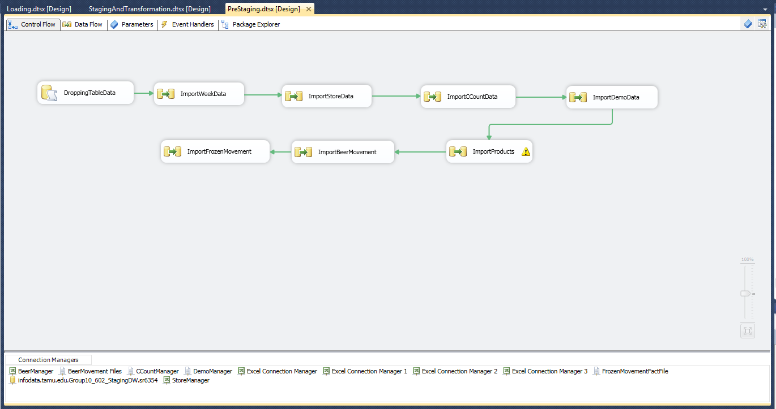

Figure 15: Control Flow of Data Extraction

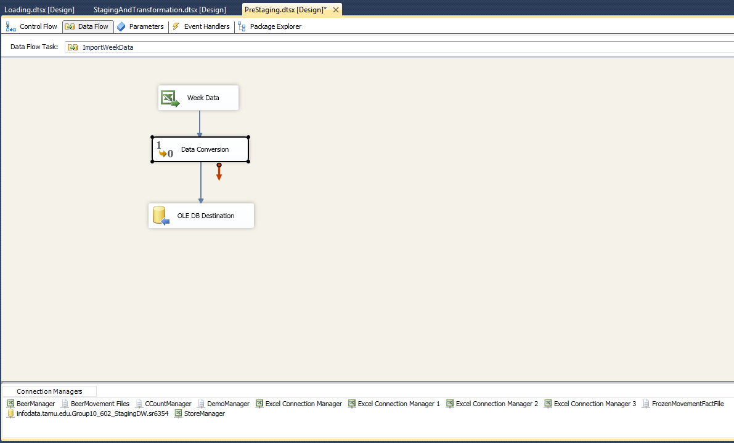

Figure 16: Extraction from Week.csv

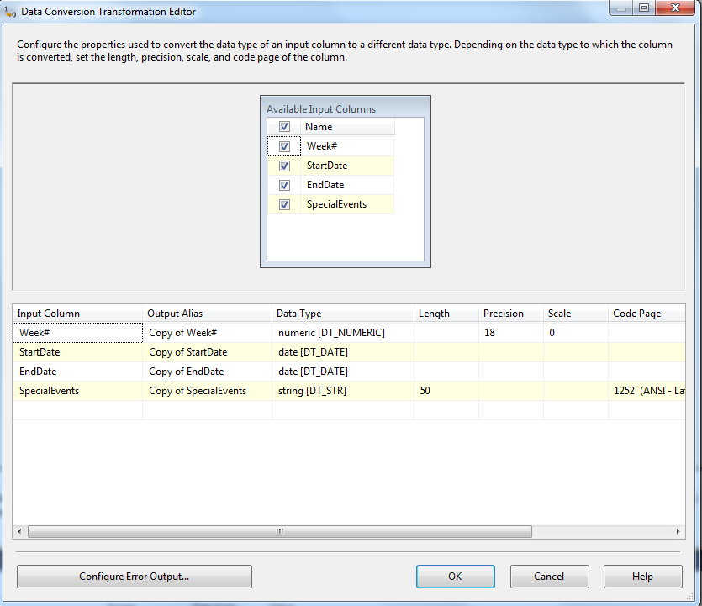

Figure 17: Extraction from Week.csv – Data Conversion

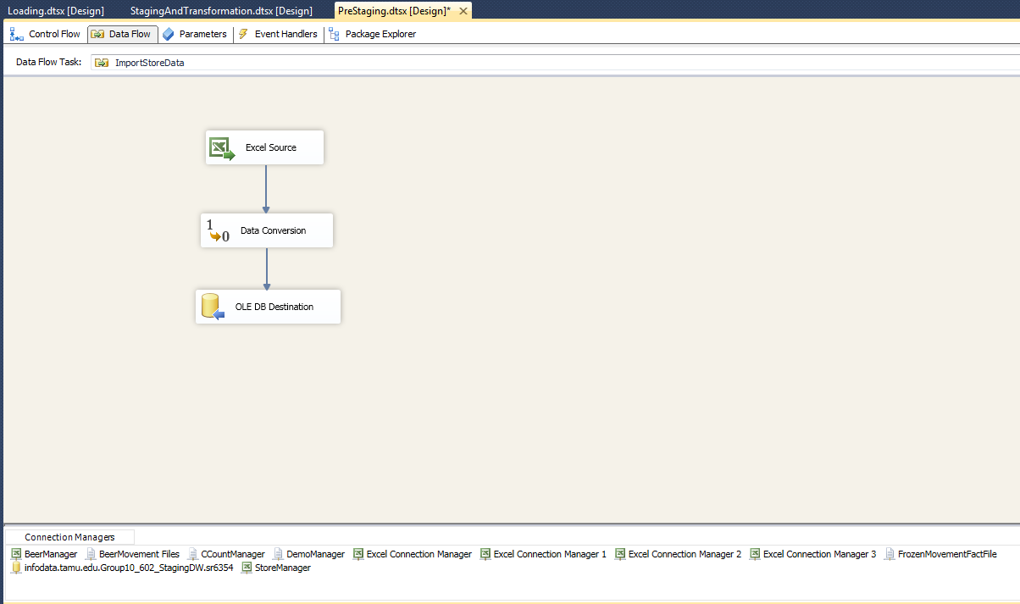

Figure 18: Extraction from Store.csv

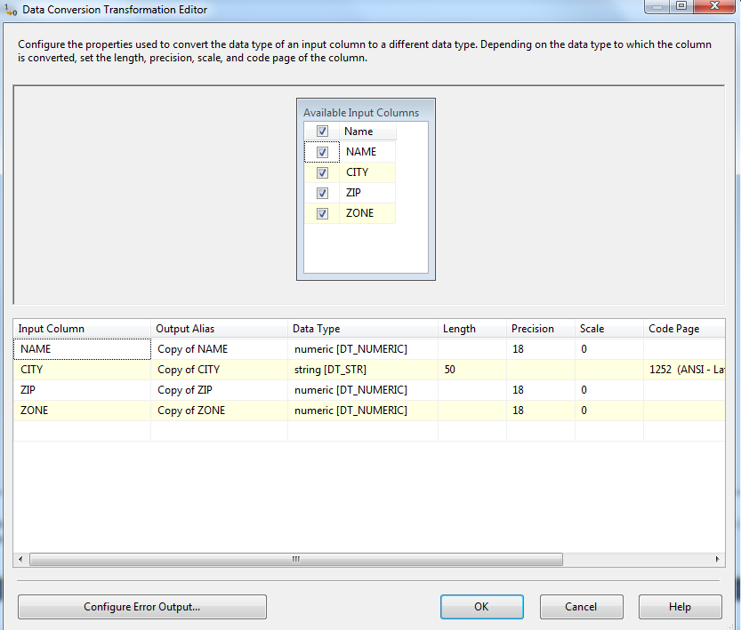

Figure 19: Extraction from Store.csv – Data Conversion

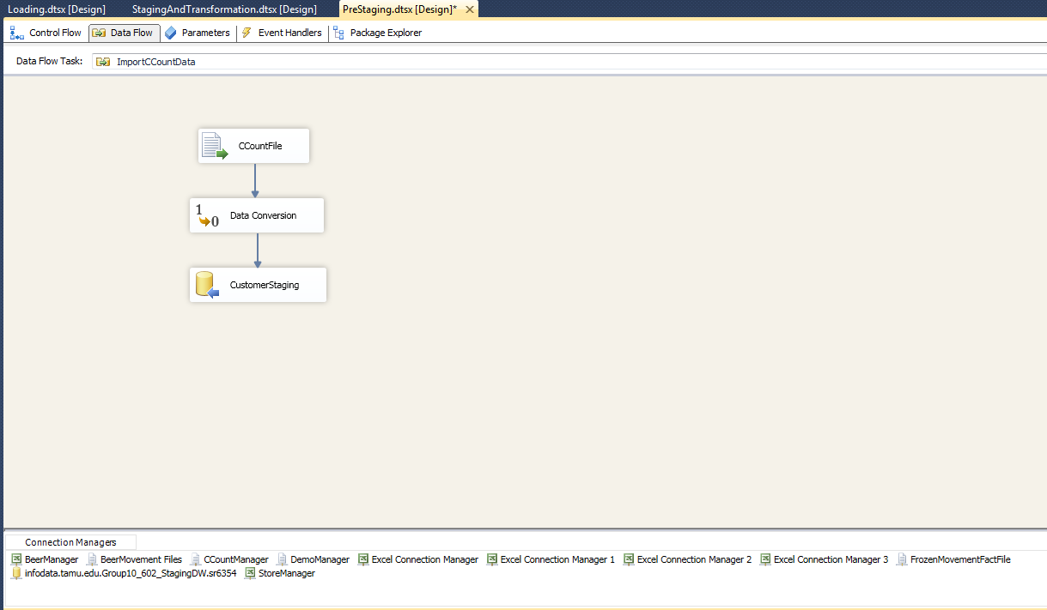

Figure 20: Extraction of CCount.csv

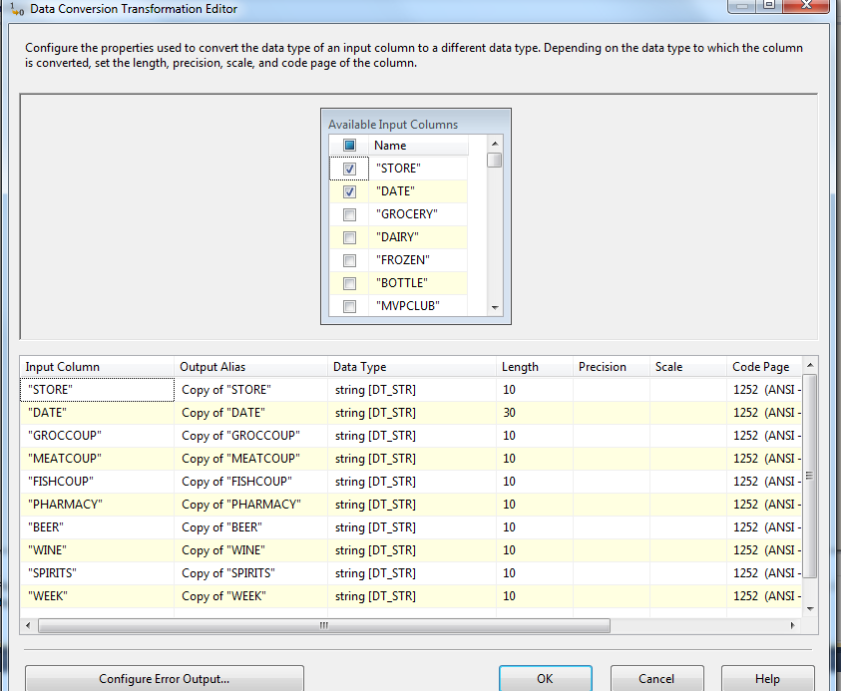

Figure 21: Extraction of CCount.csv – Data Conversion

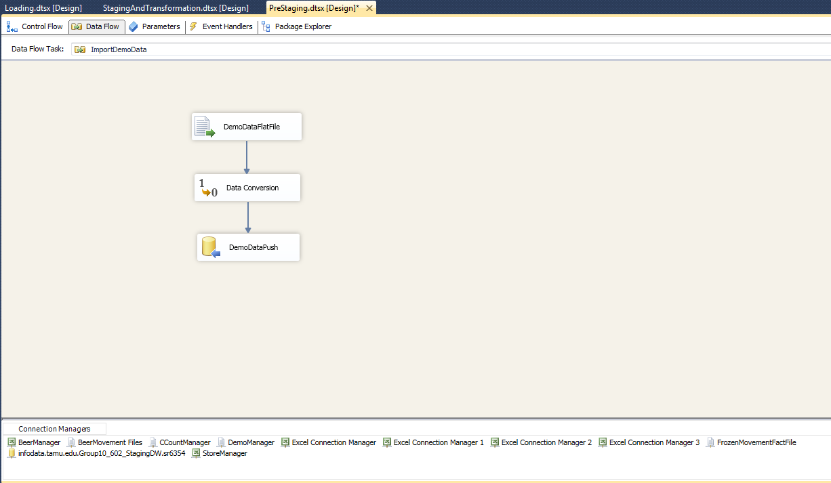

Figure 22: Extraction of Demo.csv

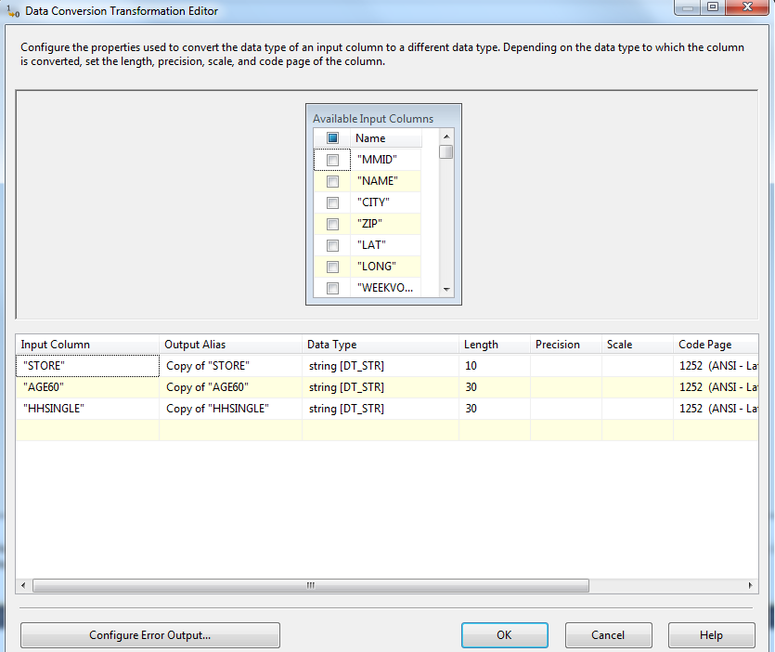

Figure 23: Extraction of Demo.csv – Data Conversion

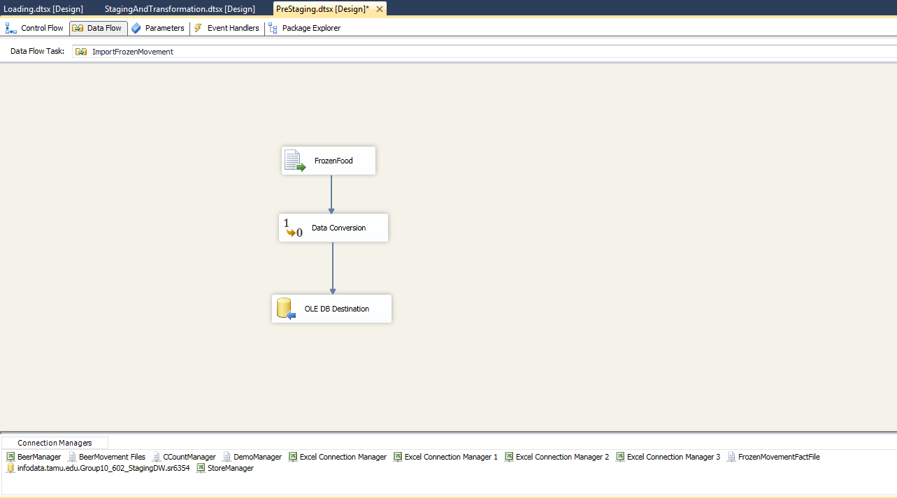

Figure 24: Extraction of WFRD.CSV

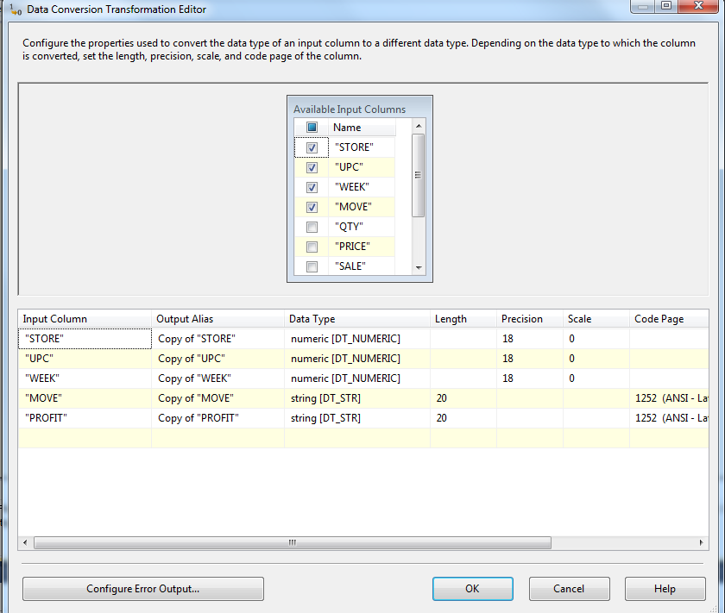

Figure 25: Extraction of WFRD.CSV- Data Conversion

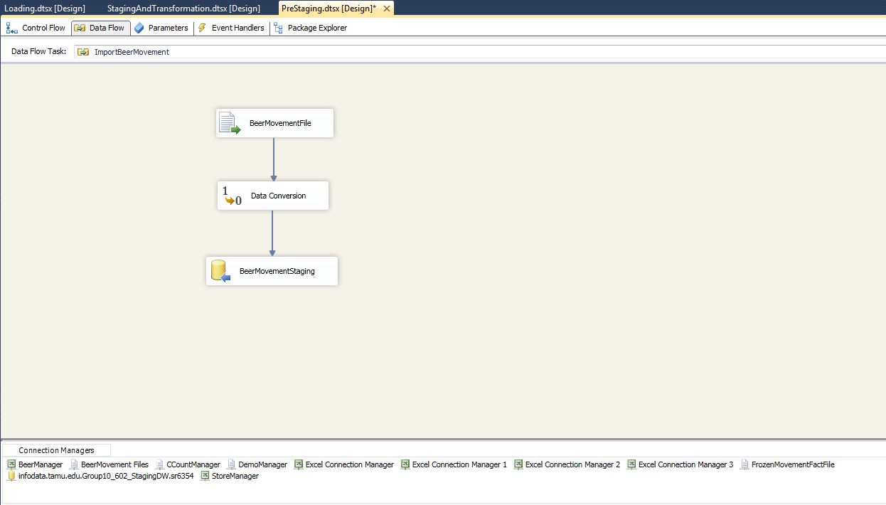

Figure 26: Extraction of DONE-WBER

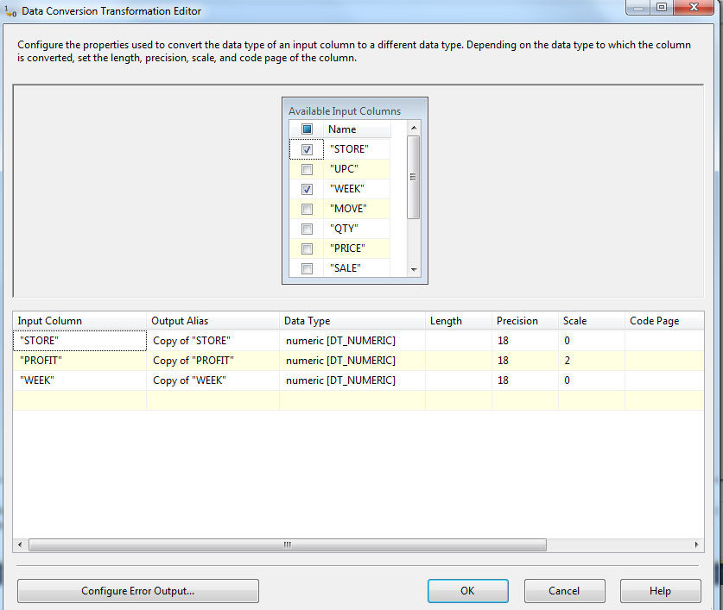

Figure 27: Extraction of DONE-WBER – Data Conversion

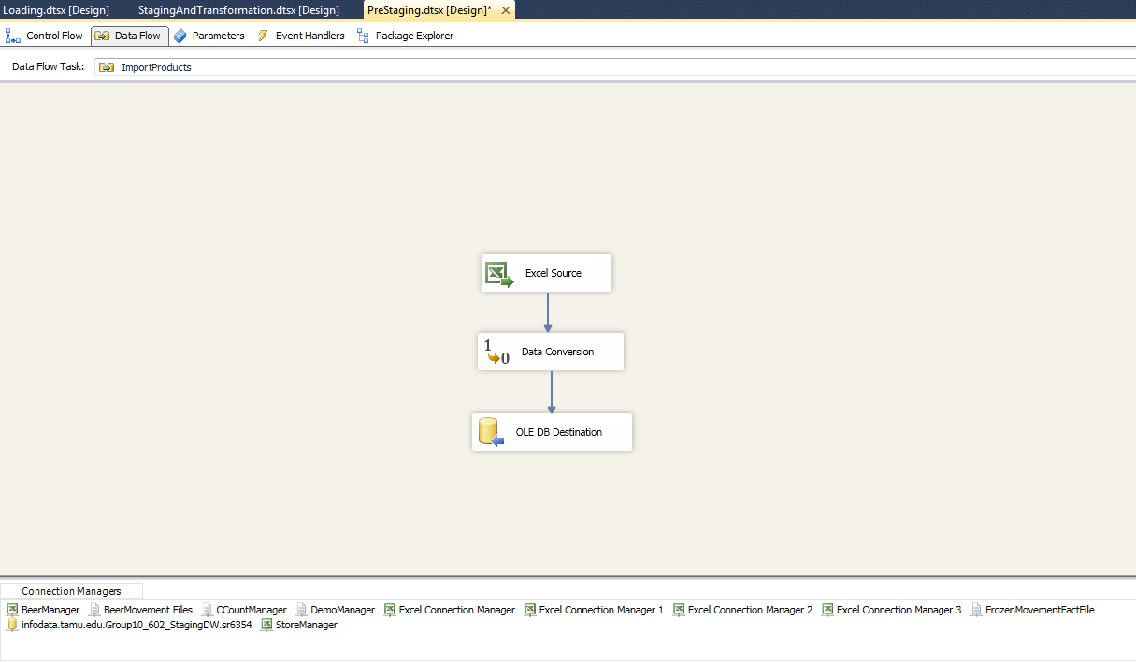

Figure 28: Extraction of Product.csv

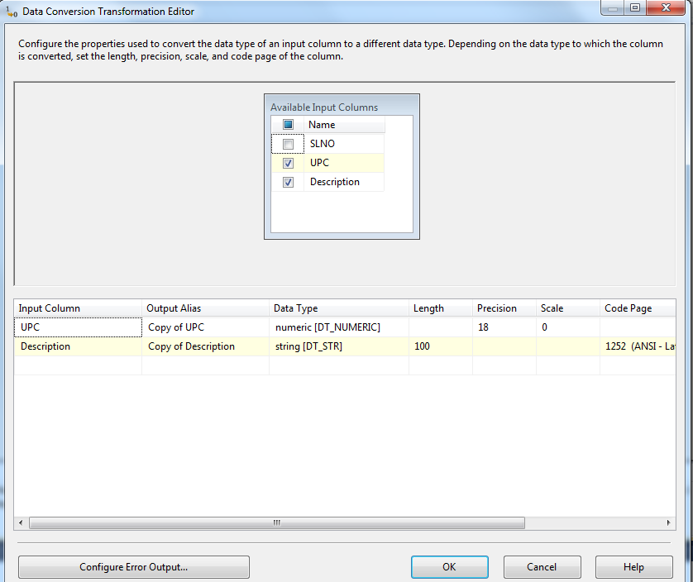

Figure 29: Extraction of Product.csv - Data Conversion

**Staging and transformation:**

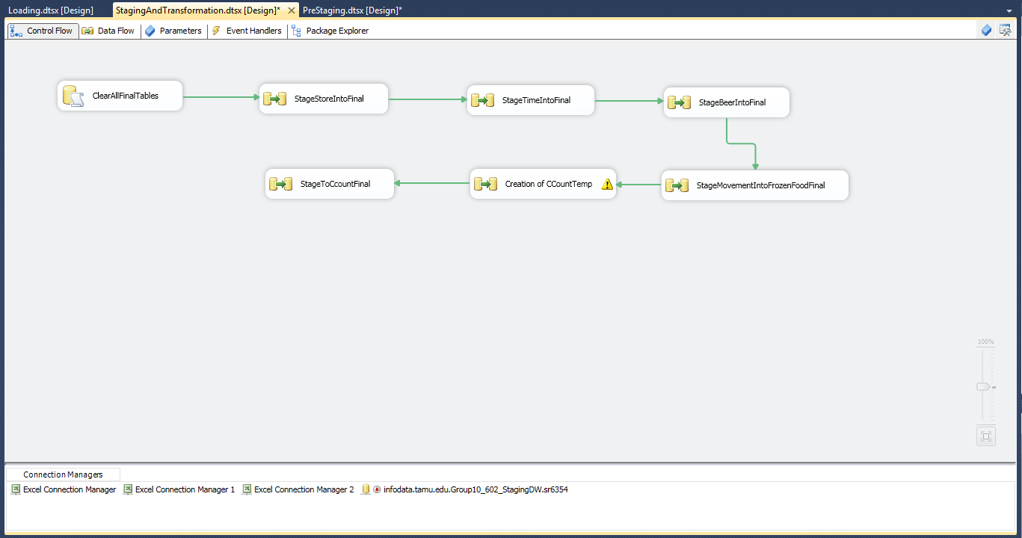

Figure 30: Control Flow of Staging and Transformation

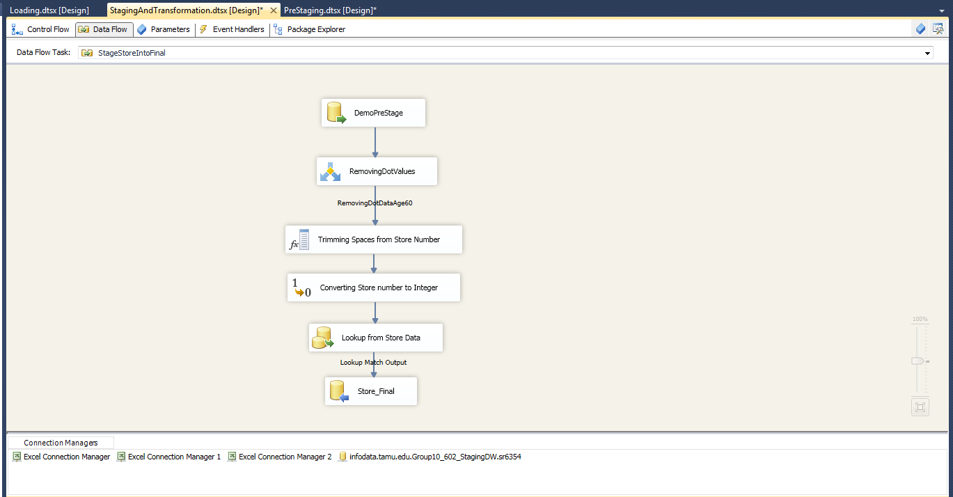

Figure 31: Pre Staging to Staging table -Store_Final

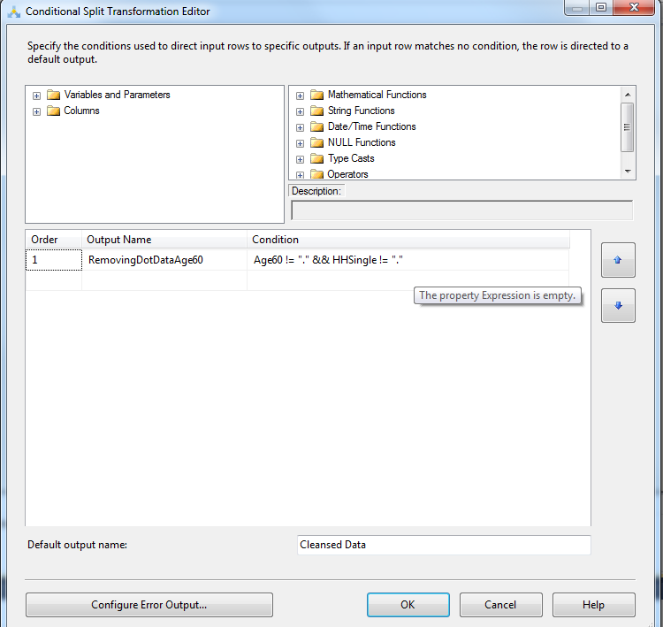

Figure 32: Pre Staging to Staging table -Store_Final – Transformation 1

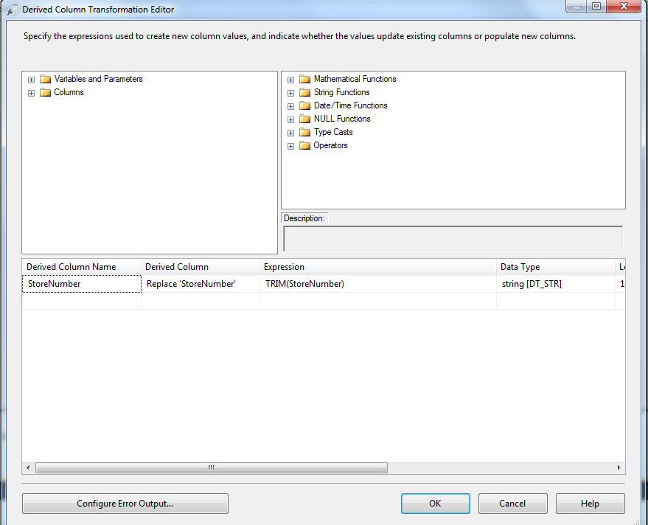

Figure 33: Pre Staging to Staging table -Store_Final – Transformation 2

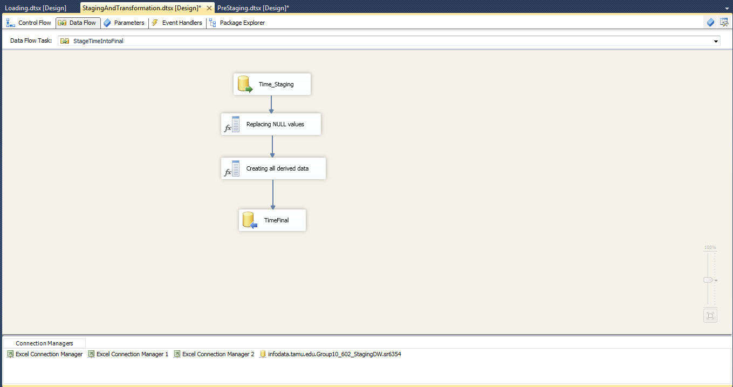

Figure 34: Pre Staging to Staging table -Time_Final

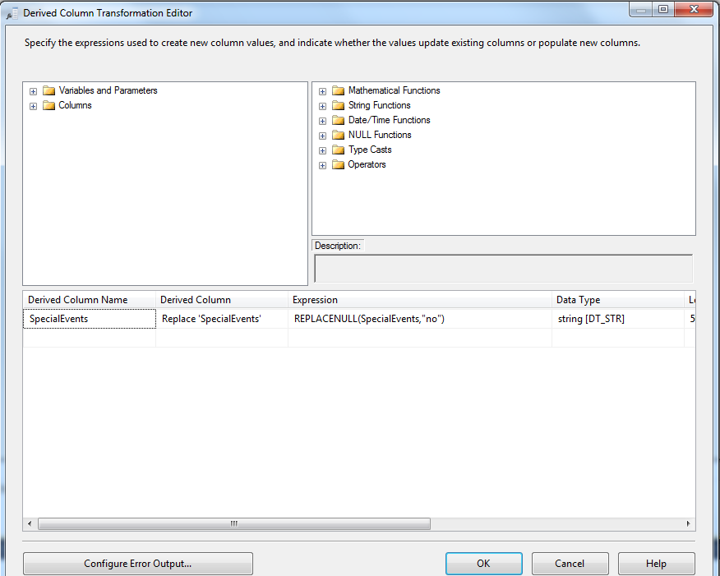

Figure 35: Pre Staging to Staging table -Beer_Final- Transformation 1

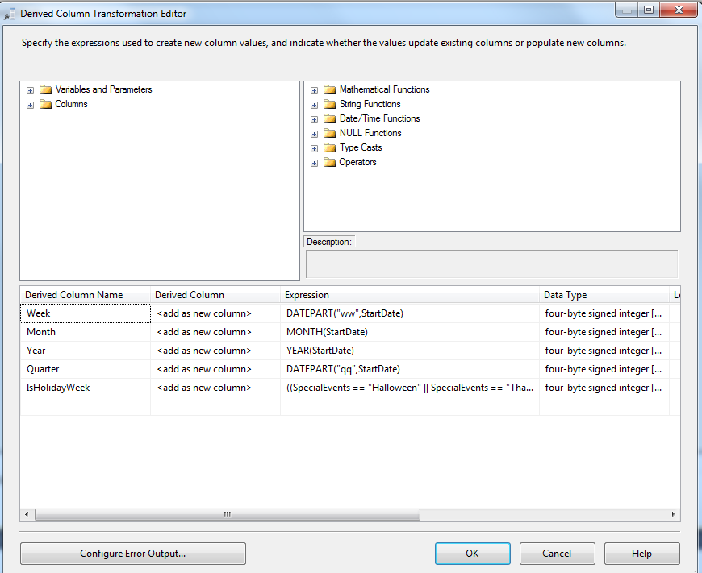

Figure 36: Pre Staging to Staging table -Time_Final – Transformation 2

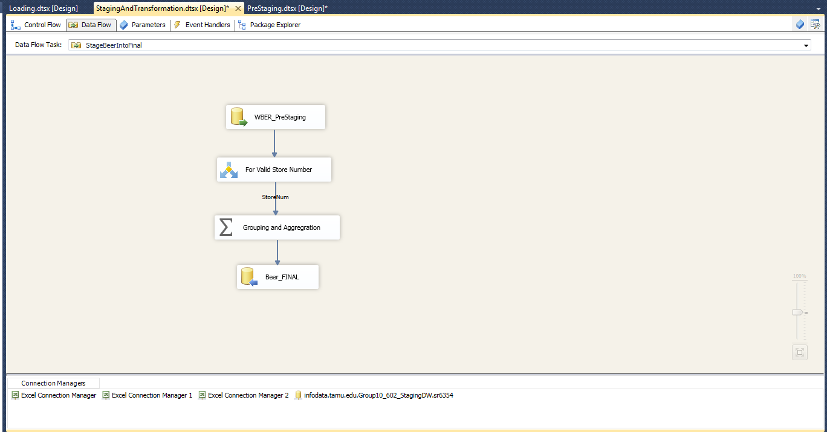

Figure 37: Pre Staging to Staging table -Beer_Final

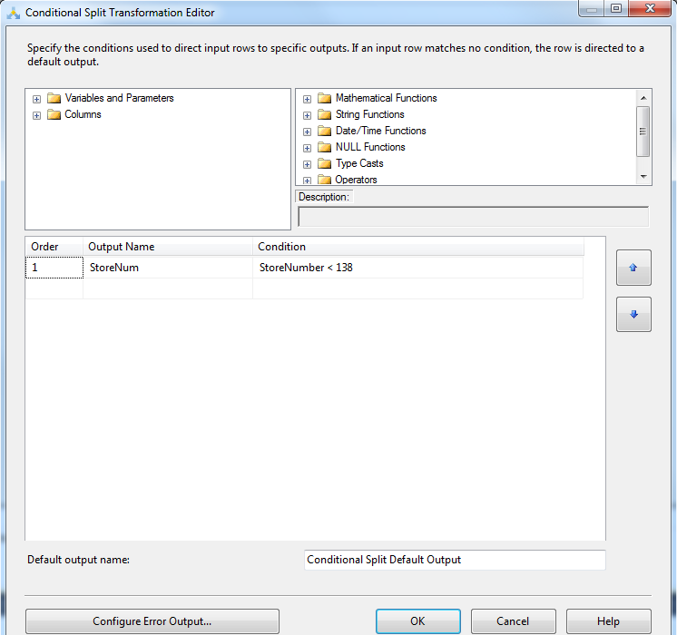

Figure 38: Pre Staging to Staging table -Beer_Final- Transformation 1

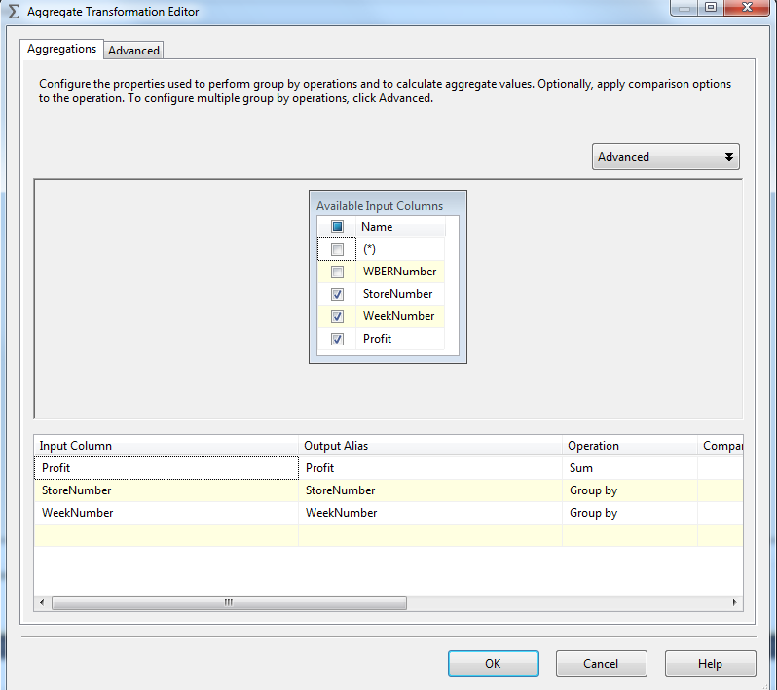

Figure 39: Pre Staging to staging table -Beer_Final- Transformation 2

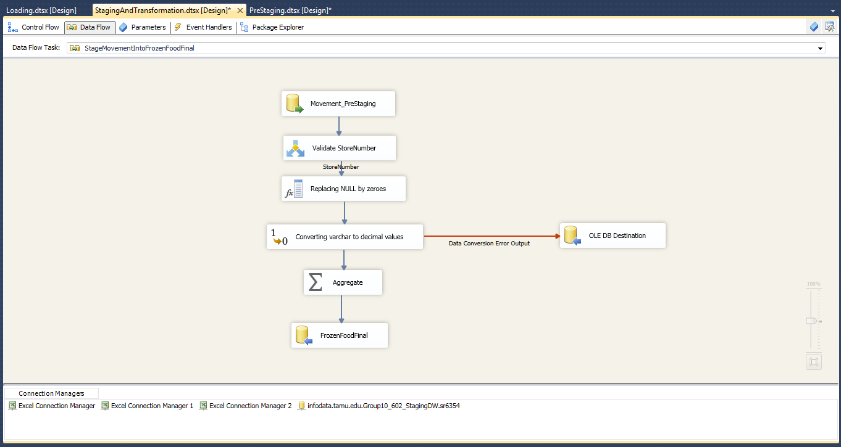

Figure 40: Pre Staging to staging table -FrozenFood_Final

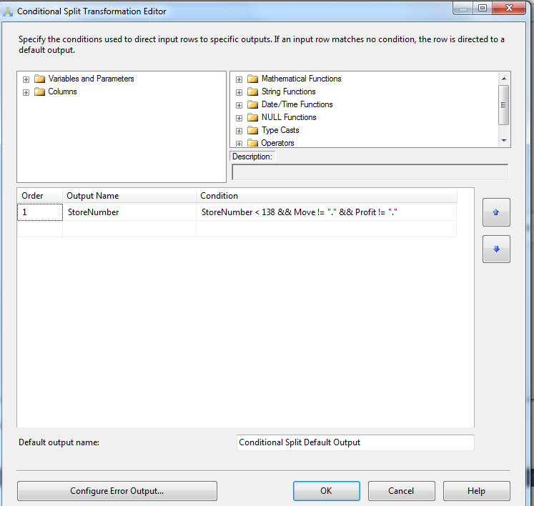

Figure 41: Pre Staging to staging table -FrozenFood_Final -Transformation 1

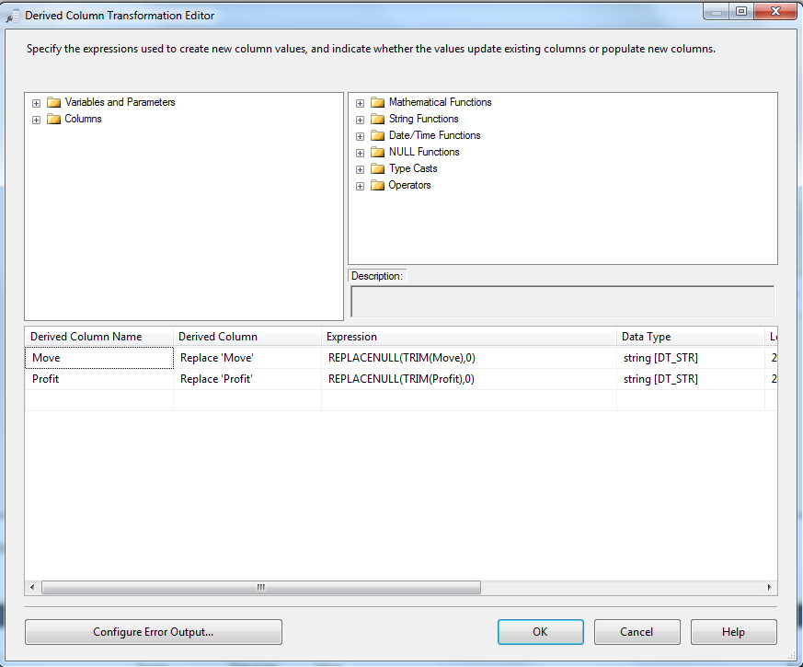

Figure 42: Pre Staging to staging table -FrozenFood_Final -Transformation 2

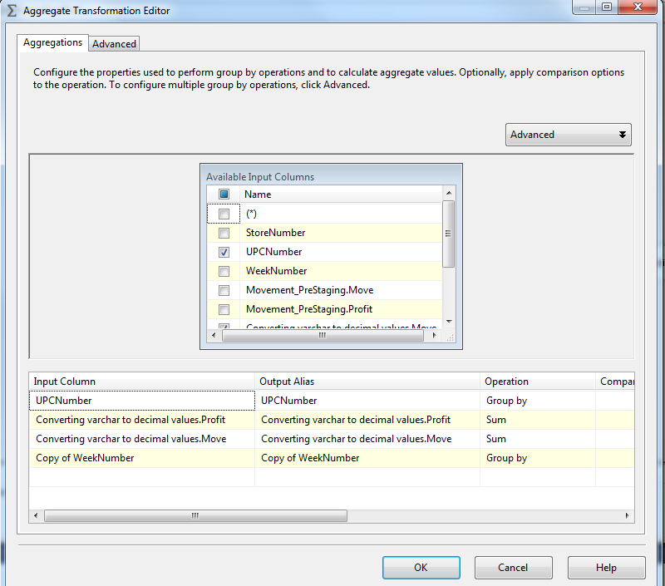

Figure 43: Pre Staging to staging table -FrozenFood_Final -Transformation 3

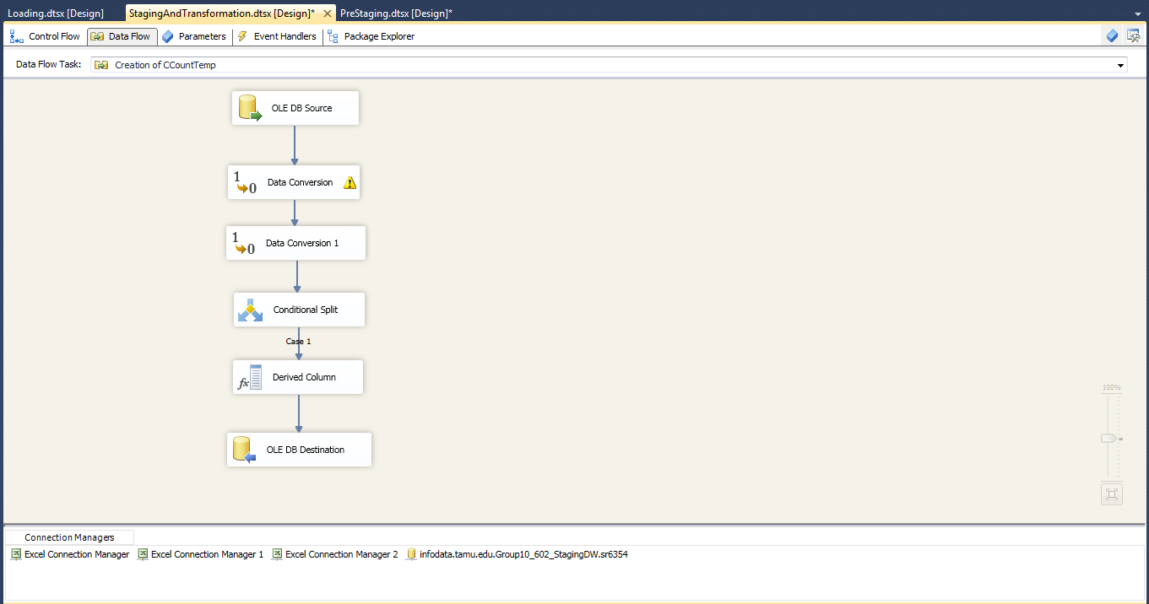

Figure 44: Pre Staging to staging table –Ccount_Temp

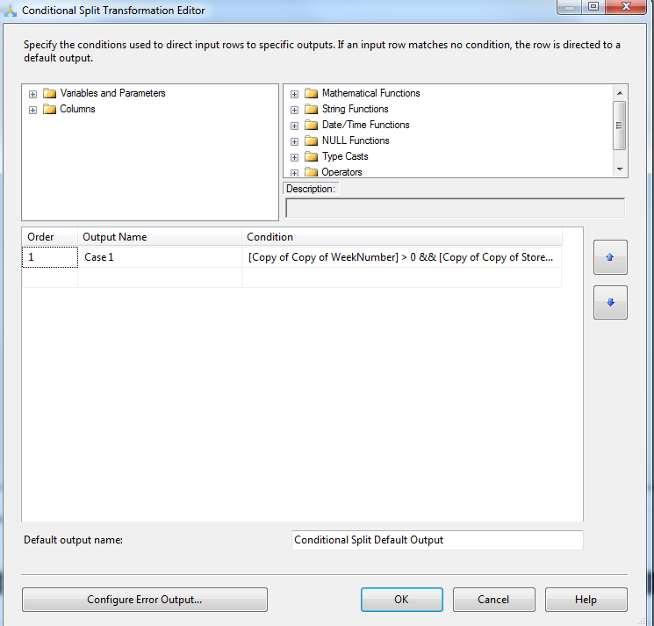

Figure 45: Pre Staging to staging table –Ccount_Temp - Transformation 1

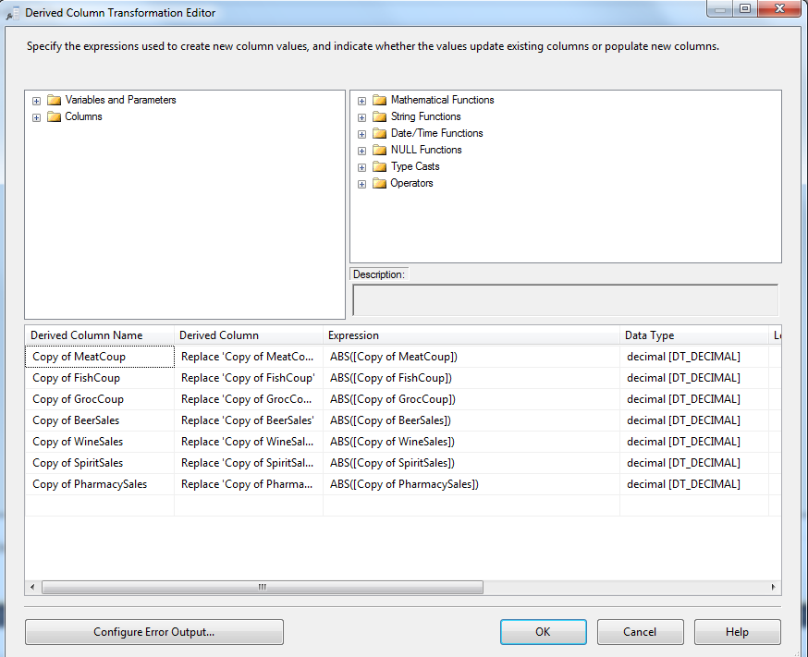

Figure 46: Pre Staging to staging table –Ccount_Temp - Transformation 2

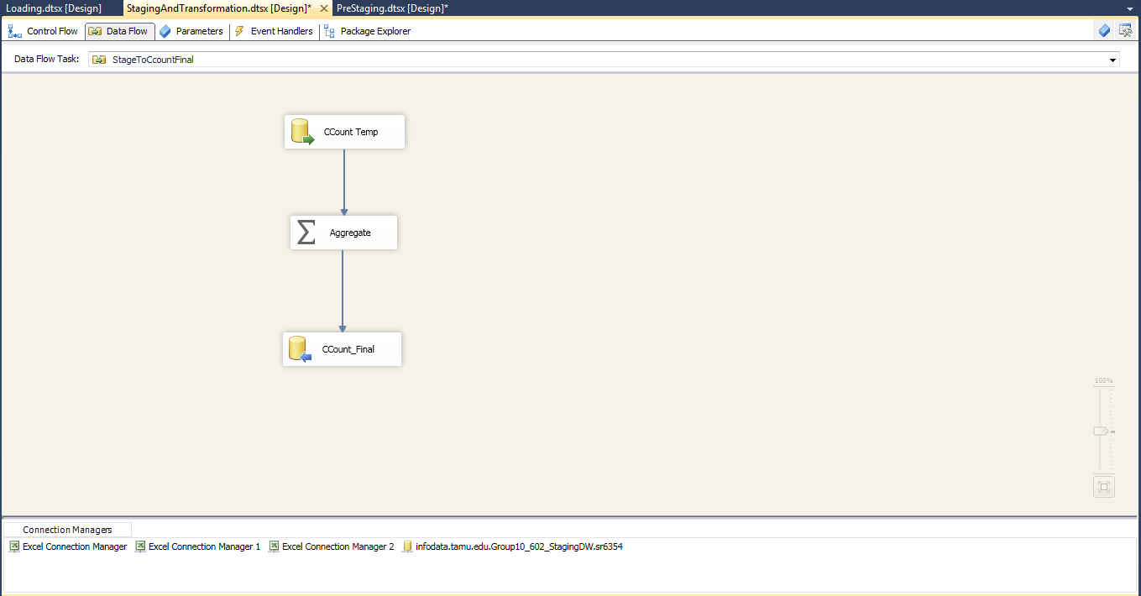

Figure 47: Pre Staging to staging table –Ccount_Final - Transformation 1

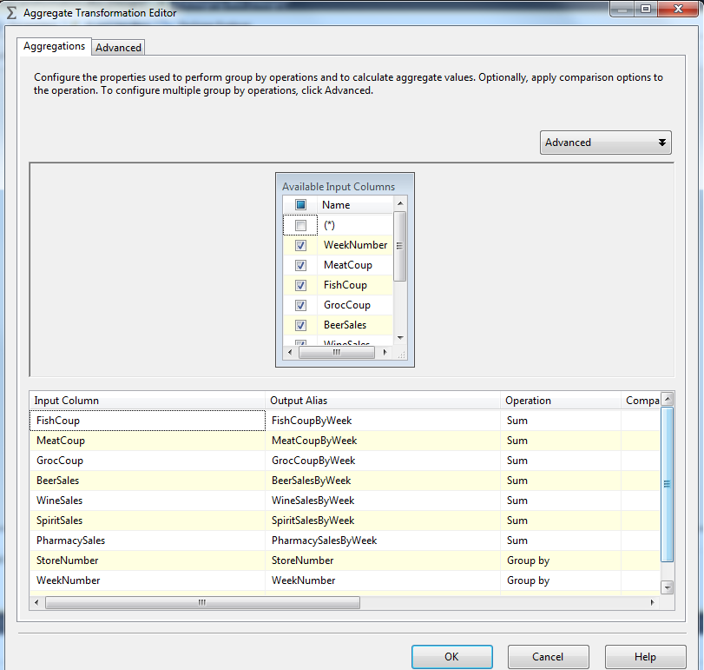

Figure 48: Pre Staging to staging table –Ccount_Final - Transformation 1

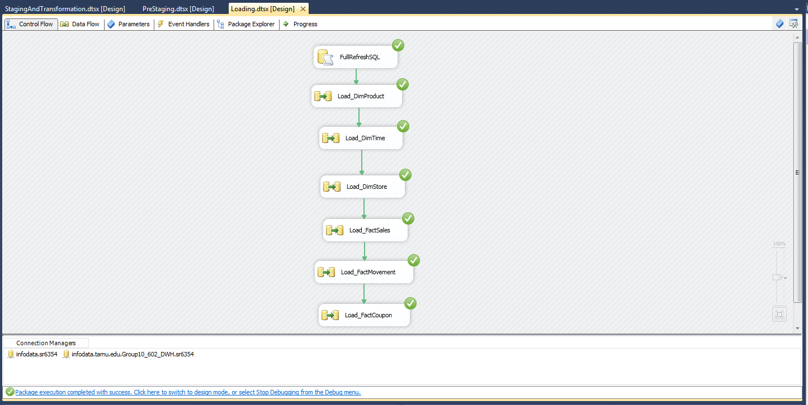

Figure 49: Control Flow of Loading

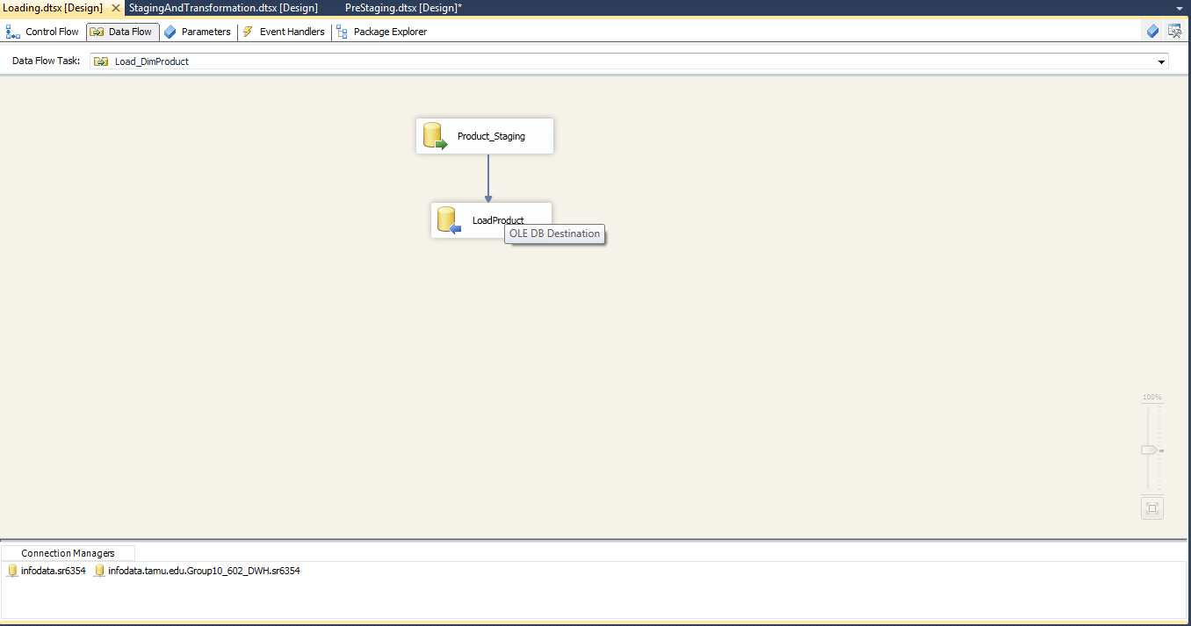

Figure 50: Load DimProduct

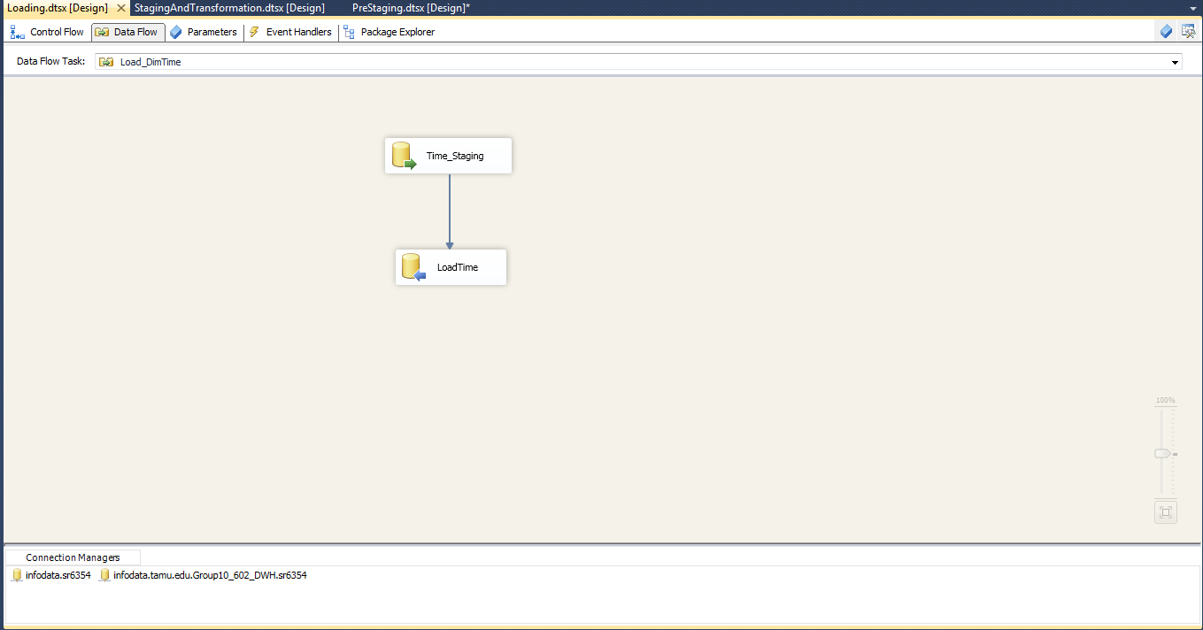

Figure 51: Load DimTime

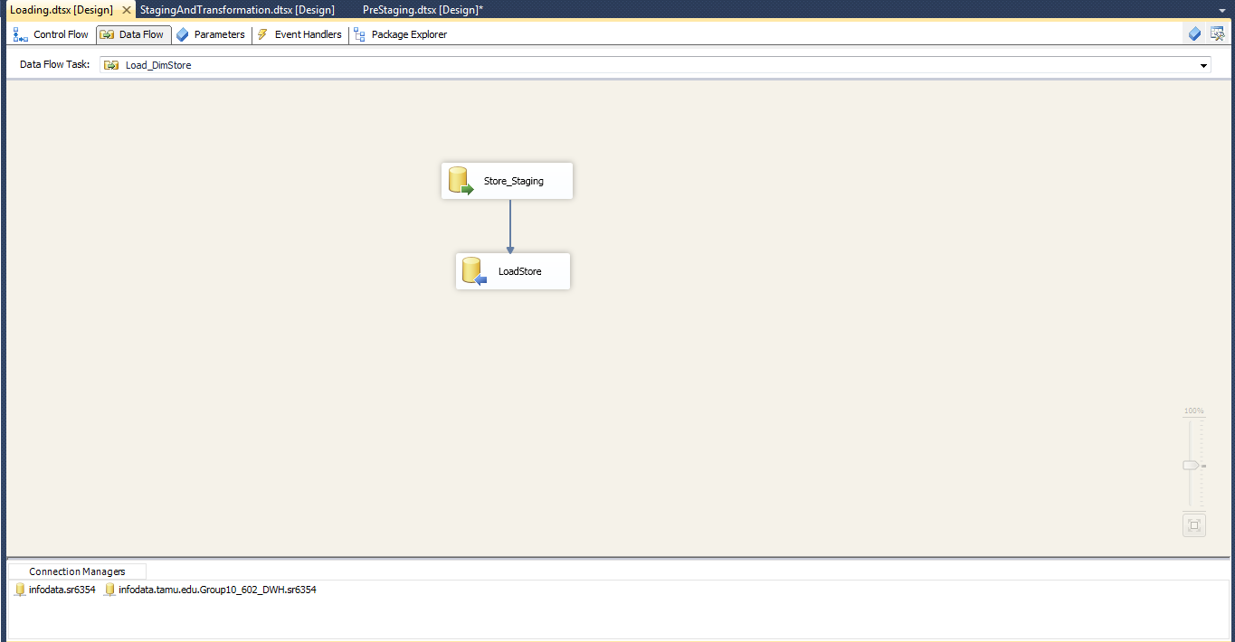

Figure 52: Load DimStore

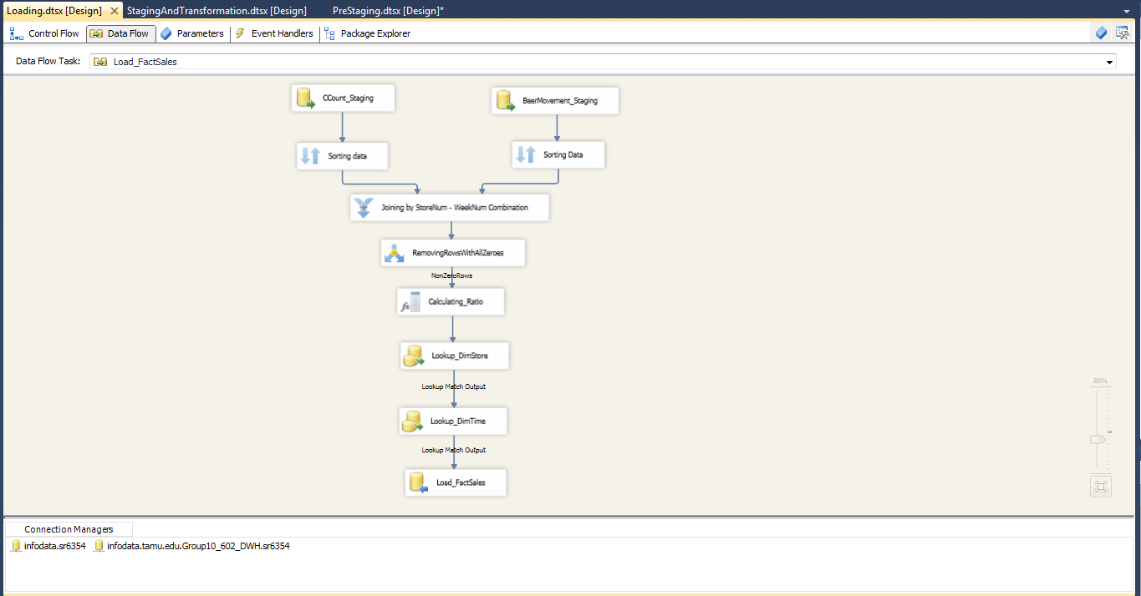

Figure 53: Load FactSales

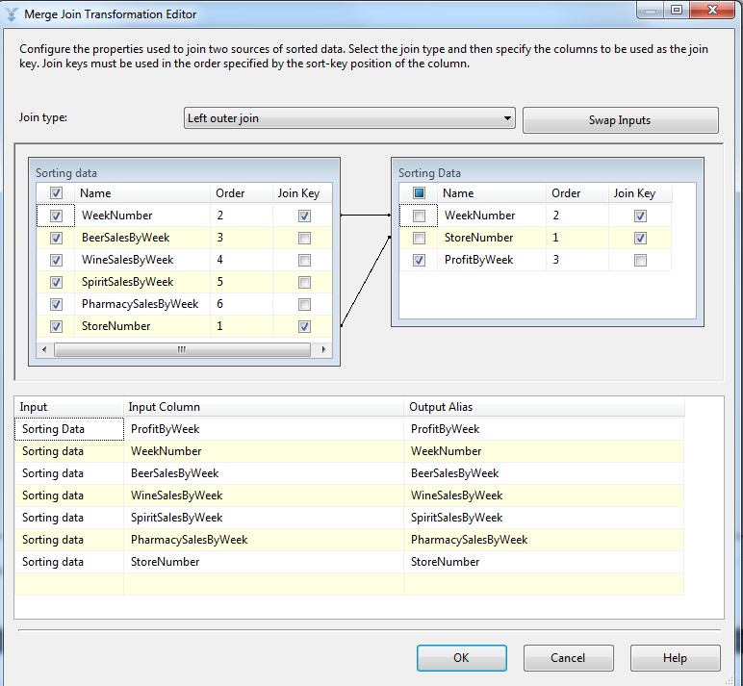

Figure 54: Load FactSales-Transformation 1

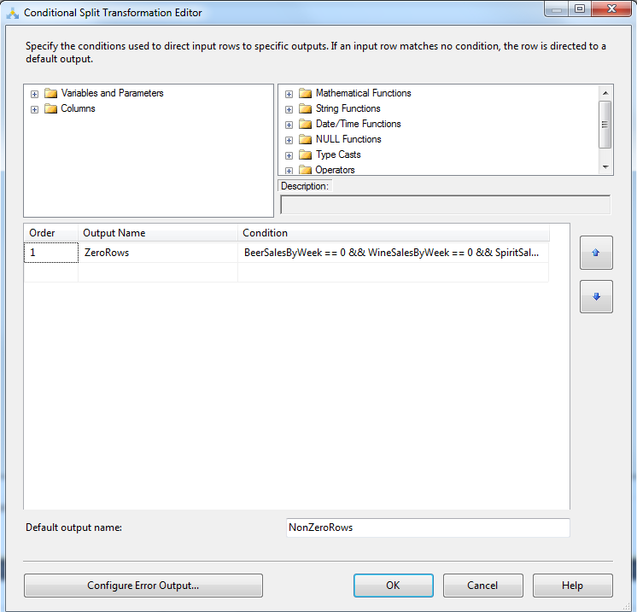

Figure 55: Load FactSales-Transformation 2

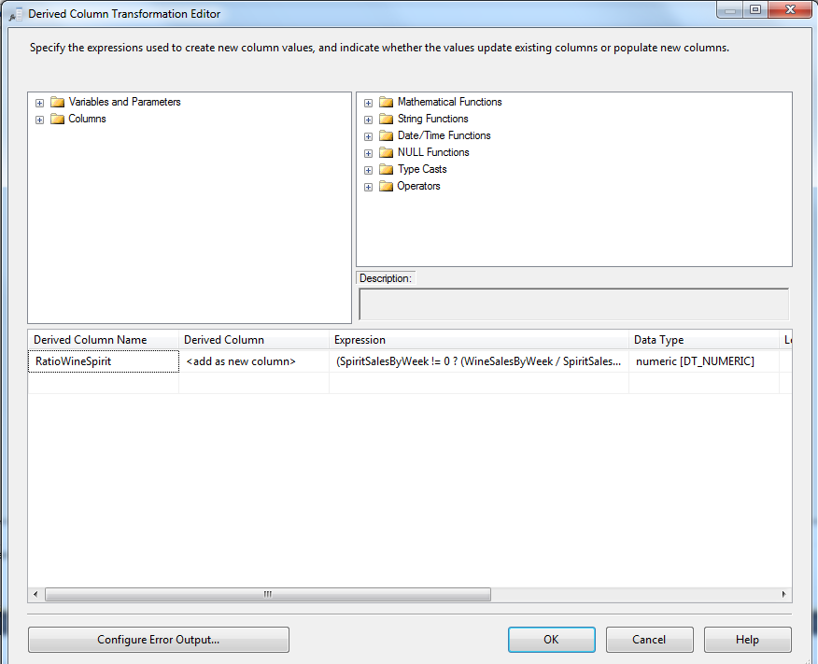

Figure 56: Load FactSales-Transformation 3

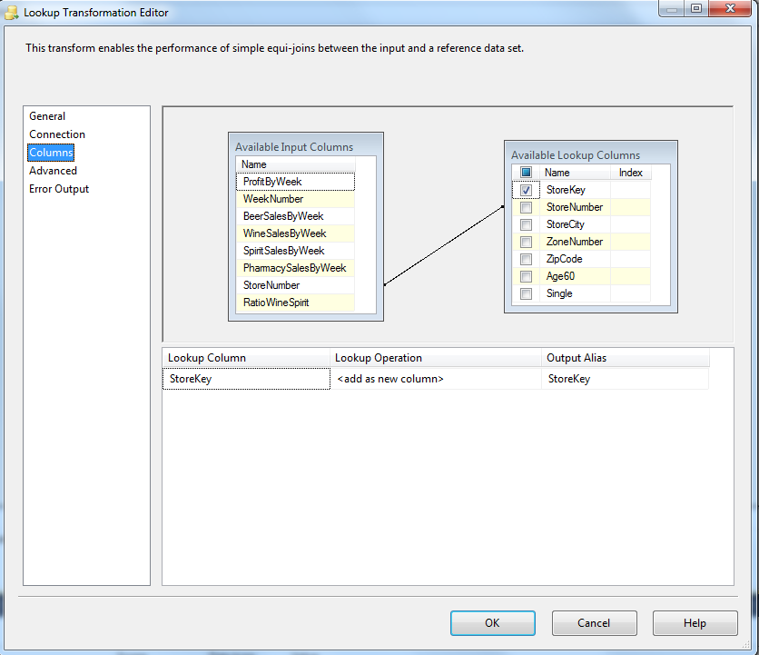

Figure 57: Load FactSales - LookUp

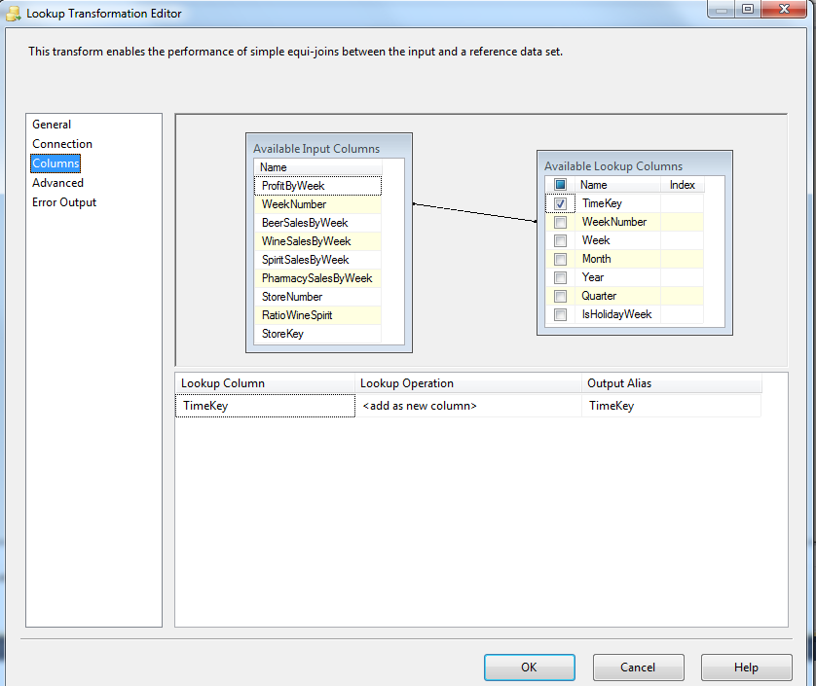

Figure 58: Load FactSales - LookUp

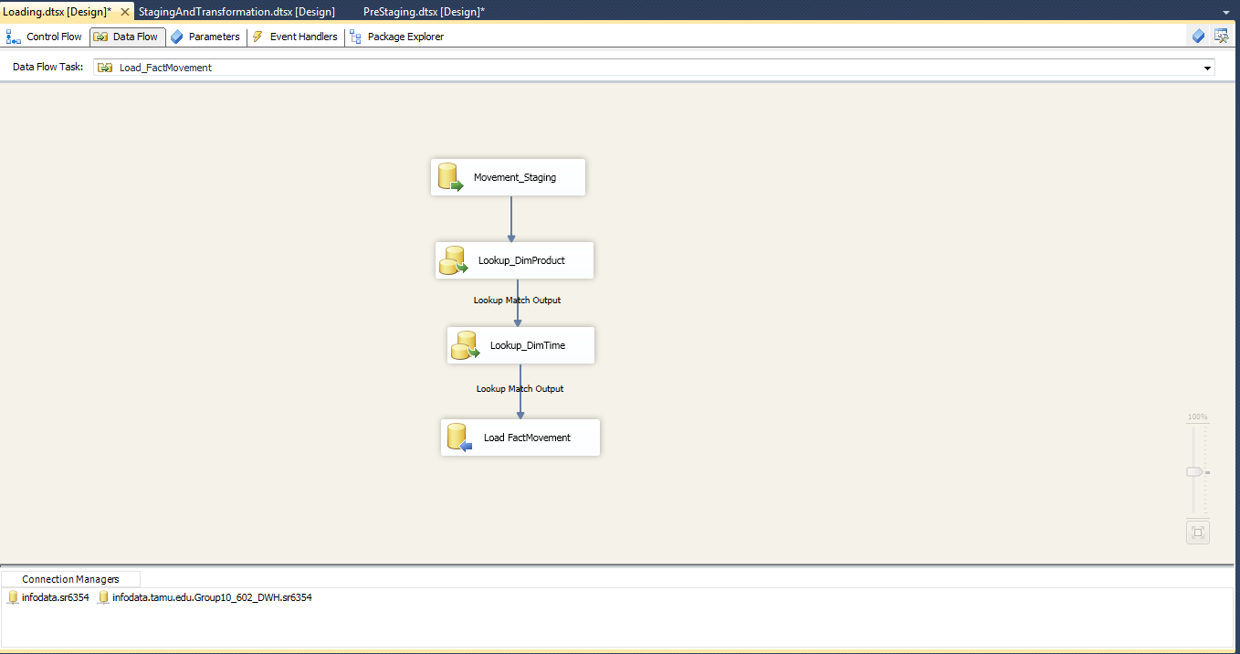

Figure 59: Load FactMovement

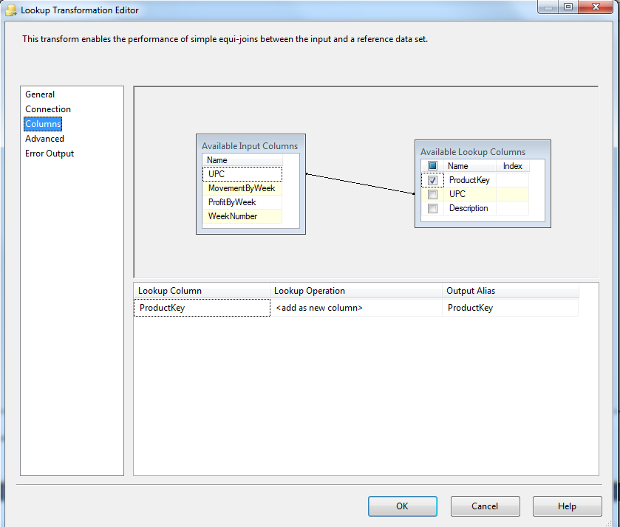

Figure 60: Load FactMovement-LookUp

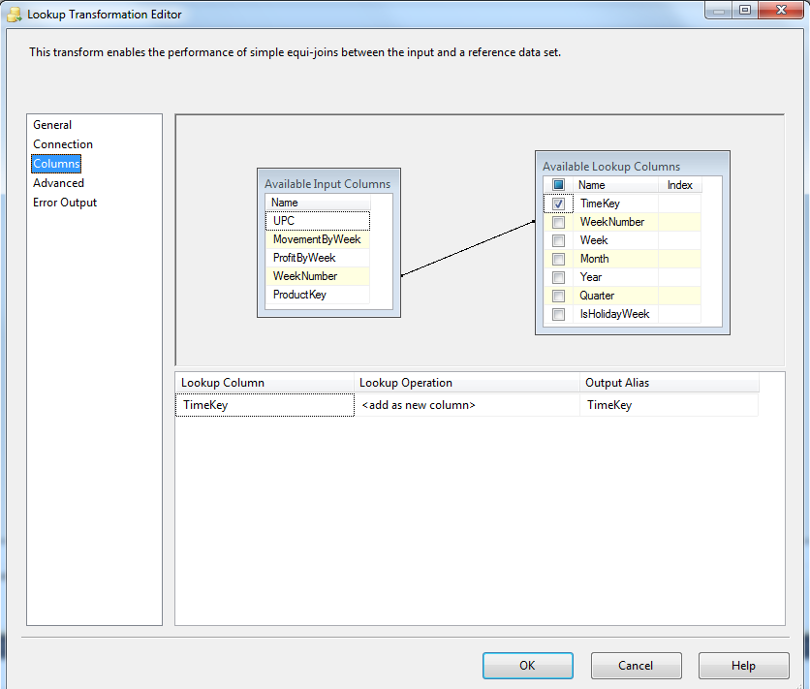

Figure 61: Load FactMovement-LookUp

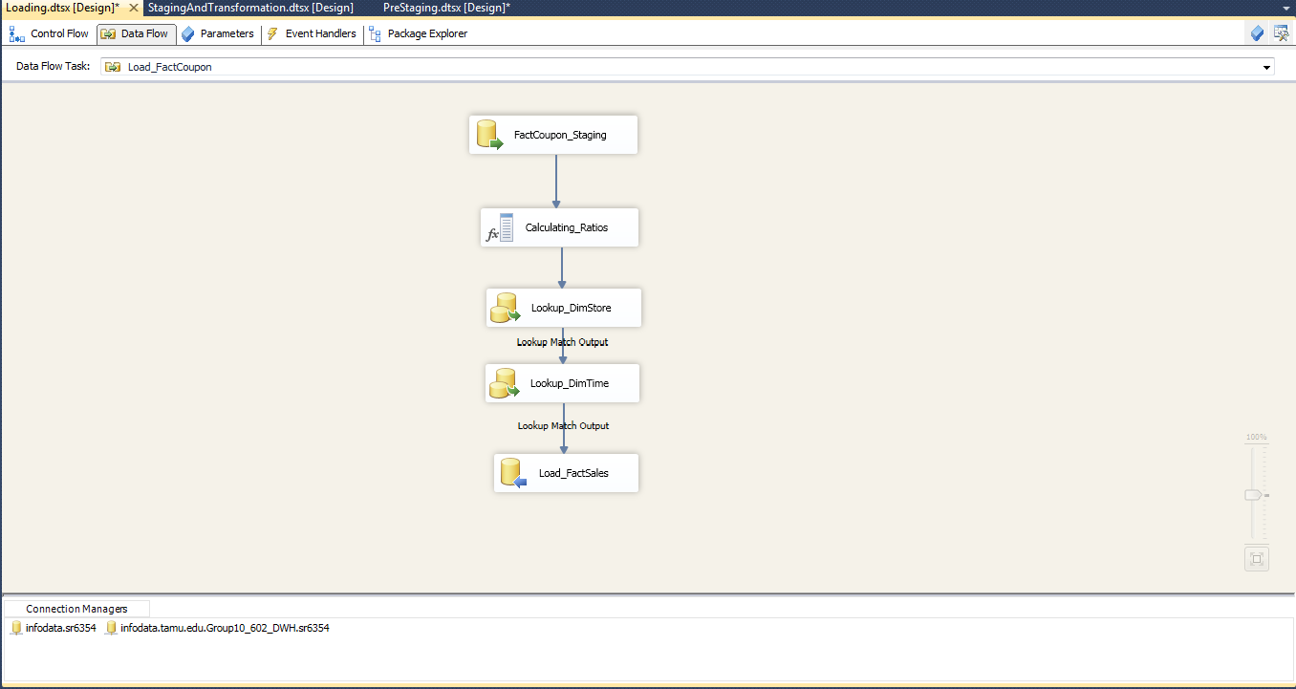

Figure 62: Load FactCoupon

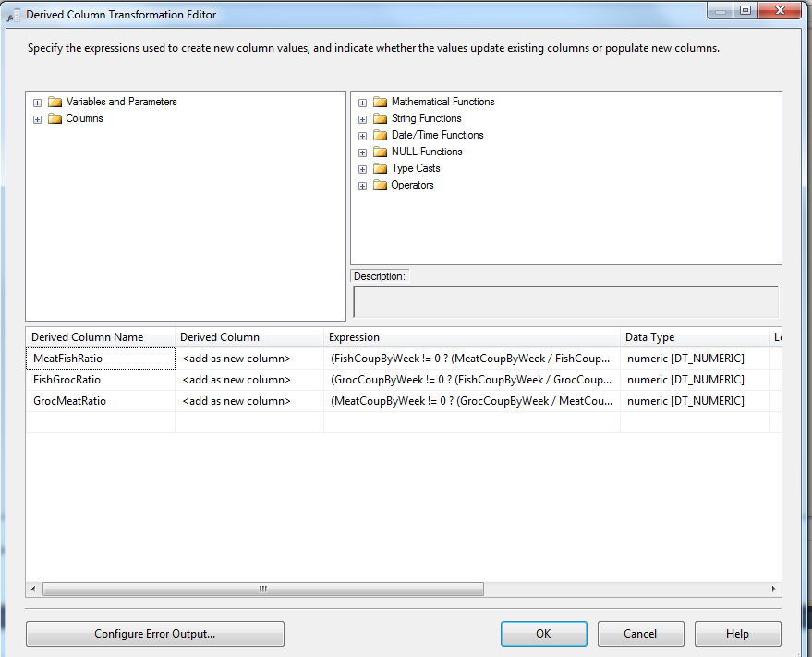

Figure 63: Load FactCoupon- Transformation 1

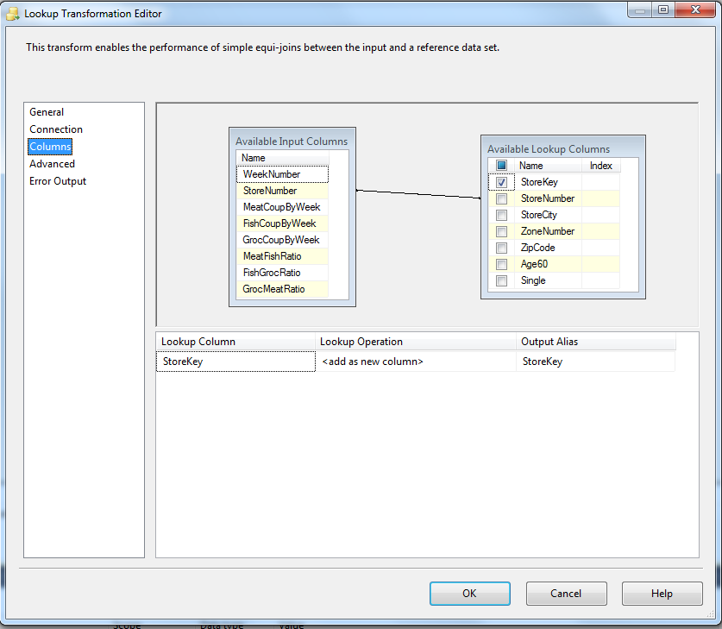

Figure 64: Load FactCoupon- LookUp

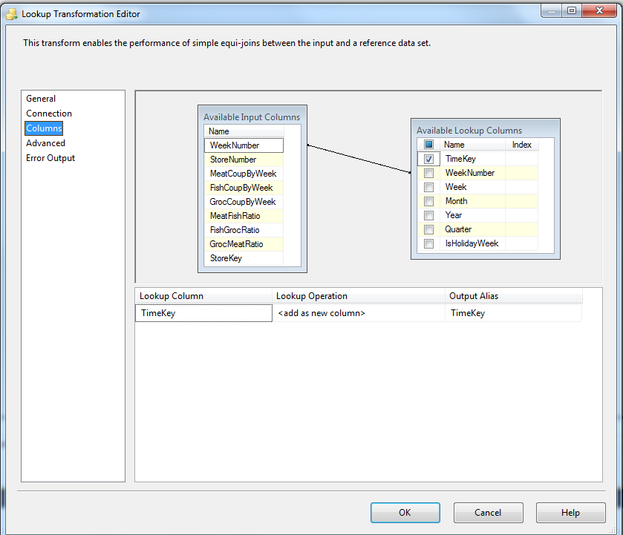

Figure 65: Load FactCoupon- LookUp

**Data Screenshots**

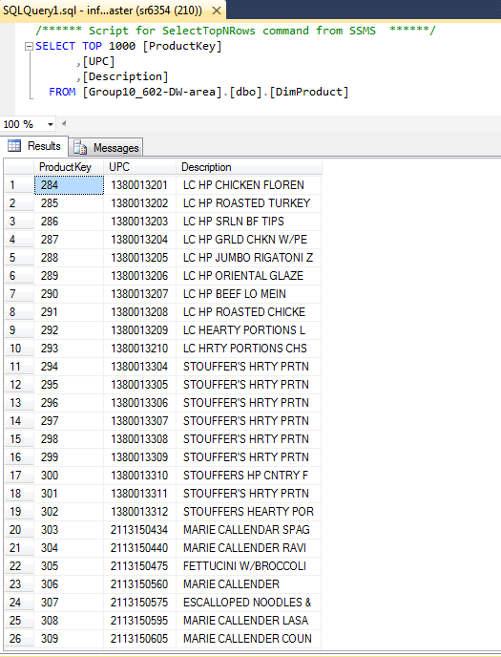

Figure 66: DimProduct

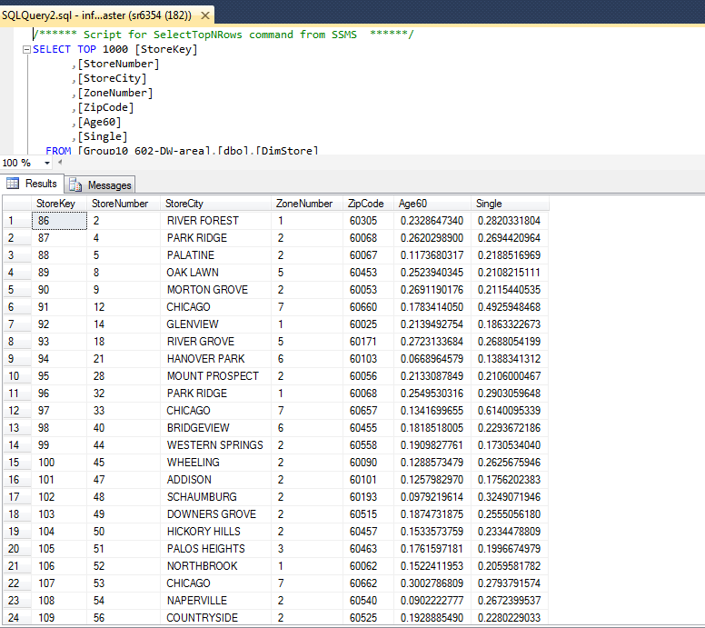

Figure 67: DimStore

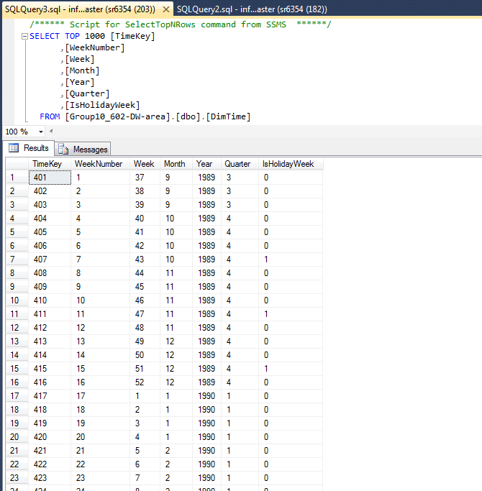

Figure 68: DimTime

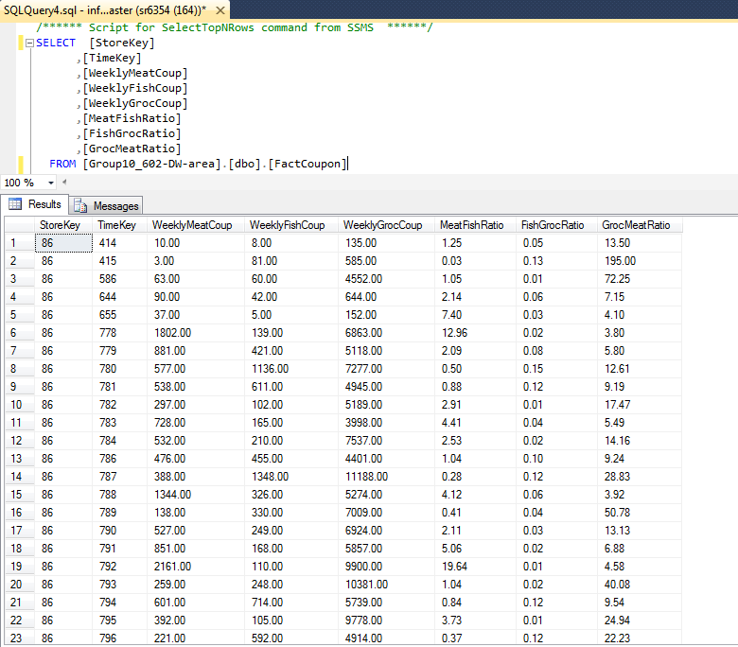

Figure 69: FactCoupon

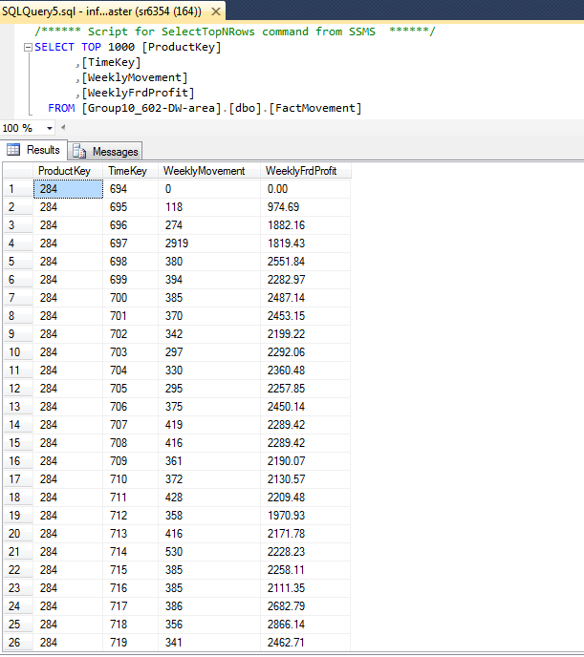

Figure 70: FactMovement

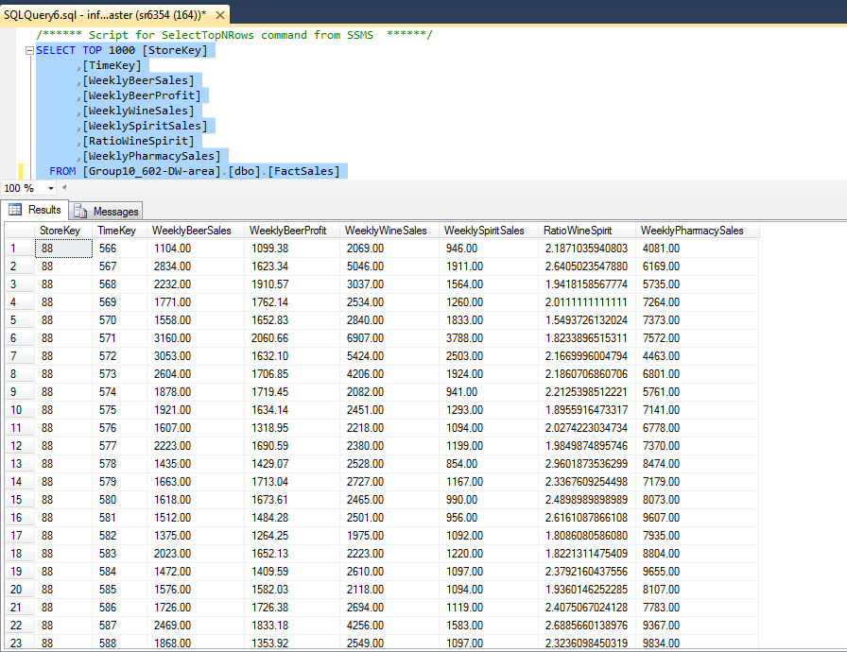

Figure 71: FactSales

## **Data Loading to the Data Warehouse**

**Staging area:**

1. The necessary files to be extracted are identified.

2. The files which are not in CSV format are created in CSV format.

3. Pre-Staging tables are created.

4. The data from the files are extracted into the Pre-Staging tables.

5. The staging tables which will have the data to be loaded to the data warehouse tables are created.

6. The data from the Pre-Staging tables are cleansed; transformed using the various rules and the resulting data is populated in the staging tables.

**Data warehouse area:**

1. The dimension and fact tables with the appropriate primary and surrogate keys are created.

2. The dimension tables DimProduct, DimTime and DimStore are loaded from the Product_Final, Time_final and Store_Final respectively.

3. The fact tables FactSales, FactCoupon and FactMovement are loaded from the CCount_Final, Beer_Final, FrozenFood_Final staging tables.

## **BI Reporting:**

|  |  |
| --- | --- |
| Question # | 1 |
| Business Question | Which of the following coupons are effectively redeemed in each DFF store?  Meat Coupons  Grocery Coupons  Fish Coupons |
| Report Type and  Justification | SSRS on SSAS  This question seeks to answer which coupon is effectively redeemed at each store. This data may be needed for every month/ every quarter/ every year depending upon how often the business wants to roll out the coupons and various other promotions. Hence aggregating these values in prior and storing it in a cube facilitates immediate retrieval of this data along the hierarchy of time dimension.  A report on this cube will help the business make decisions pertaining to the coupon redemption and effectively time their promotions and coupon production.  Hence SSRS on SSAS is the right choice of reporting to answer this business question. |
| Report Title | Comparison of Different Coupon Sales |
| Report Attributes Mapping | |  |  | | --- | --- | | SSRS Report on top of SSAS Cube | | | Data Mart Table | **Attribute** | | DimStore | Store Number | | DimTime | Week Number | | DimTime | Month | | DimTime | Quarterly | | DimTime | Year | | FactCoupon | Weekly Fish Coup | | FactCoupon | Weekly Groc Coup | | FactCoupon | Weekly Meat Coup | |
| Report Description | This report gives the data of the meat, fish and grocery coupon weekly sales for each store. In the report, the users can see the aggregated values for each month, quarter and year. The same data is visually represented using a line chart. The X-axis has the store numbers and Y-axis has the sales of all the coupons. The meat and grocery coupon sales are represented in 0.0001 thousand USD. The fish coupon sales are represented in USD. |

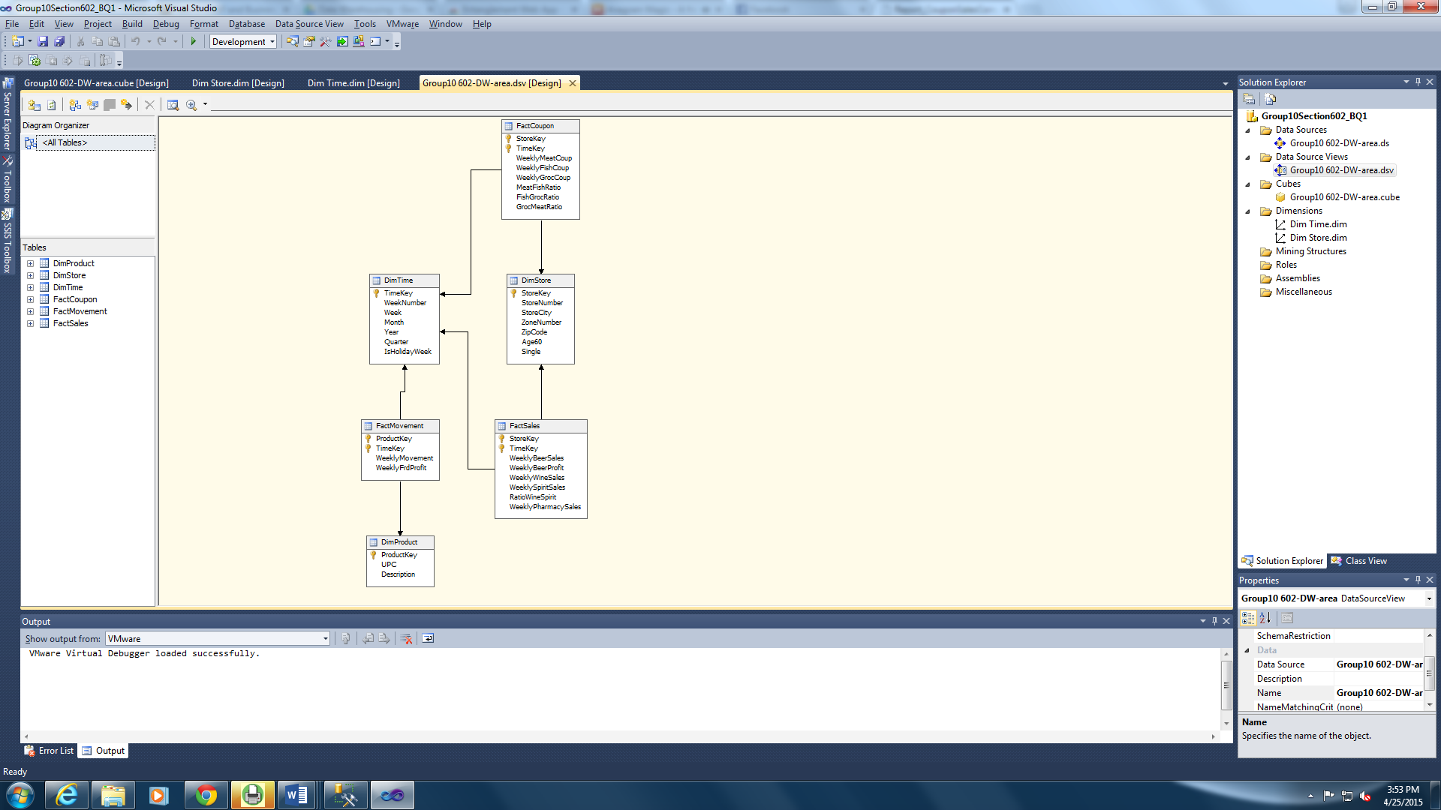

Figure 72: SSAS Data Source View

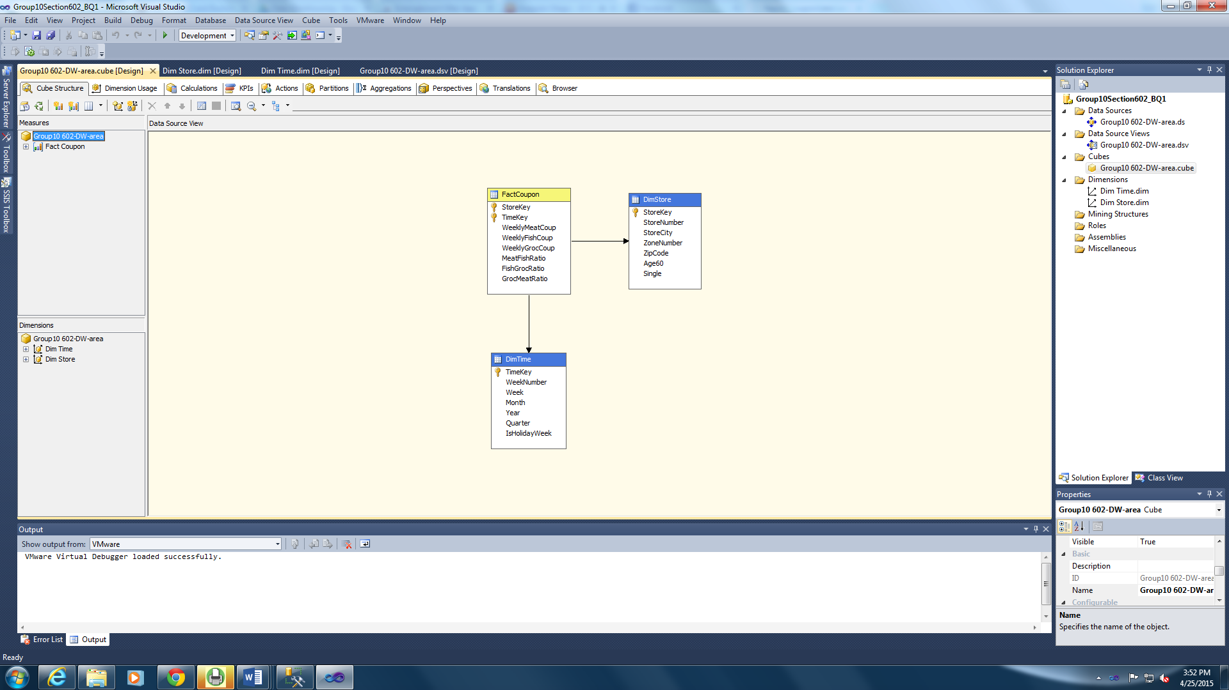

Figure 73: SSAS Cube

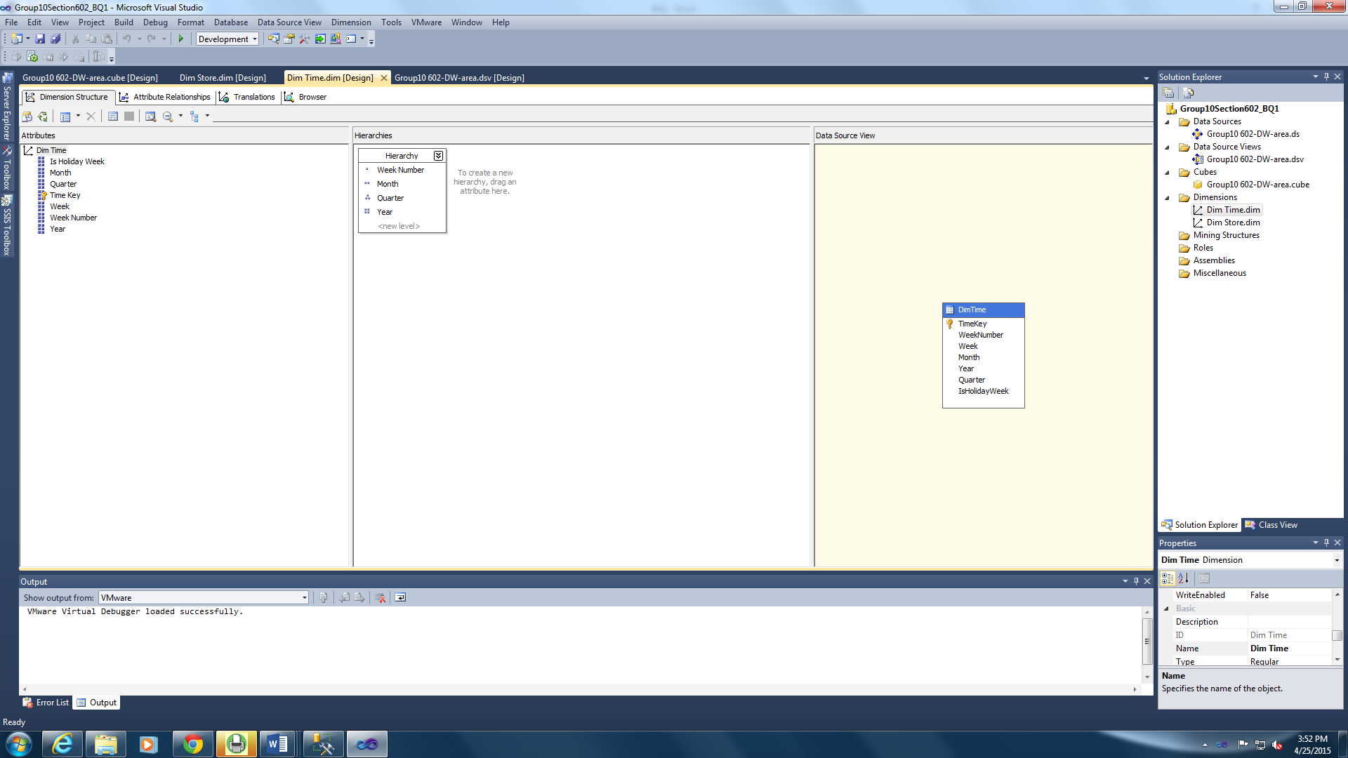

Figure 74: Creating Hierarchy for the Time Dimension

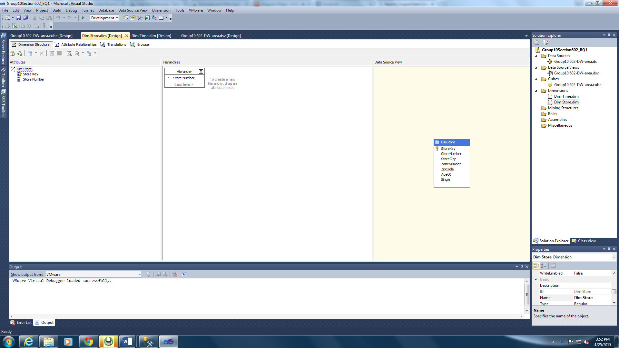

Figure 75: Adding store number to the hierarchy.

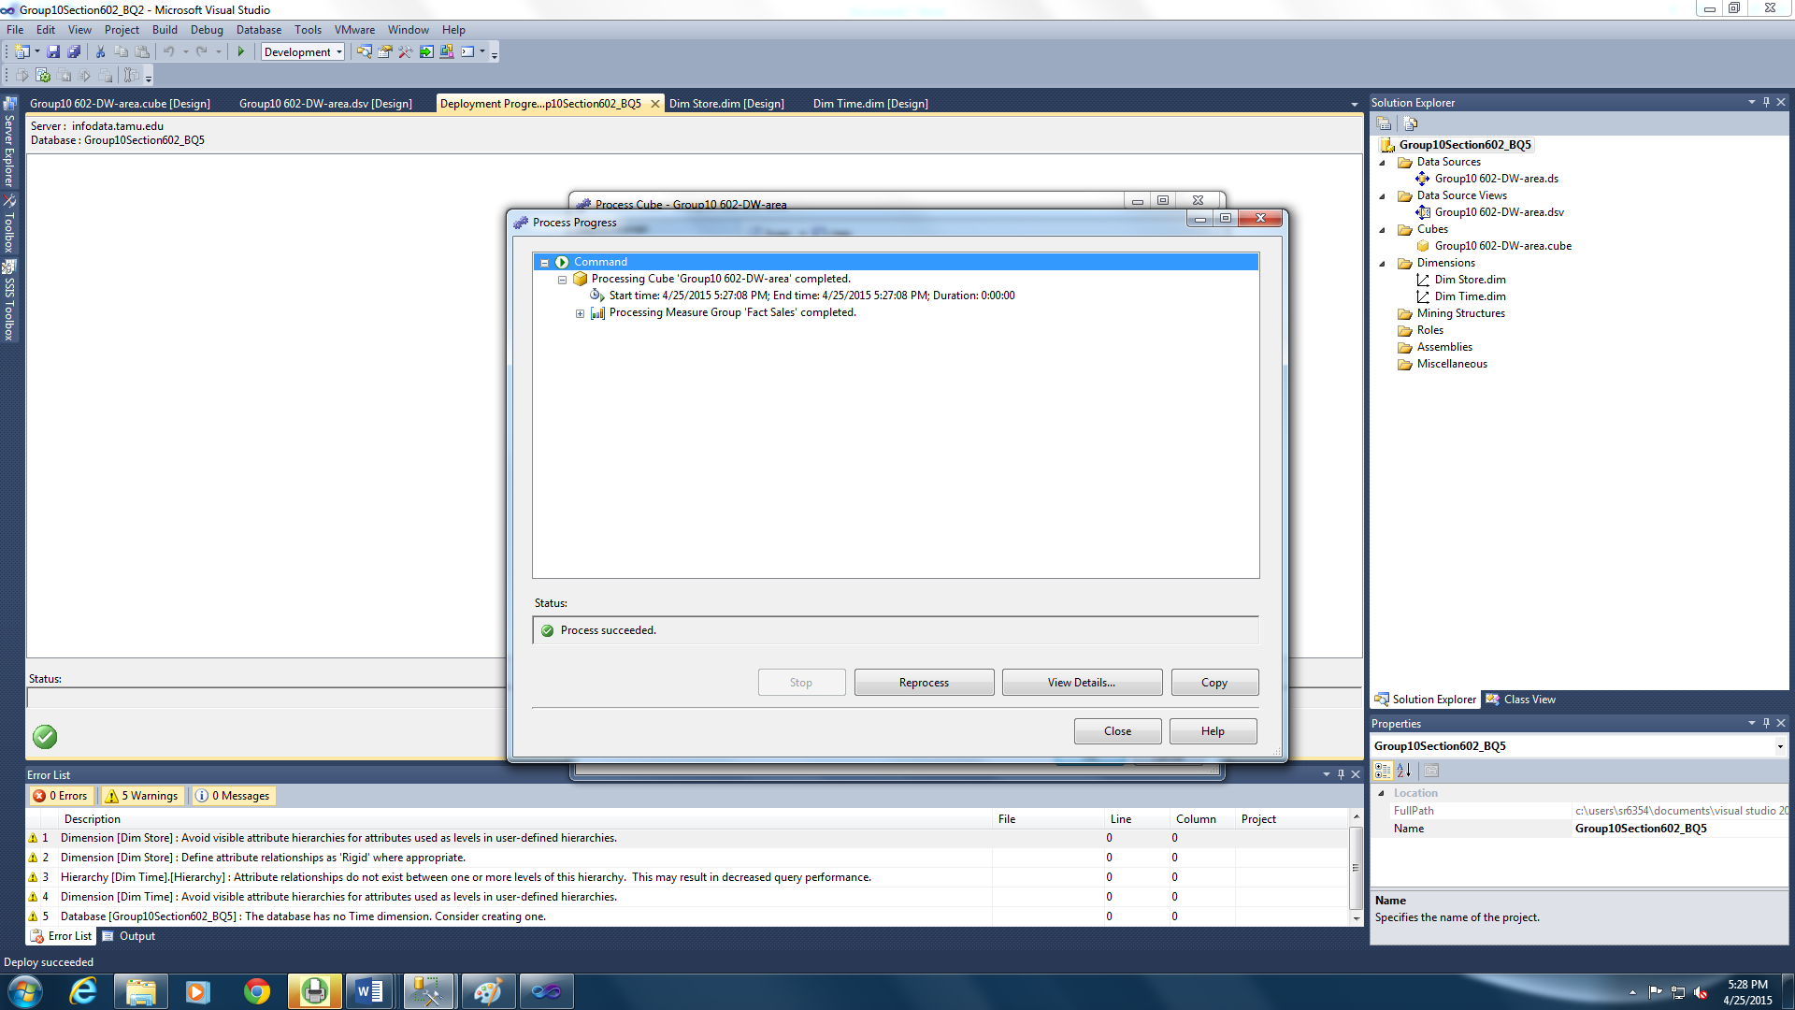

Figure 76: Processing the Cube

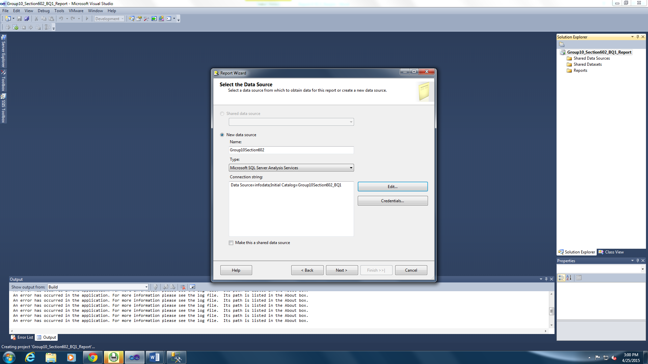

Figure 77: Data Source

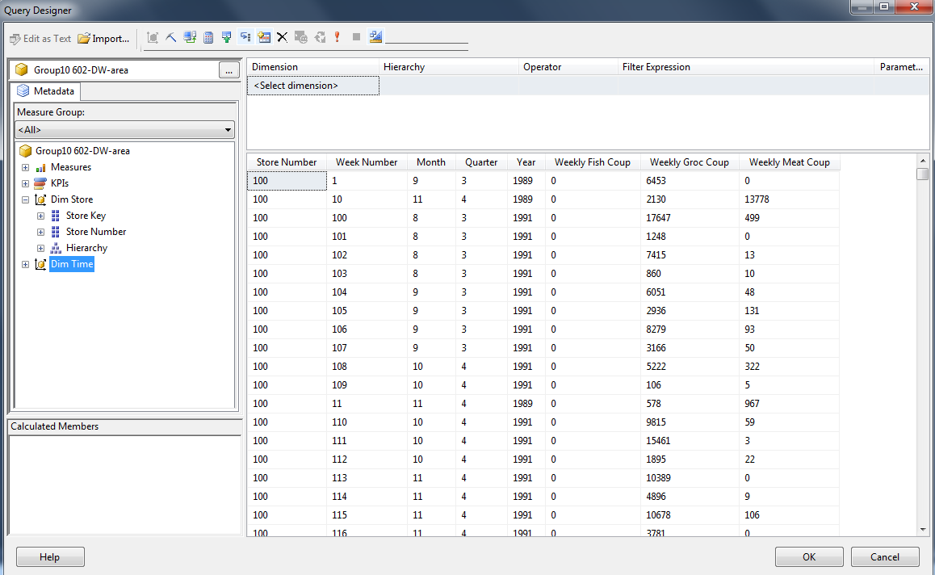

Figure 78: Query Designer

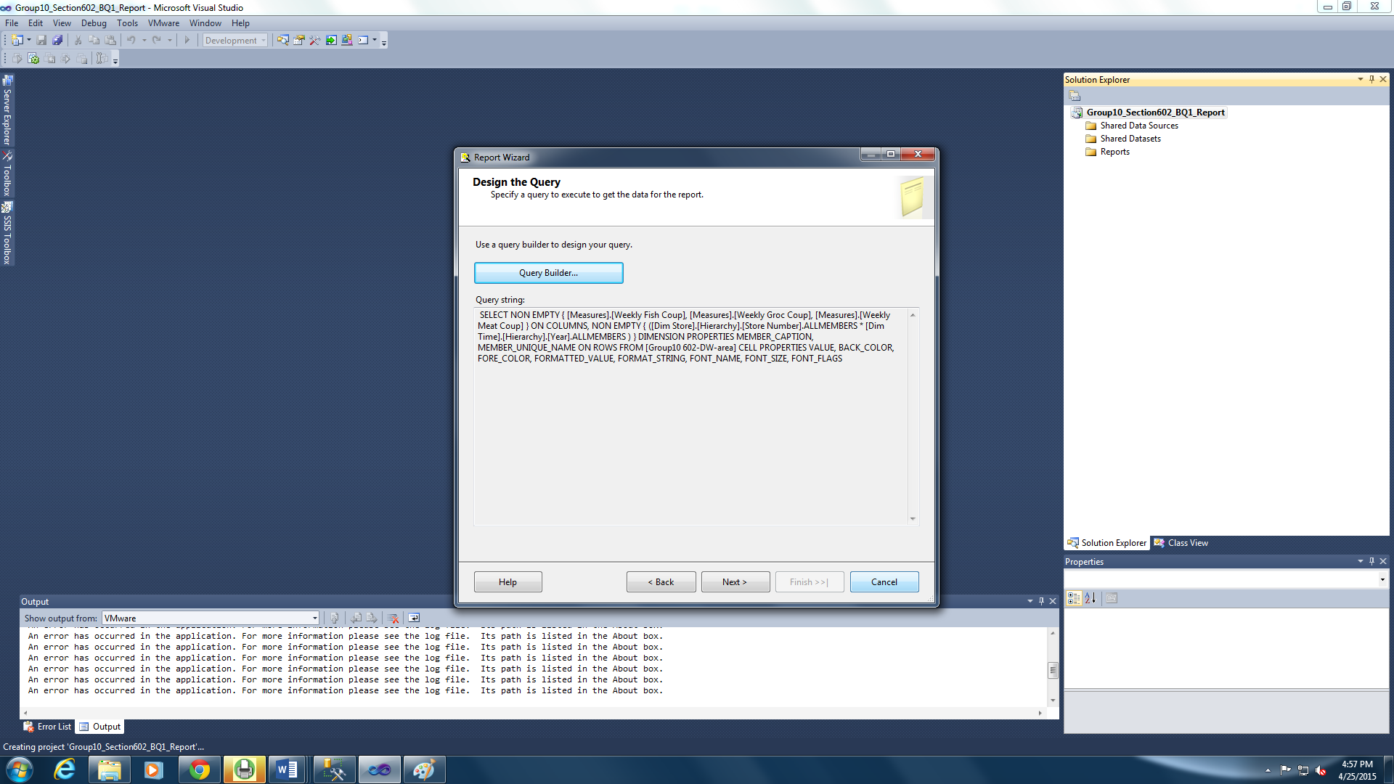

Figure 79: Auto generated script for query builder

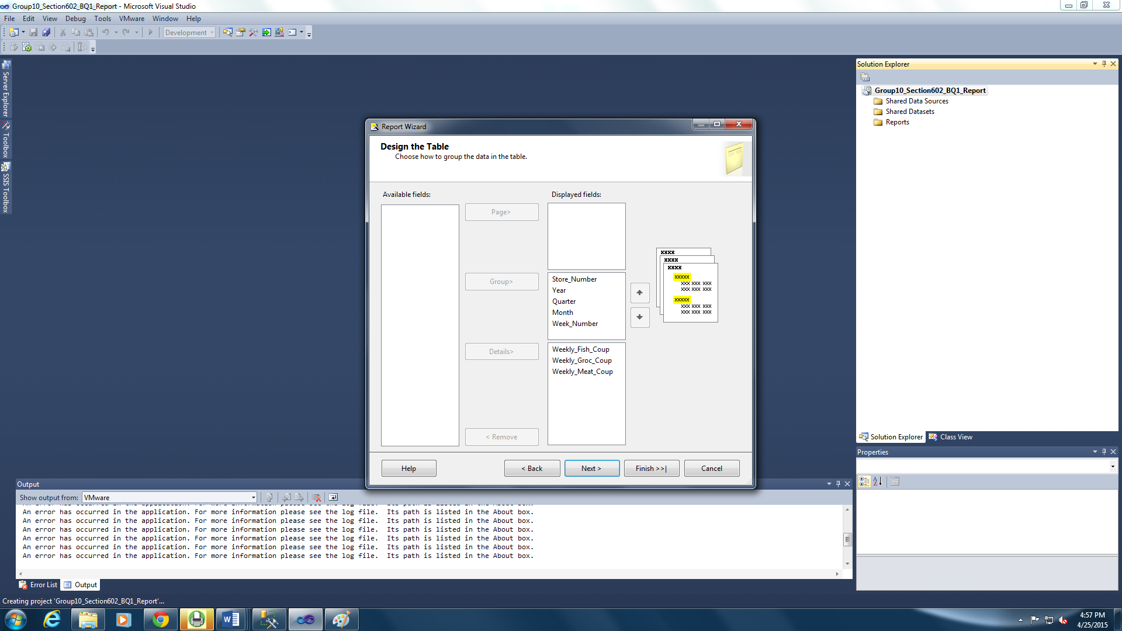

Figure 80: Designing the table

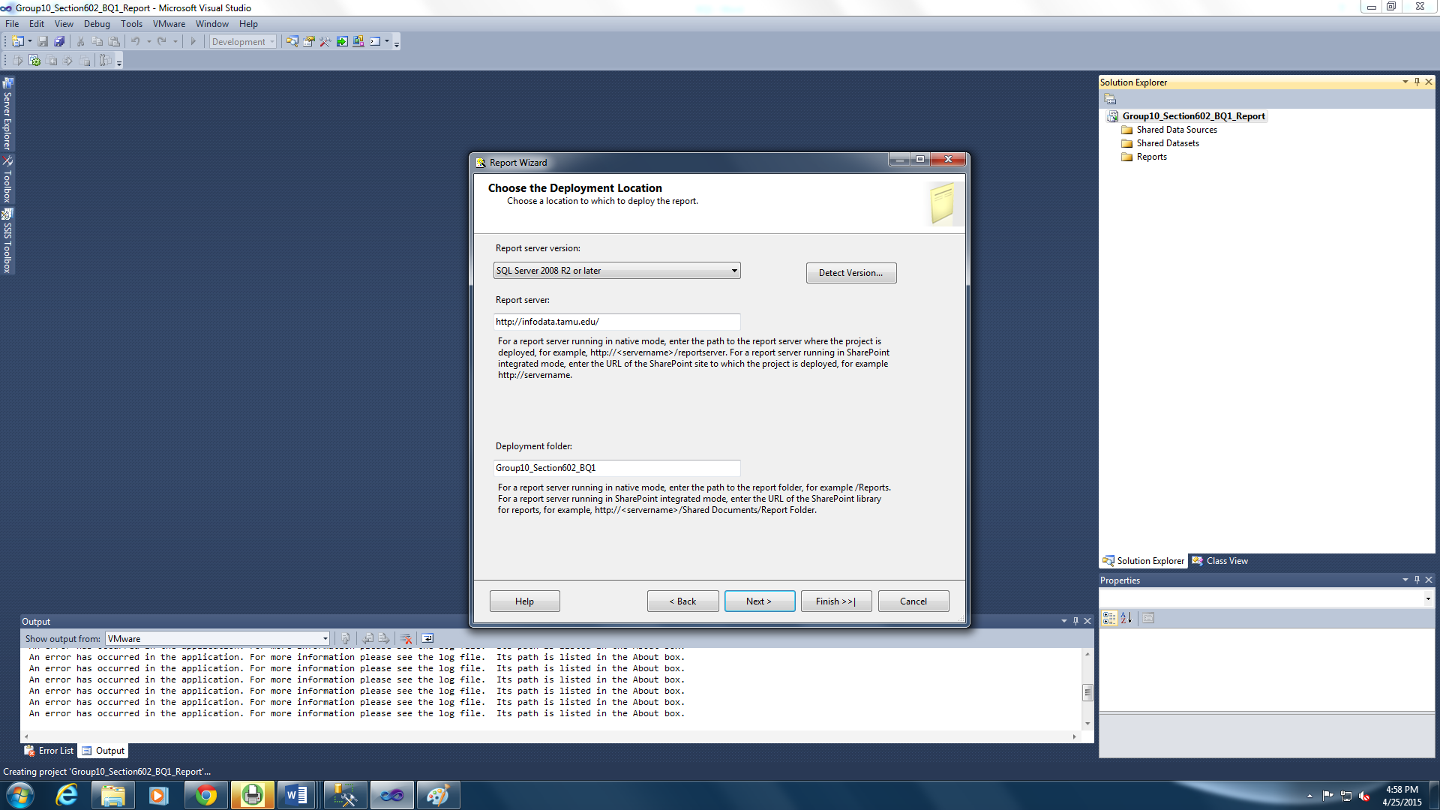

Figure 81: Choosing deployment location and folder

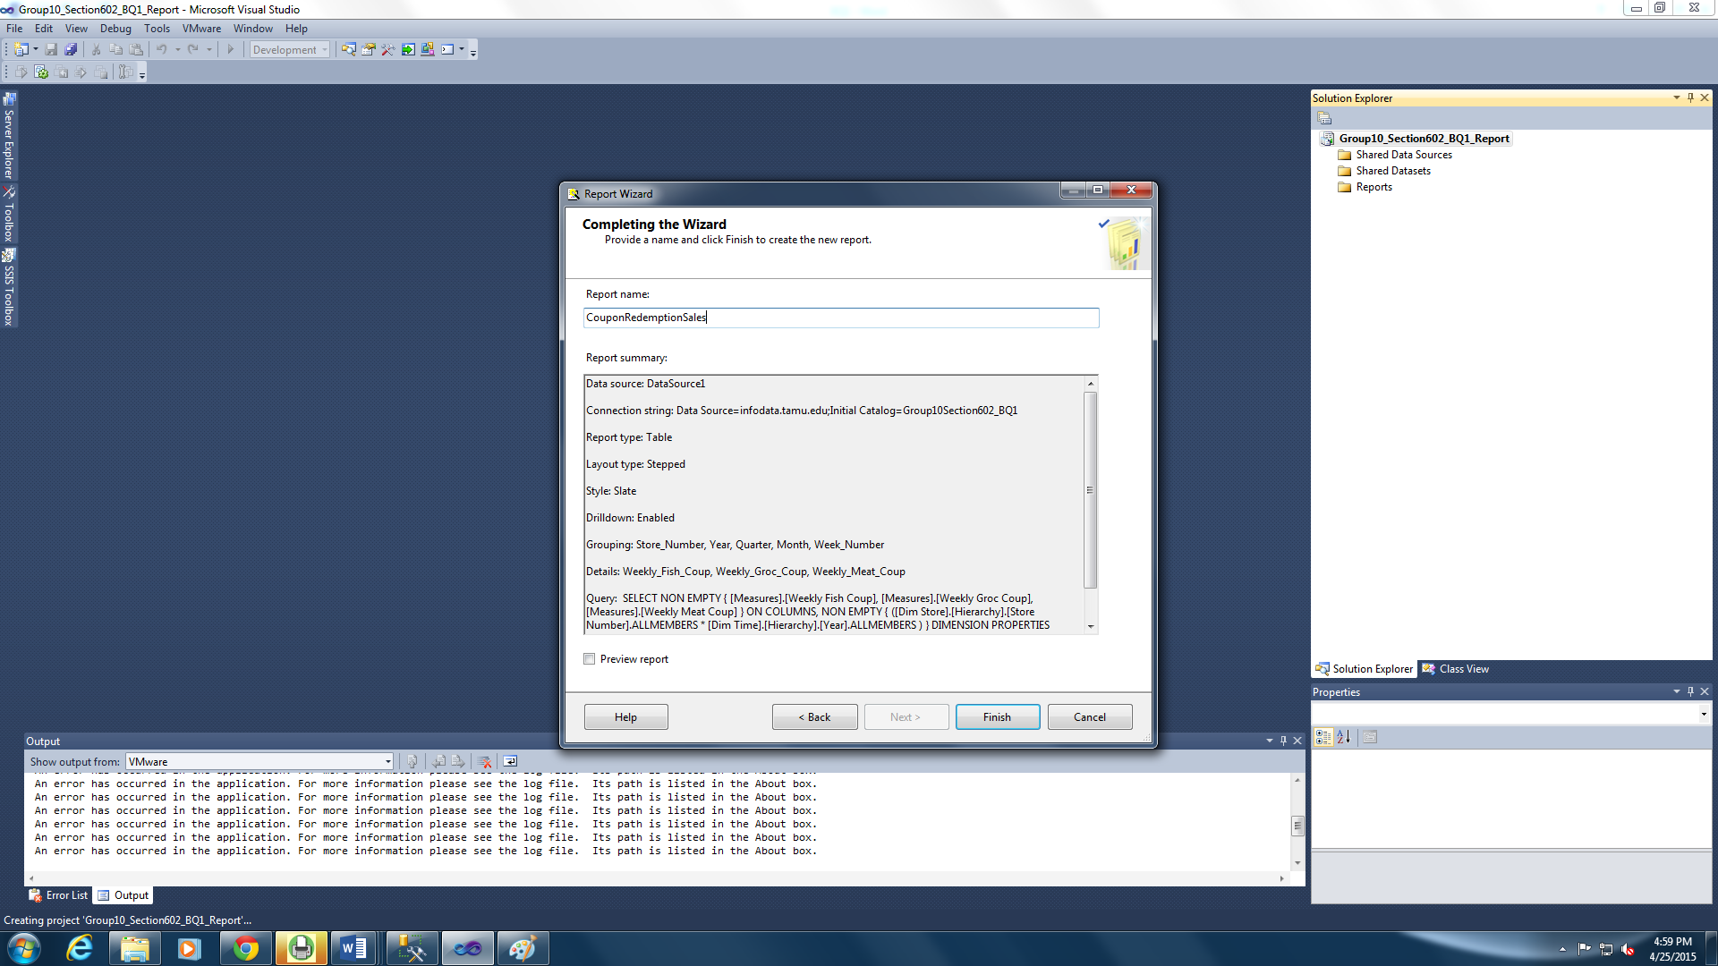

Figure 82: Naming the report

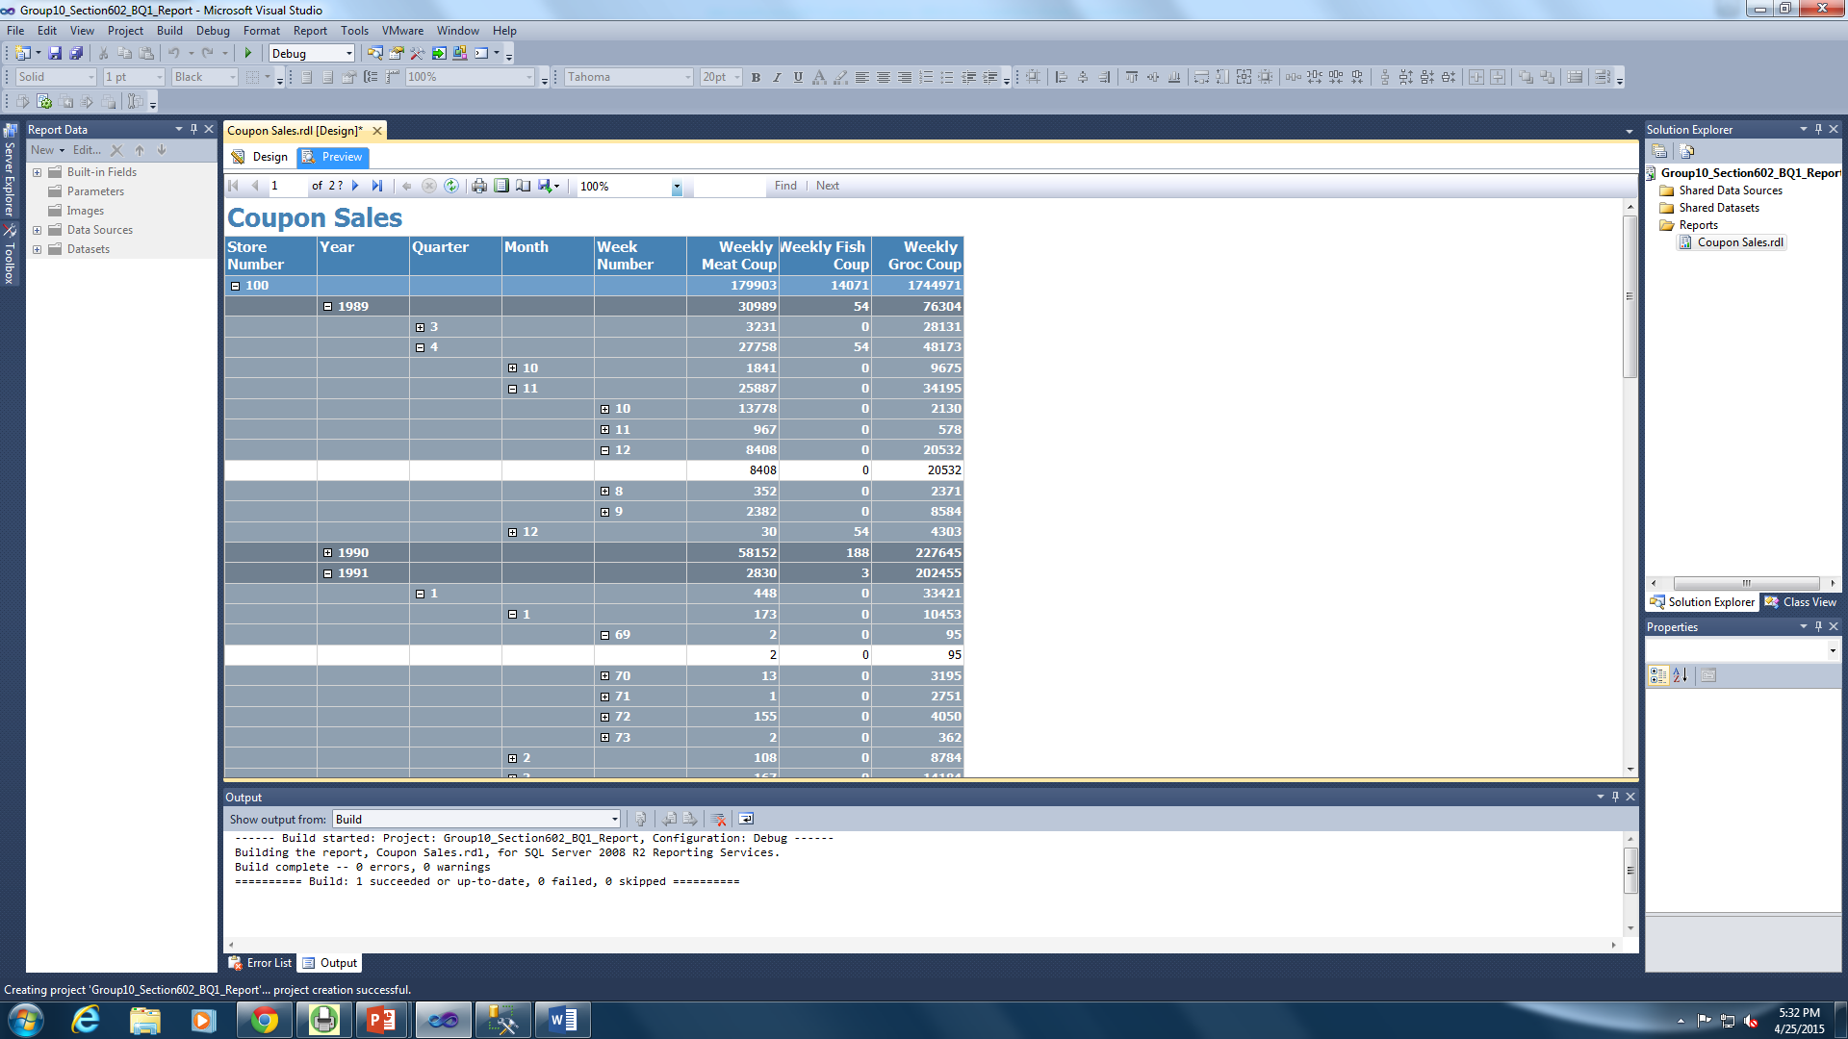

Figure 83: Designing the report

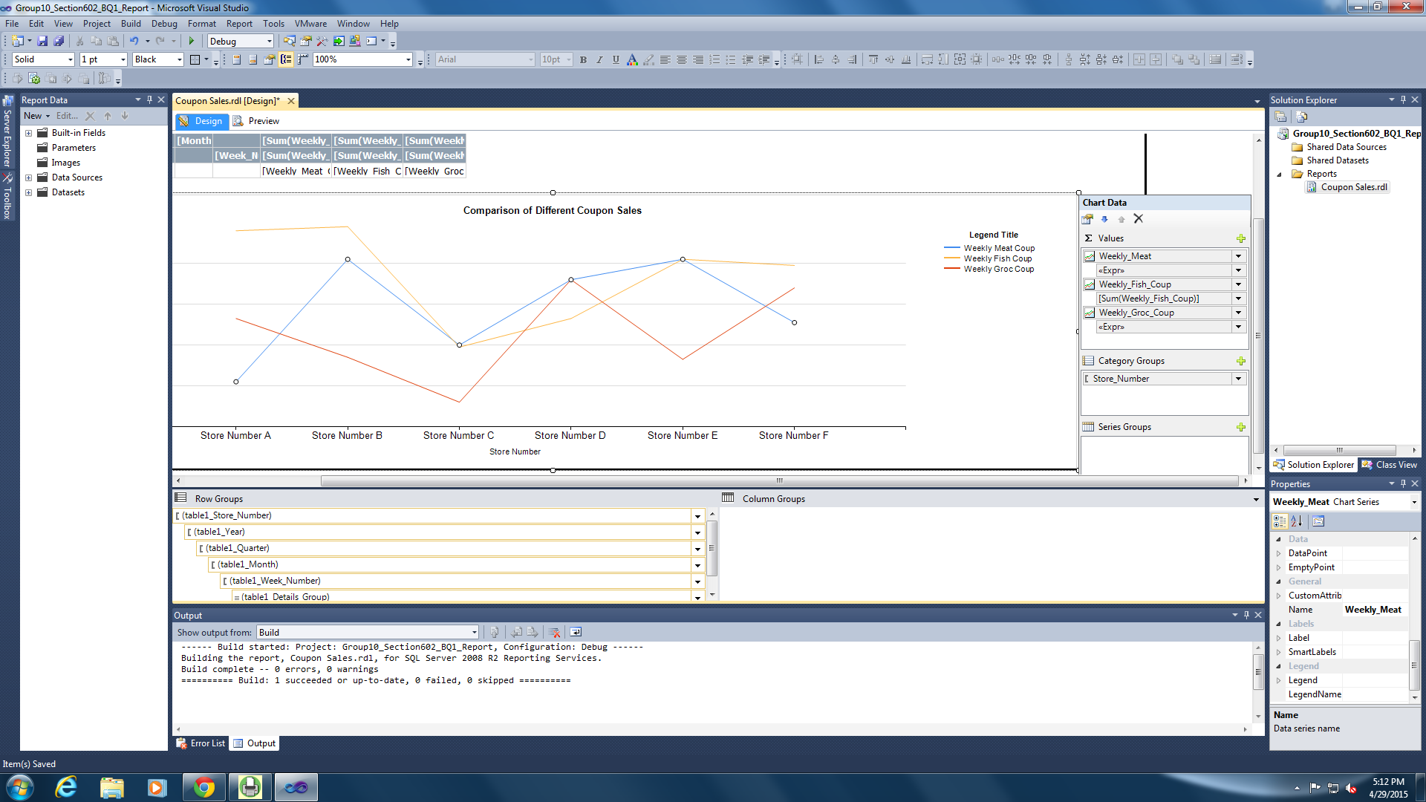

Figure 84: Designing the Chart to Display the Weekly Coupon Sales of Meat, Fish and Grocery

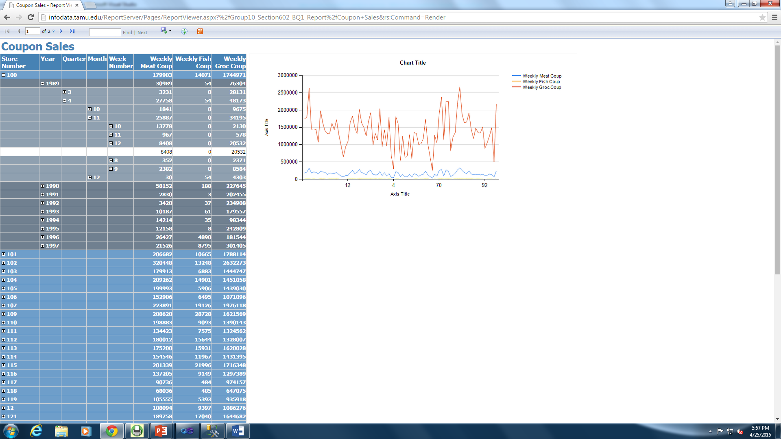

Figure 85: Deployed report with the chart accessed in the browser

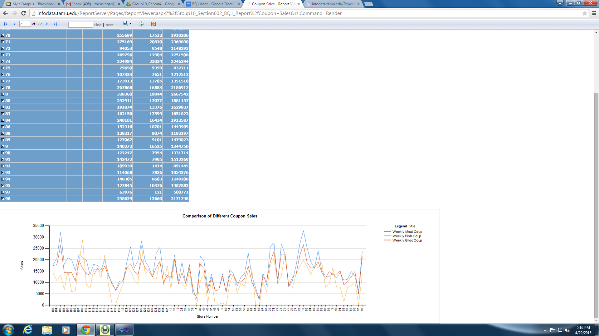

Figure 86: Displaying the Chart Comparing the Meat, Fish and Grocery Coupon Sales across Various Stores

|  |  |
| --- | --- |
| Question# | 2 |
| Business Question | How does age of the customers and demography affect the pharmacy sales? |
| Report Type and  Justification | SSRS-  This question seeks to show the impact of the population over Age 60 in an area on the pharmacy sales in a store in the area. This needs the store number, the pharmacy sales in the store and the percentage of population over the age of 60 in the area where the store is located.  An SSRS report can be used to present this data effectively to the business. |
| Report Title | Effect of Population over Age60 on Pharmacy Sales |
| Report Attributes Mapping | |  |  | | --- | --- | | SSRS Report | | | Data Mart Table | **Attribute** | | DimStore | Store Number | | DimStore | Percentage of population over Age60 | | FactSales | Pharmacy Sales | |
| Report Description | The report consists of the columns pharmacy sales and the percentage of population over the age of 60 in the area of store location. An Effect of Population over Age60 on Pharmacy Sales chart depicts the data in the report in a graphical format. The store numbers are the values along the X-axis and the pharmacy sales and population over age 60 values are along the Y- axis.  The Y- axis denotes a percentage for age and denotes pharmacy sales in 10 million USD. |

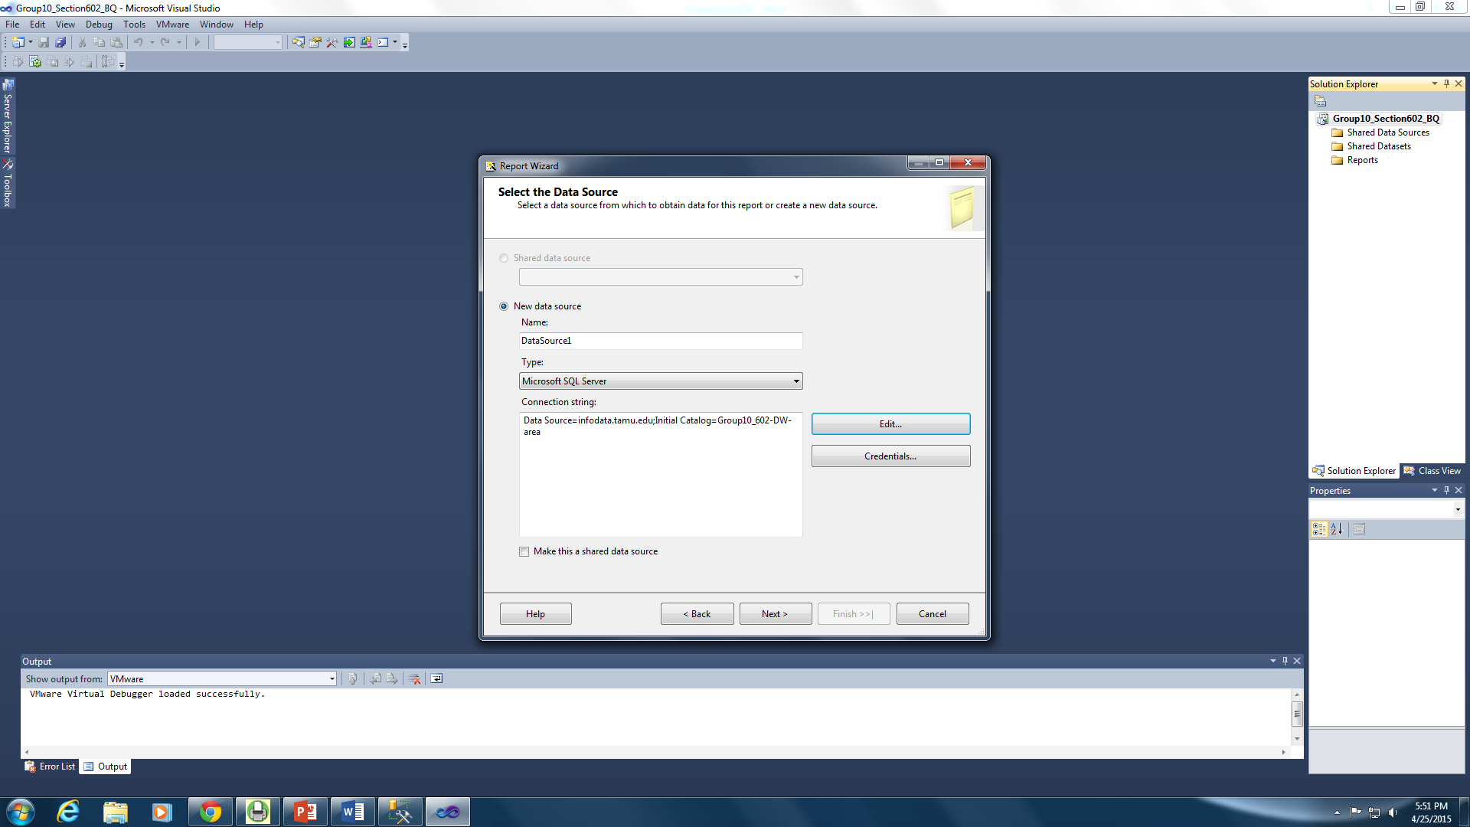

Figure 87: Data Source

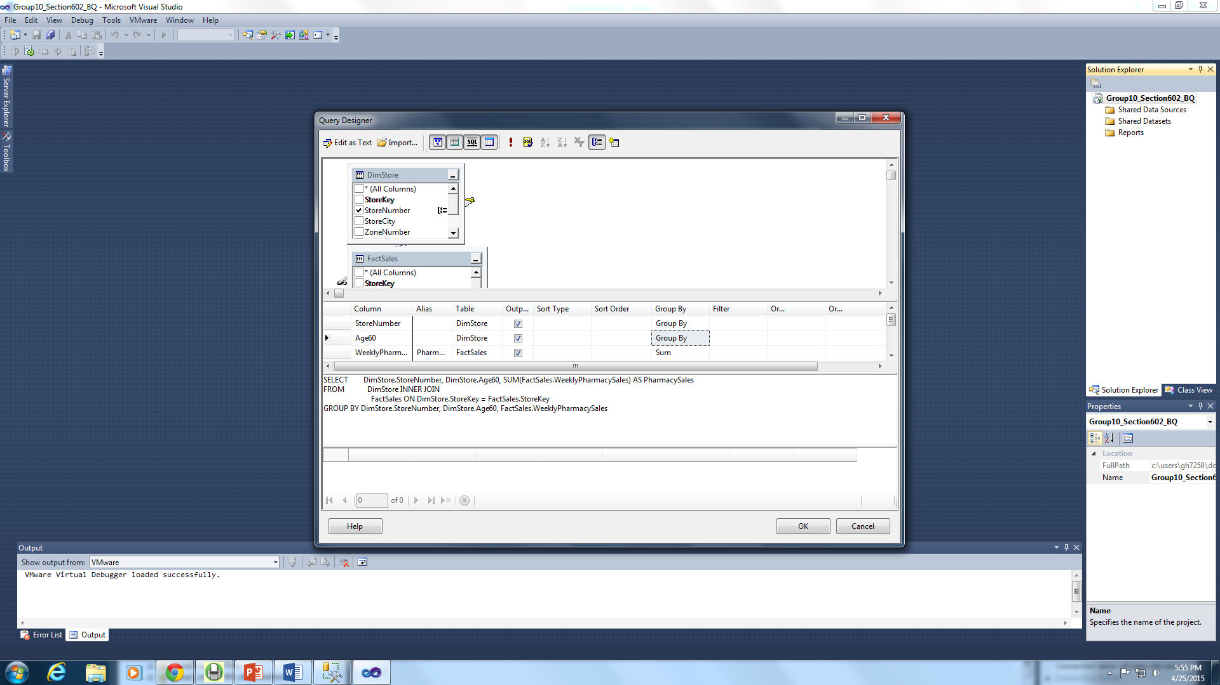

Figure 88: Query Designer

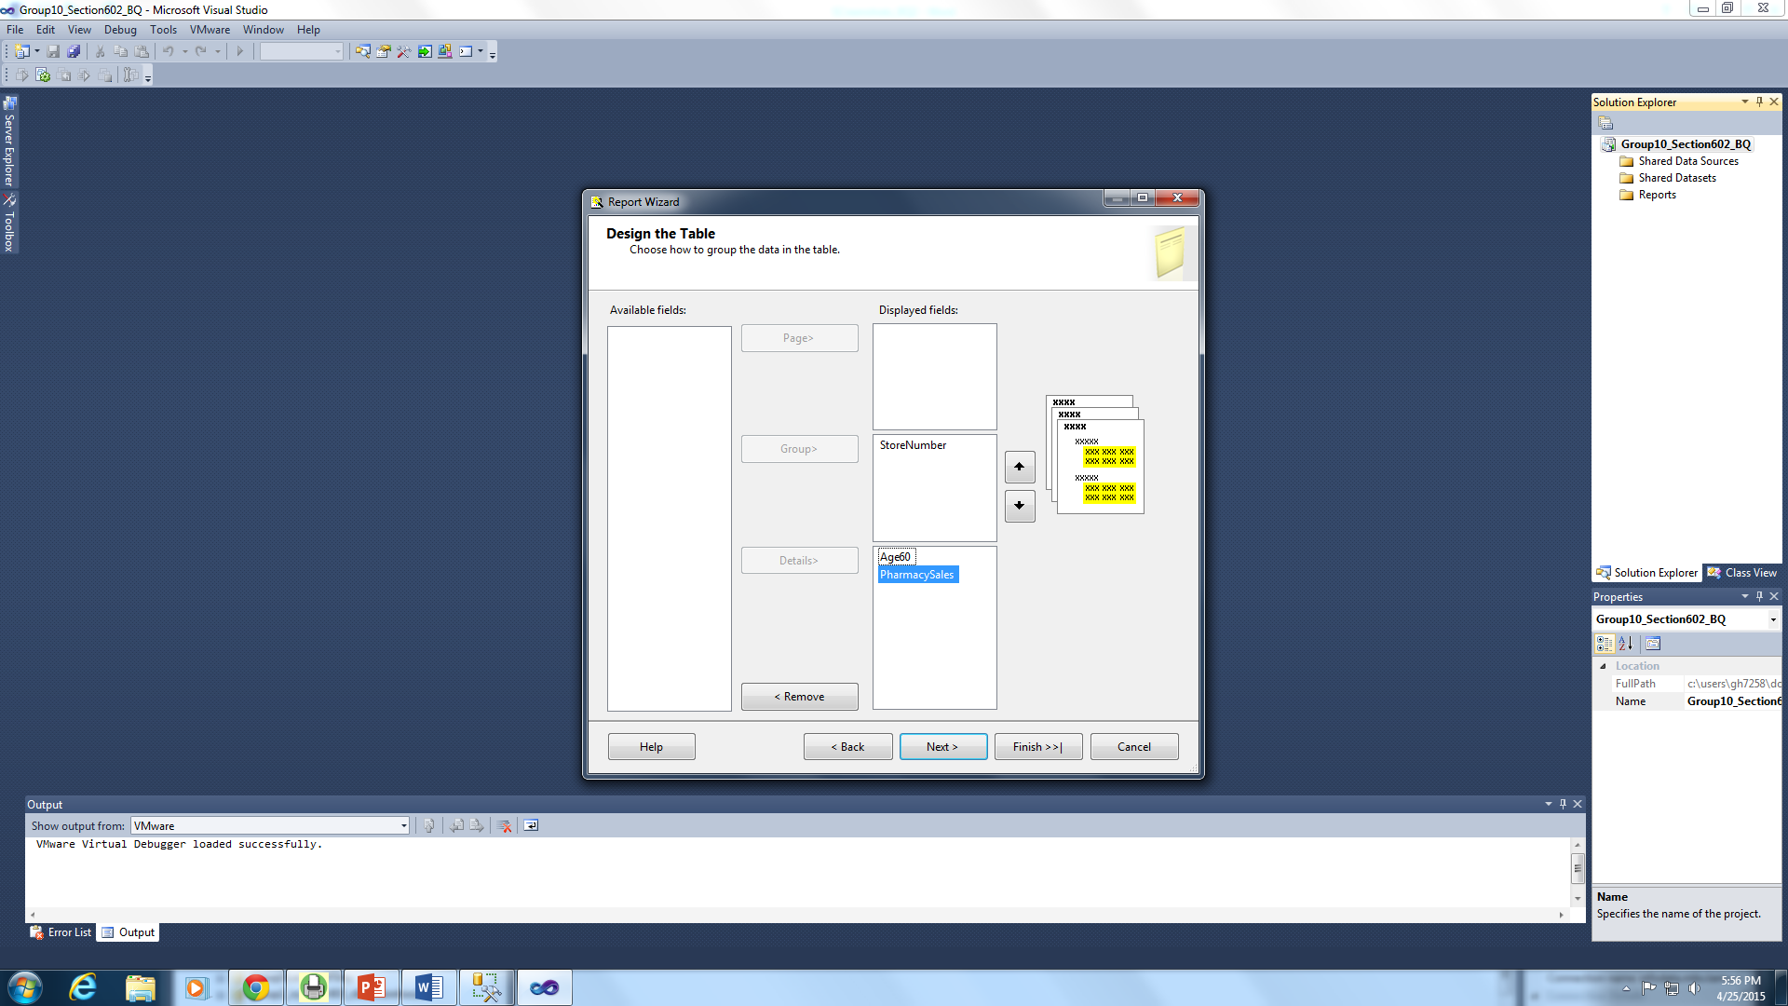

Figure 89: Designing the Table

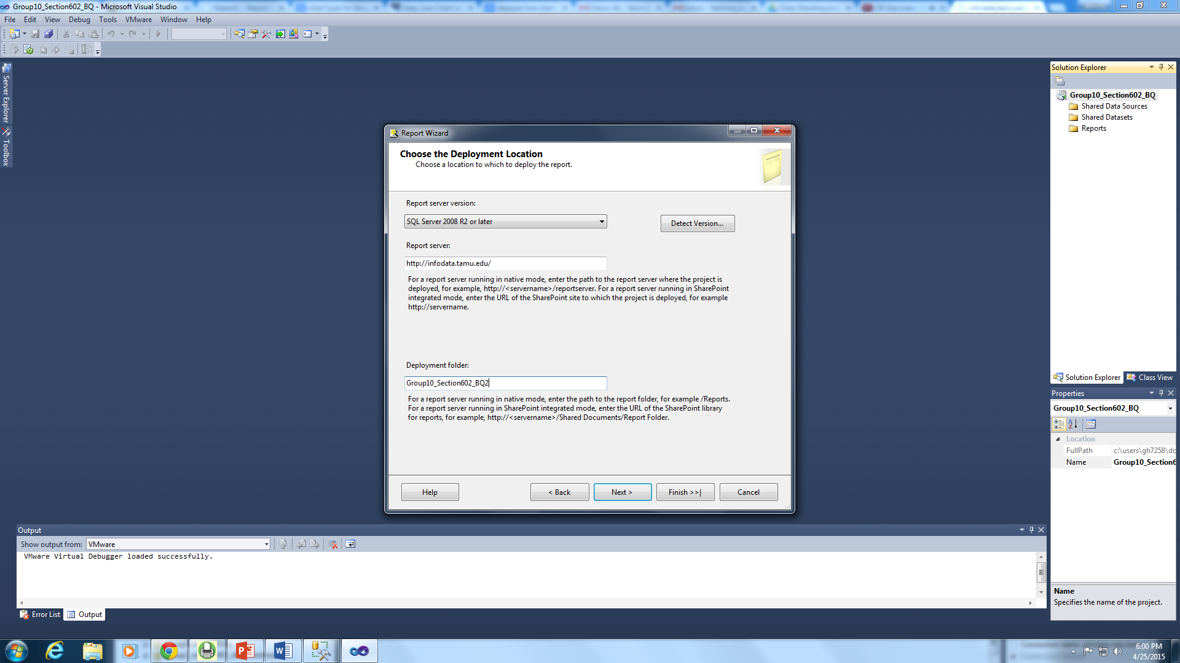

Figure 90: Choosing Deployment Location and Folder

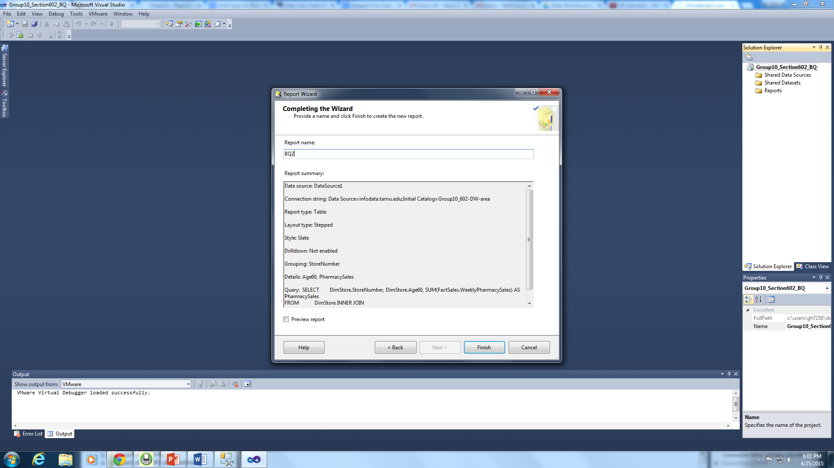

Figure 91: Naming the Report

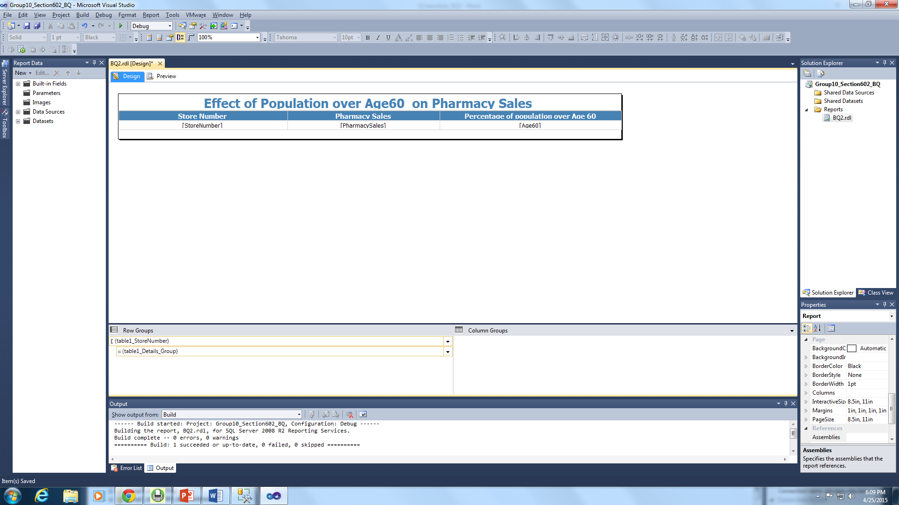

Figure 92: Designing the Report

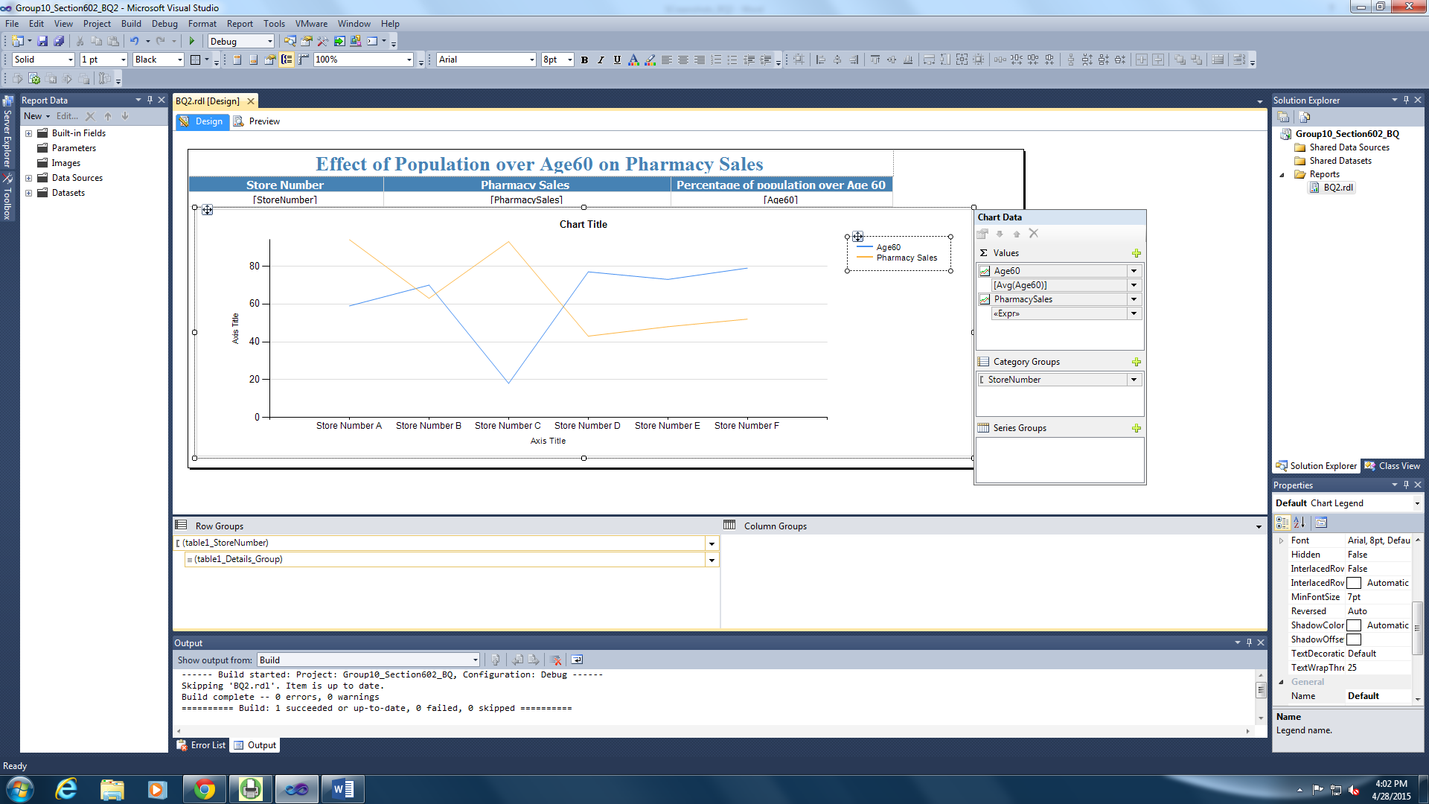

Figure 93: Designing the Chart to Display the Pharmacy Sales and the Age60 Population

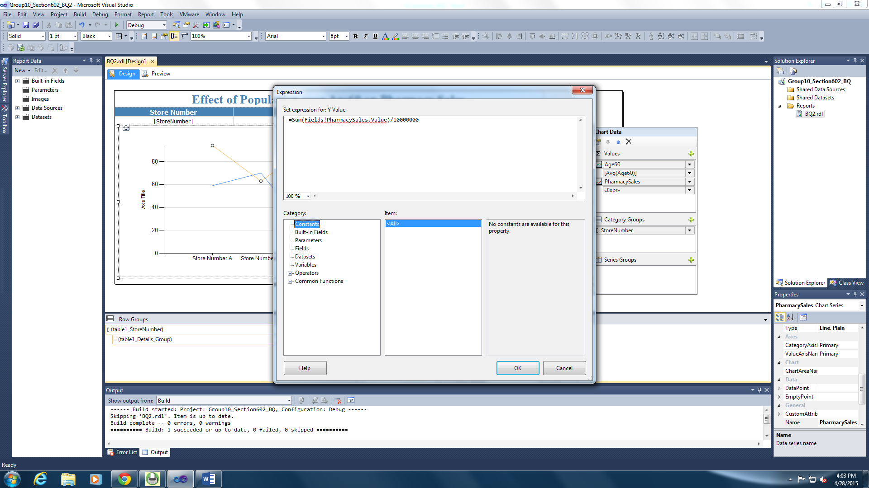

Figure 94: Displaying the Scaled Down Value of Pharmacy Sales

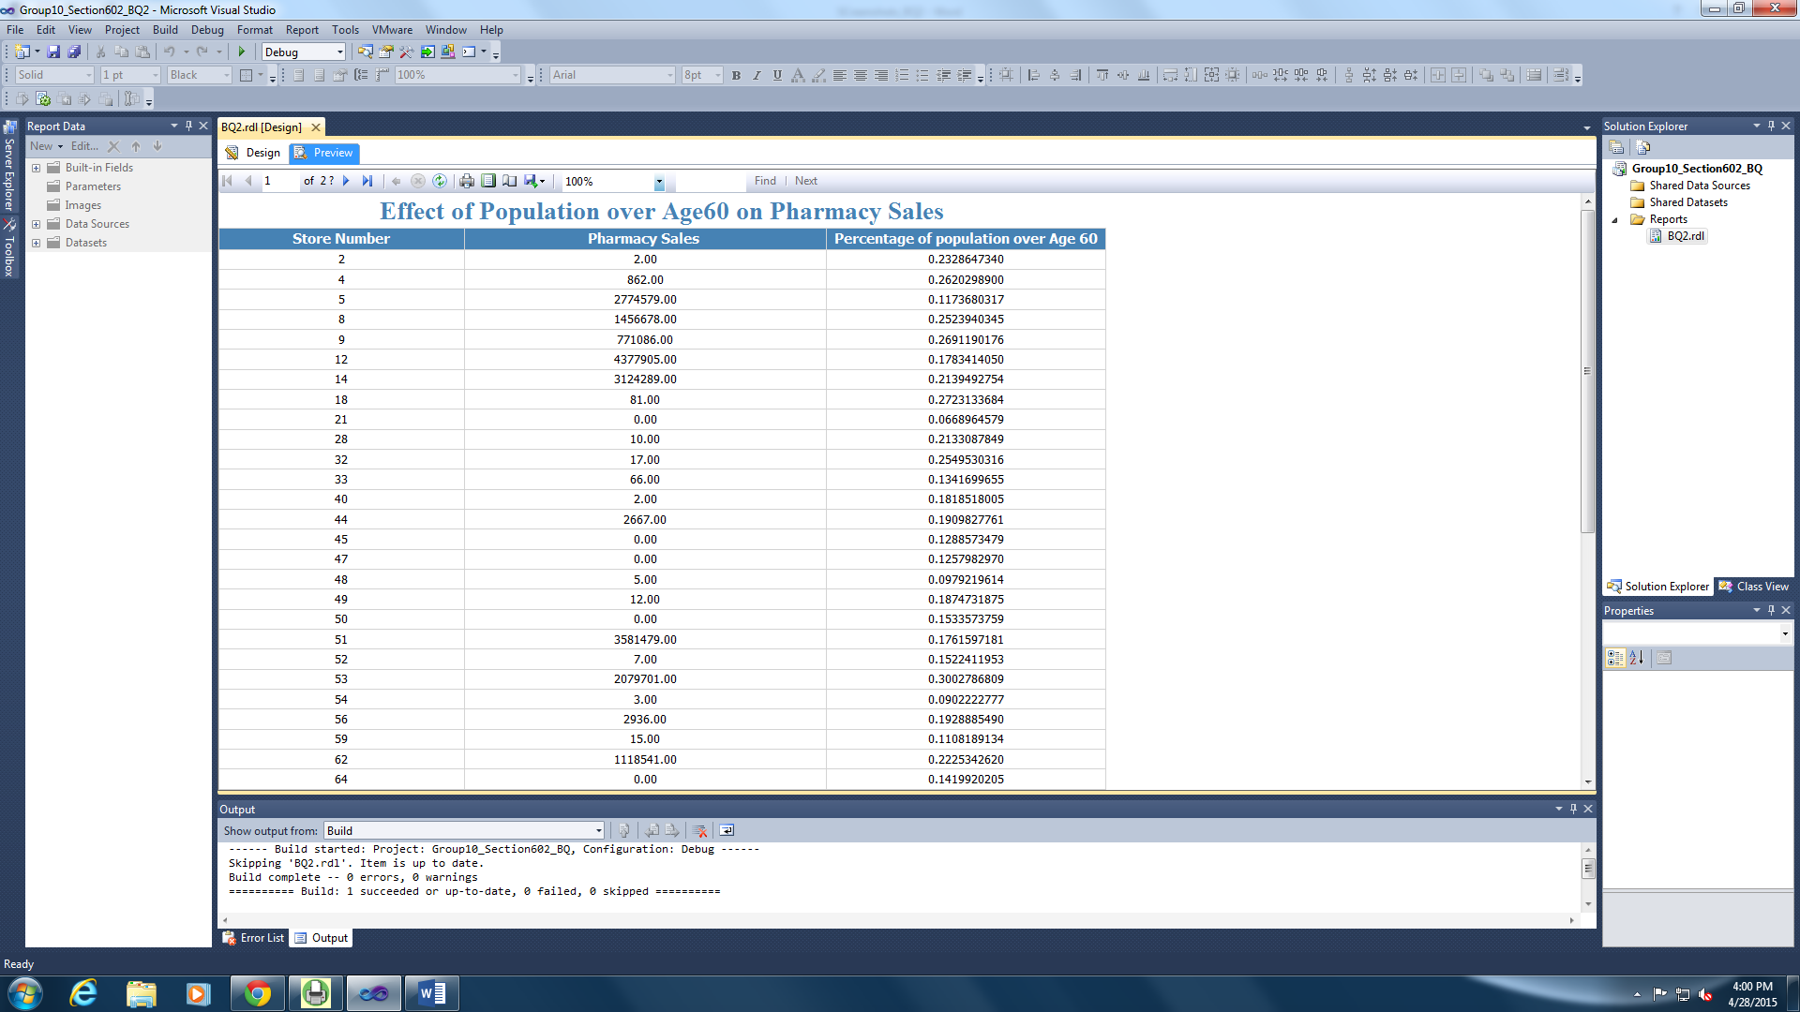

Figure 95: Displaying the Report in the SSRS

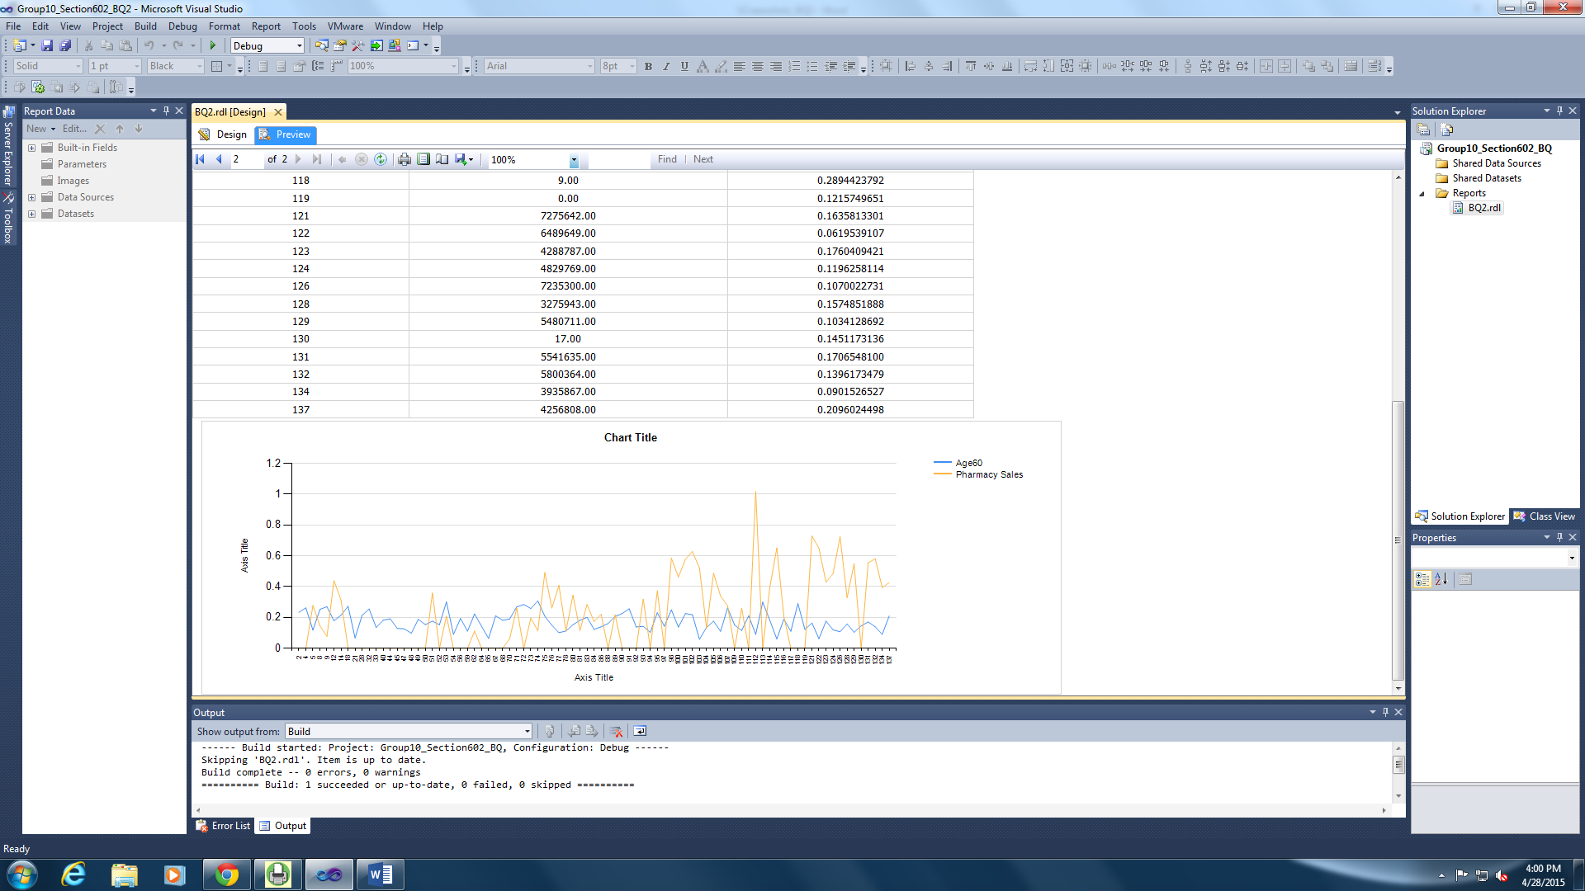

Figure 96: Designing the Chart in the SSRS

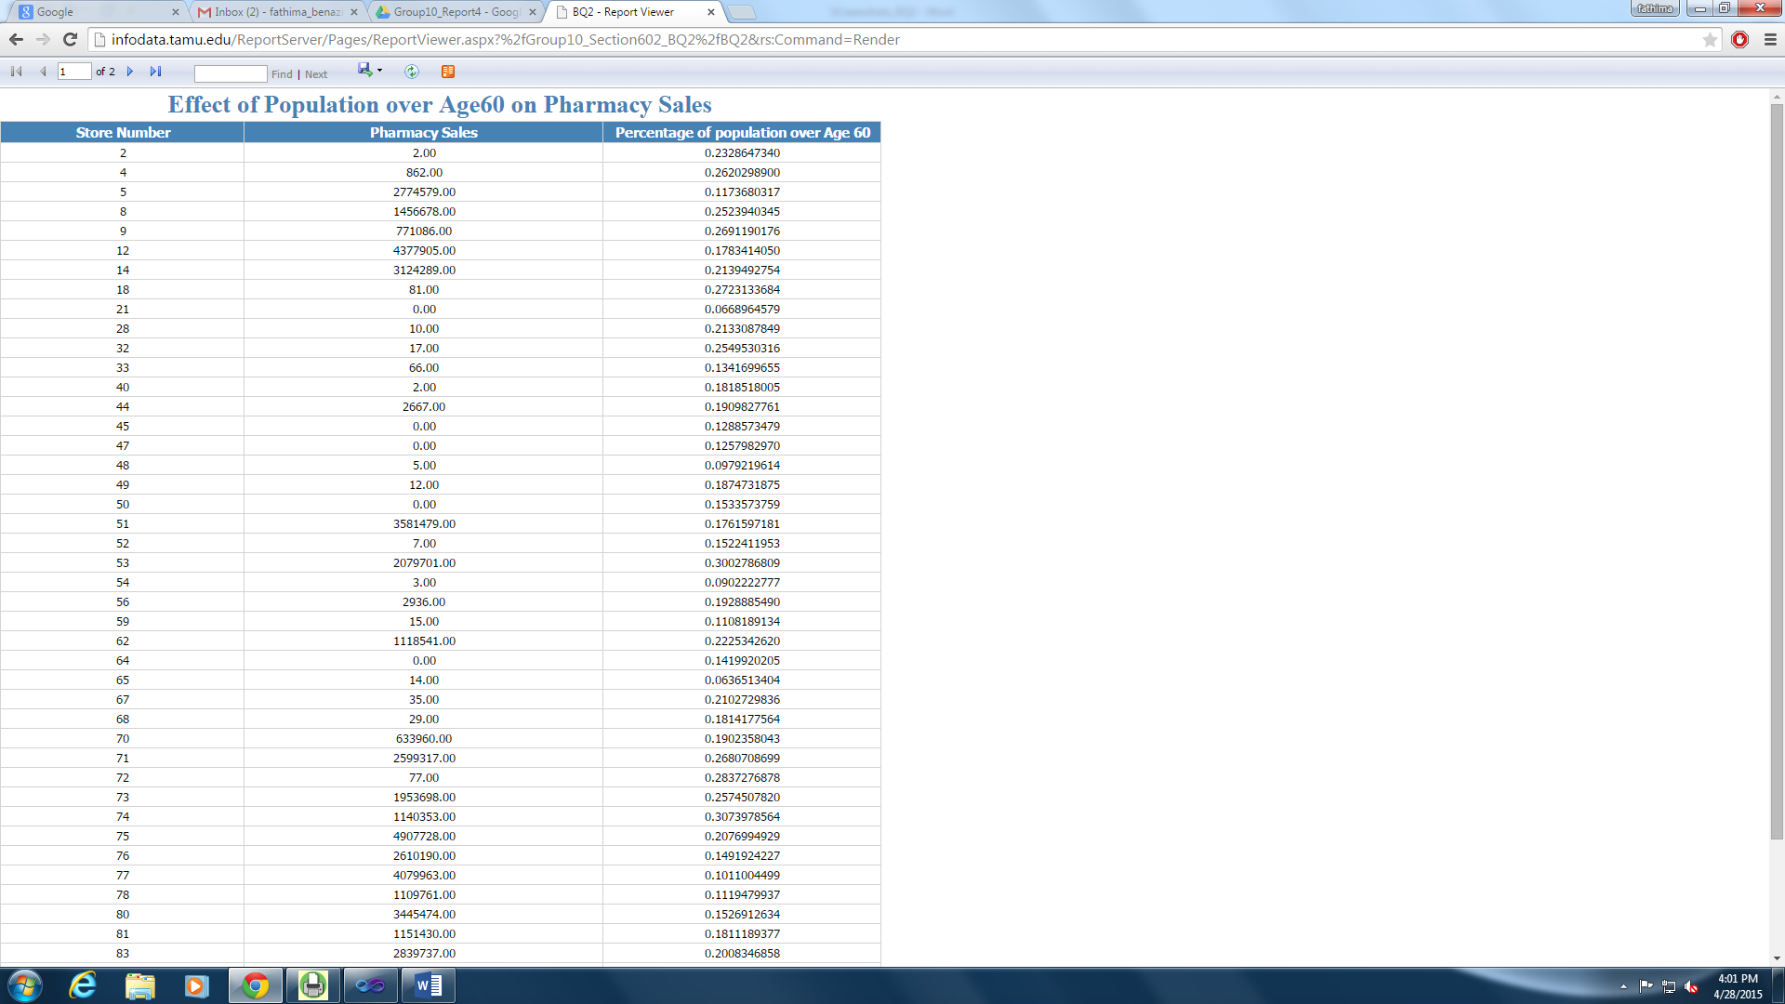

Figure 97: Deployed Report Accessed in the Browser

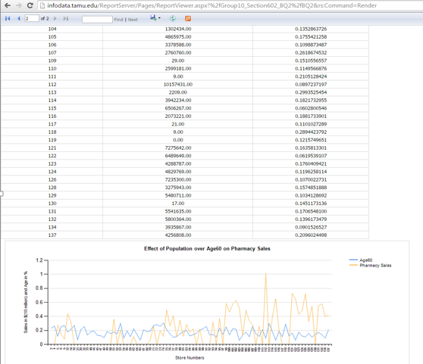

Figure 98: Deployed Report with the Chart Accessed in the Browser

|  |  |
| --- | --- |
| Question# | 3 |
| Business Question | Which type of frozen food that is in high demand in the whole of DFF? |
| Report Type and  Justification | SSRS on SSAS  This question seeks to answer which frozen food has grossed the highest profit for DFF. This data may be needed for every month/ every quarter/ every year to plan DFF’s inventory accordingly. Hence aggregating the movement and profit values for the frozen foods in prior and storing it in a cube facilitates immediate retrieval of this data along the hierarchy of time dimension.  A report on this cube will help the business make decisions pertaining to the frozen foods’ procurement and inventory management. Hence SSRS on SSAS is the right choice of reporting to answer this business question. |
| Report Title | Comparison of Sales of Frozen Food Products |
| Report Attributes Mapping | |  |  | | --- | --- | | SSRS Report on top of SSAS Cube | | | Data Mart Table | **Attribute** | | DimProduct | UPC | | DimProduct | Description | | DimTime | Week Number | | DimTime | Month | | DimTime | Quarterly | | DimTime | Year | | FactMovement | Weekly Frd Profit | | FactMovement | Weekly Movement | |
| Report Description | The report illustrates the weekly sales data of each frozen food product across all stores. Hence the table consists of the UPC code and the description of the product, and the corresponsing weekly sales and movement. The chart gives a visual representation of the same data. All the products are listed along the X-axis. The description, rather than the UPC code, is used for clarity in the report. The weekly movement and the weekly profit is compared for each product. From these reports, it is easier to conclude which product in the frozen food category would yield the maximum profit and movement in Dominick’s. |

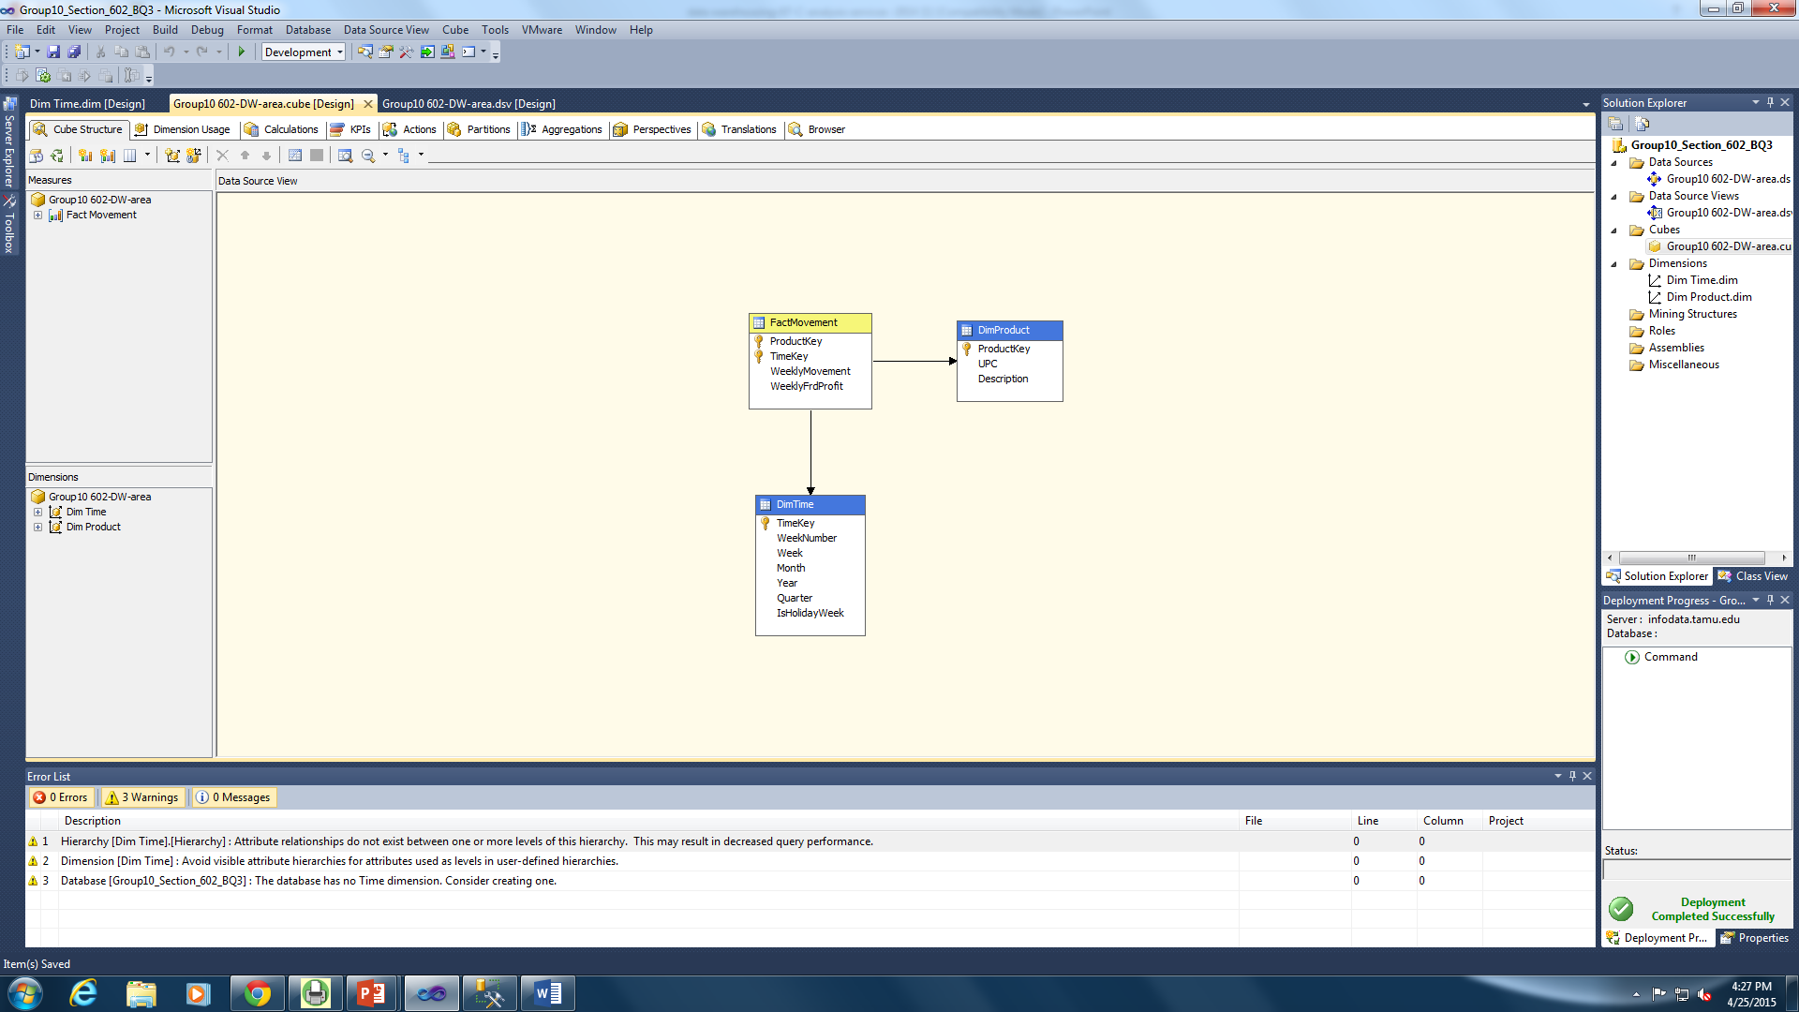

Figure 99: SSAS Cube

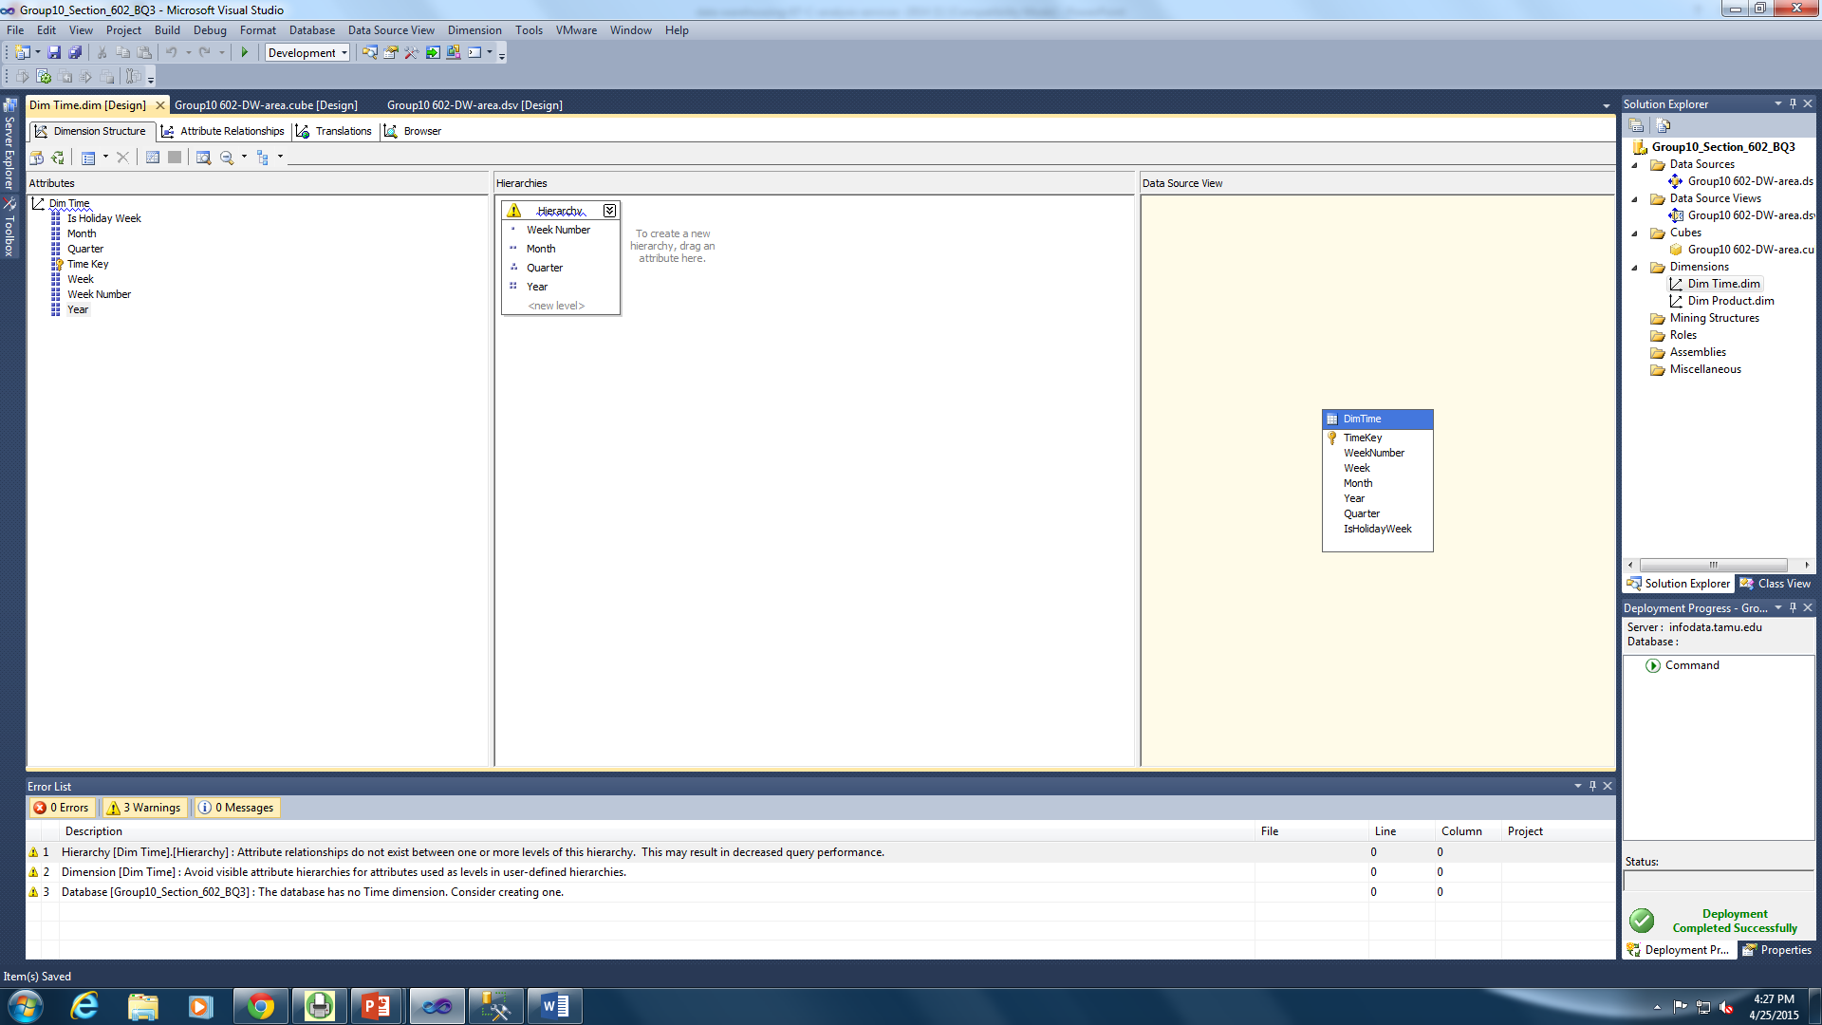

Figure 100: Creating hierarchy for the time dimension

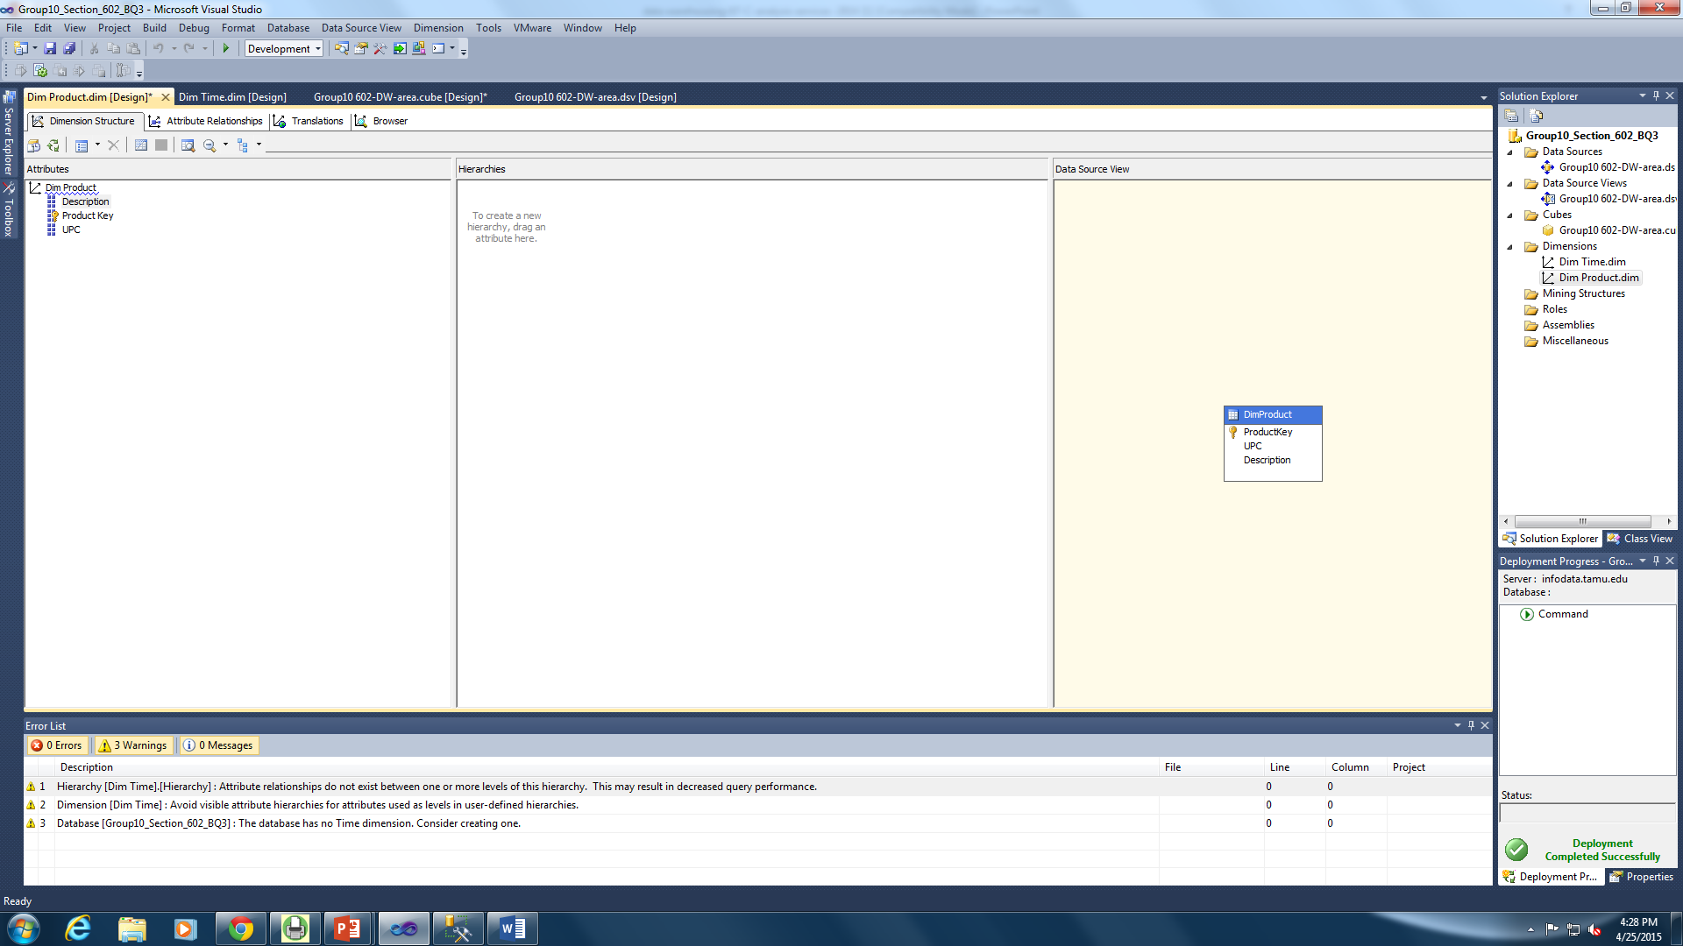

Figure 101: Adding the Attributes of Dim Product

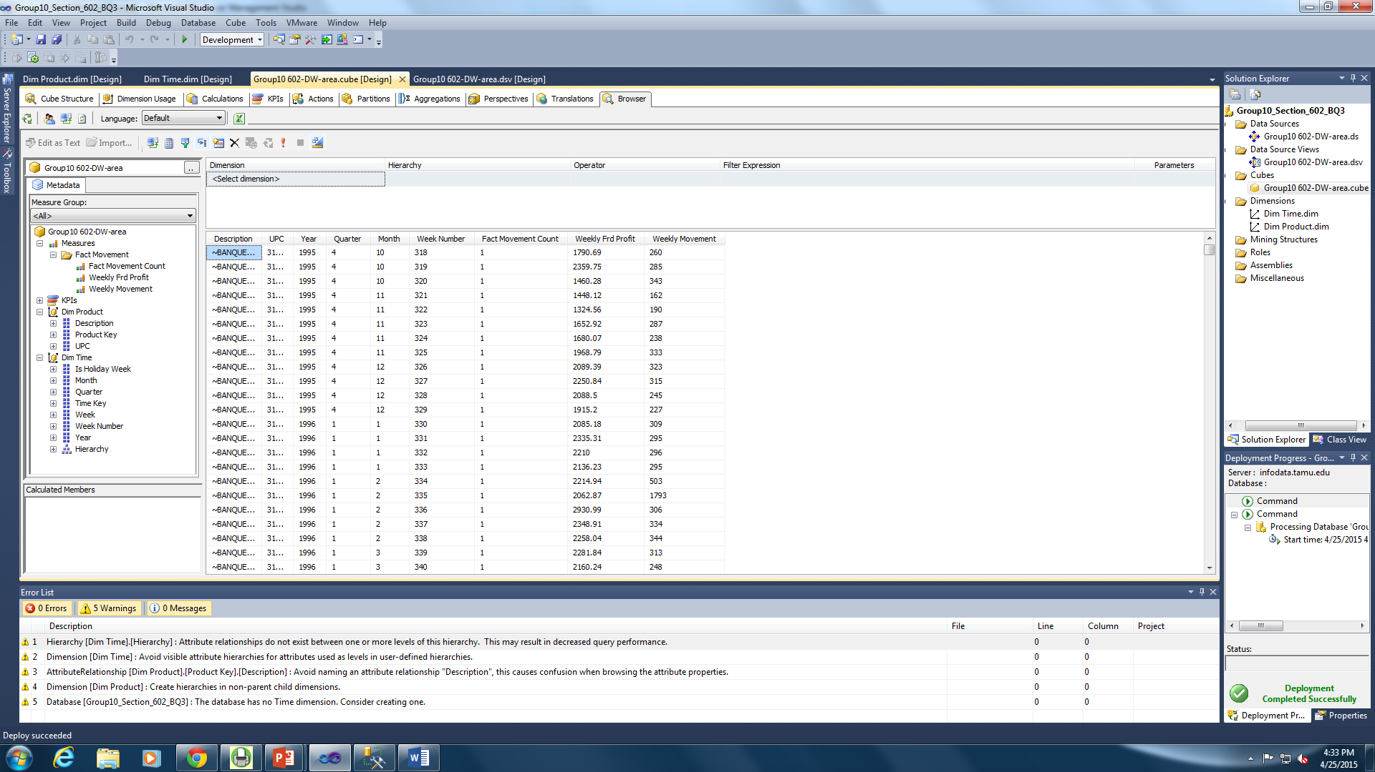

Figure 102: Displaying the Data in the Server Side (SSAS)

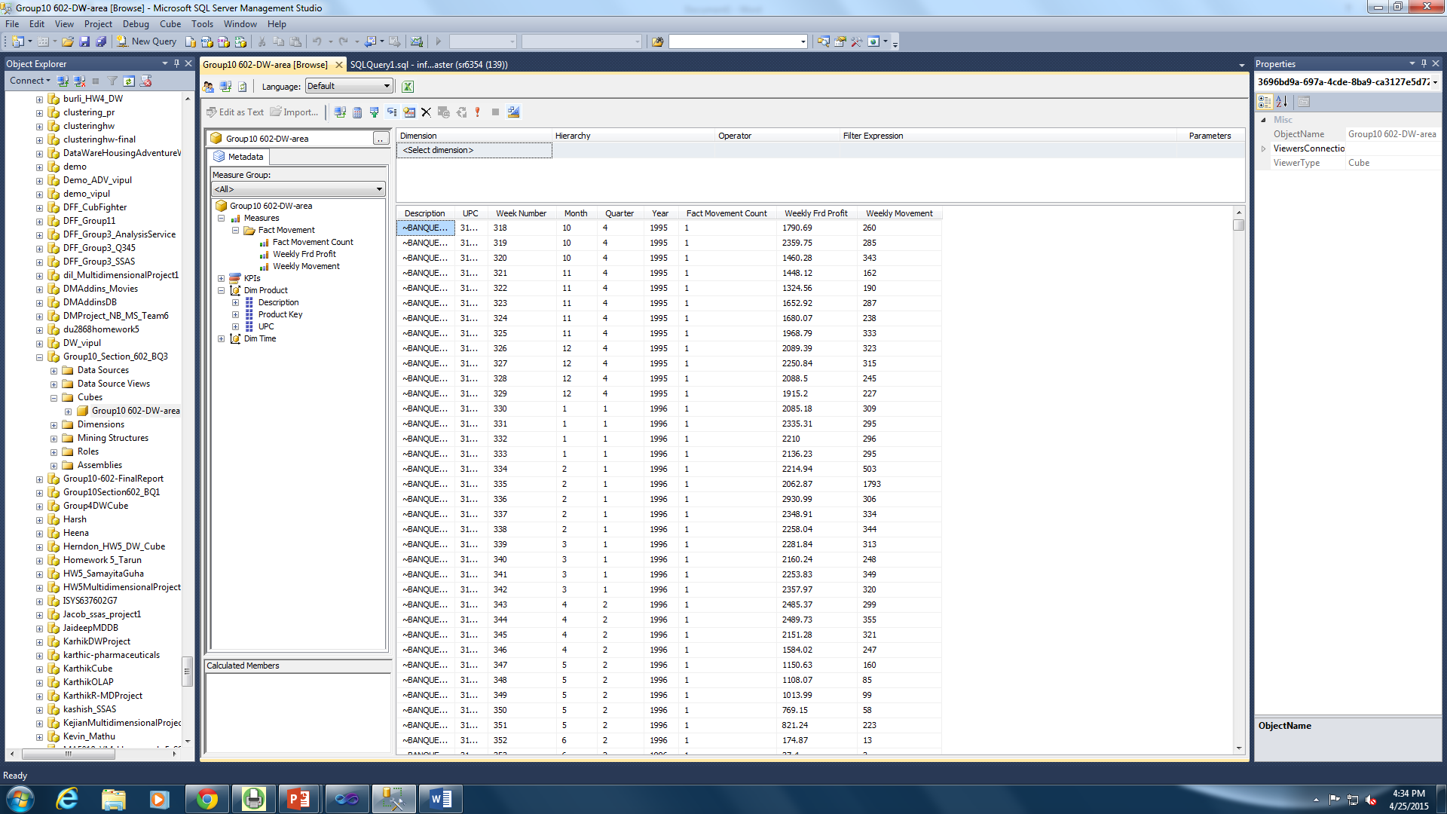

Figure 103: Displaying the Report in the Client Side (SQL Server Management Studio)

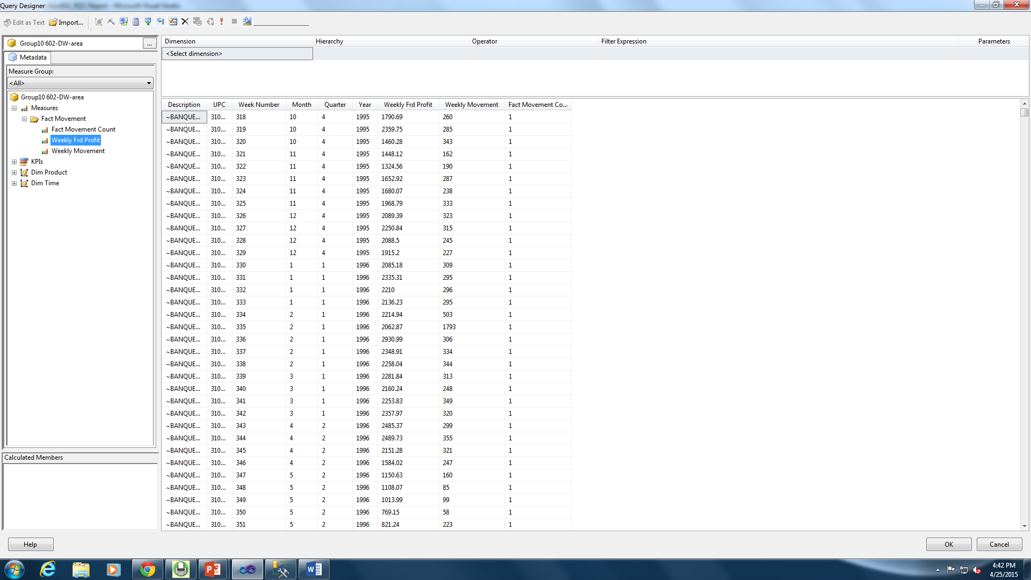

Figure 104: Query Designer

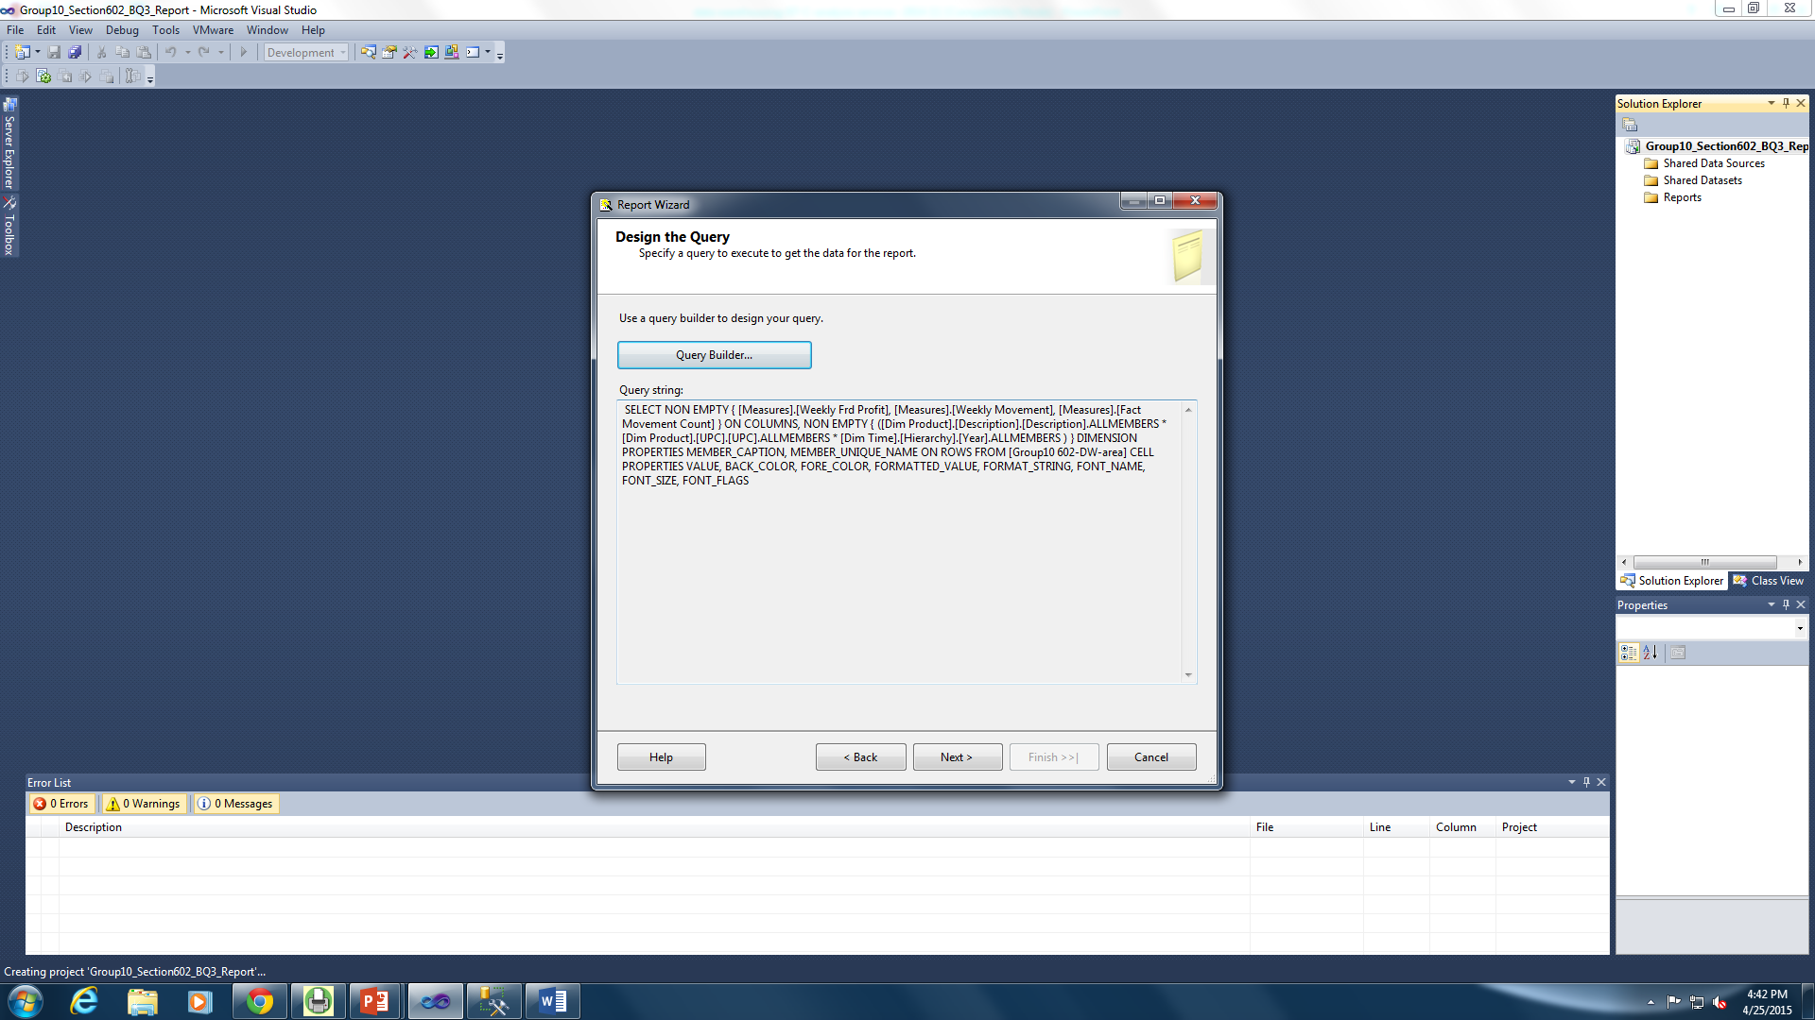

Figure 105: Auto generated script for query builder

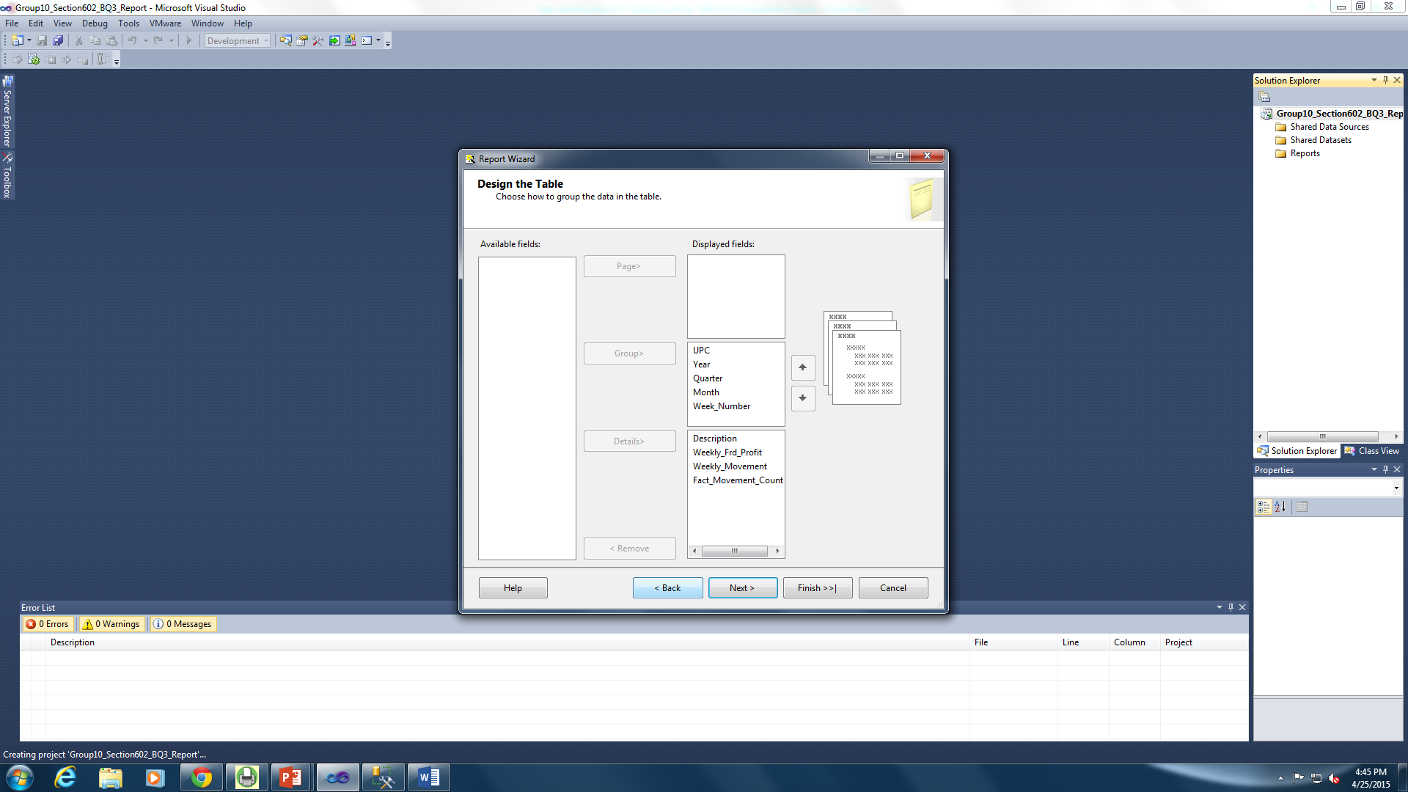

Figure 106: Designing the table

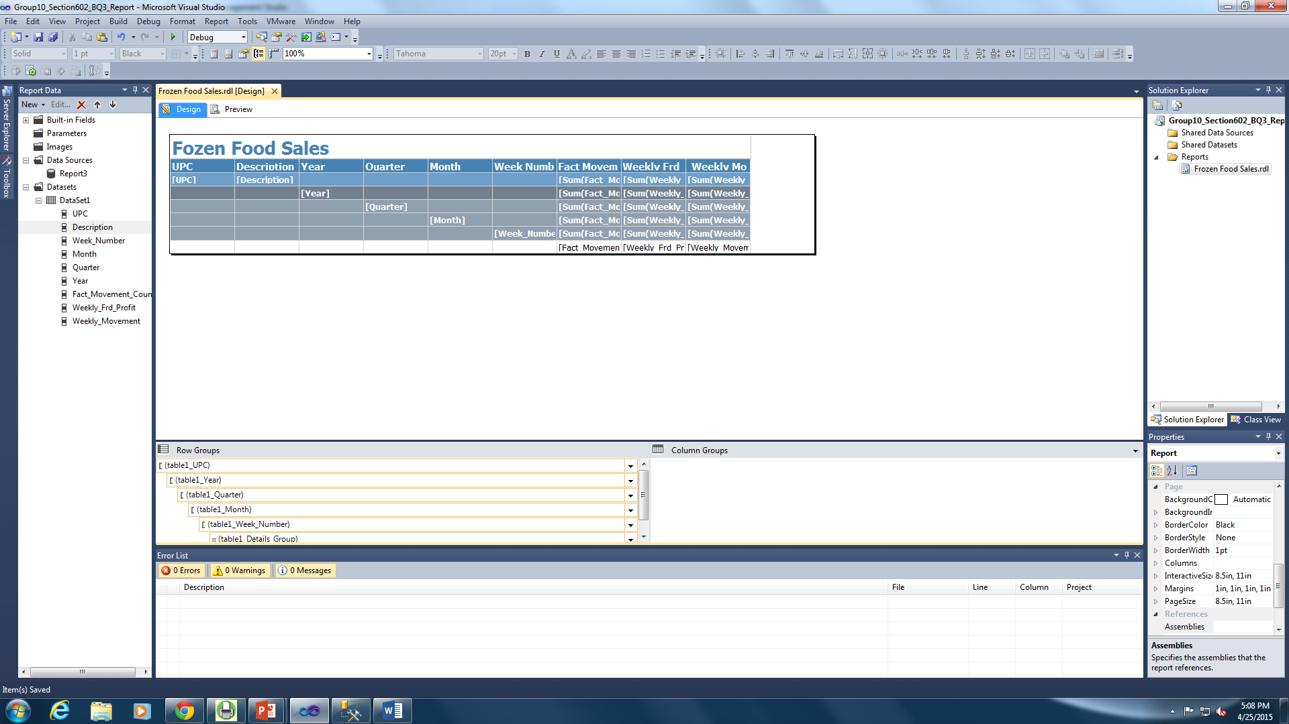

Figure 107: Designing the report

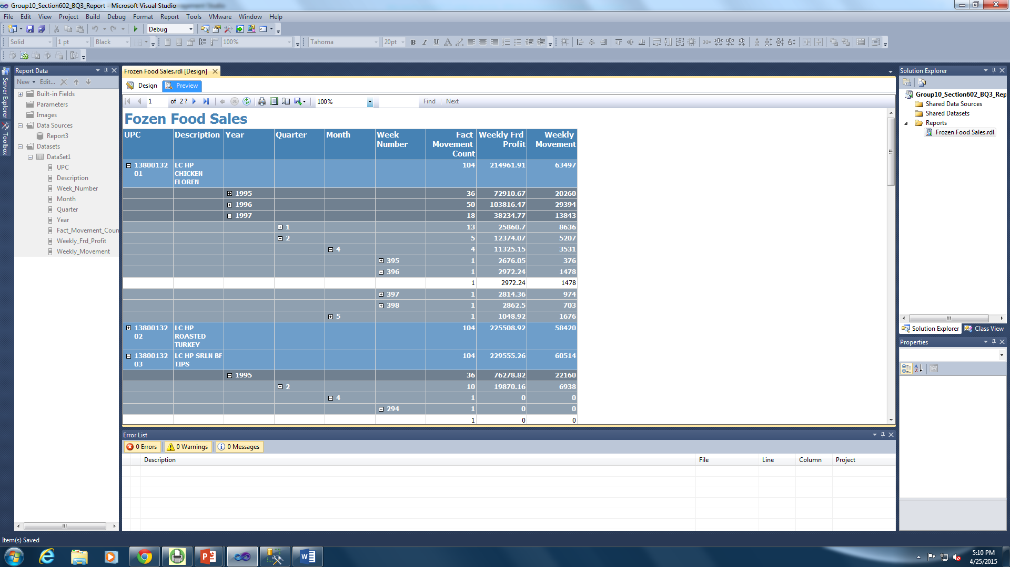

Figure 108: Displaying the report on SSRS

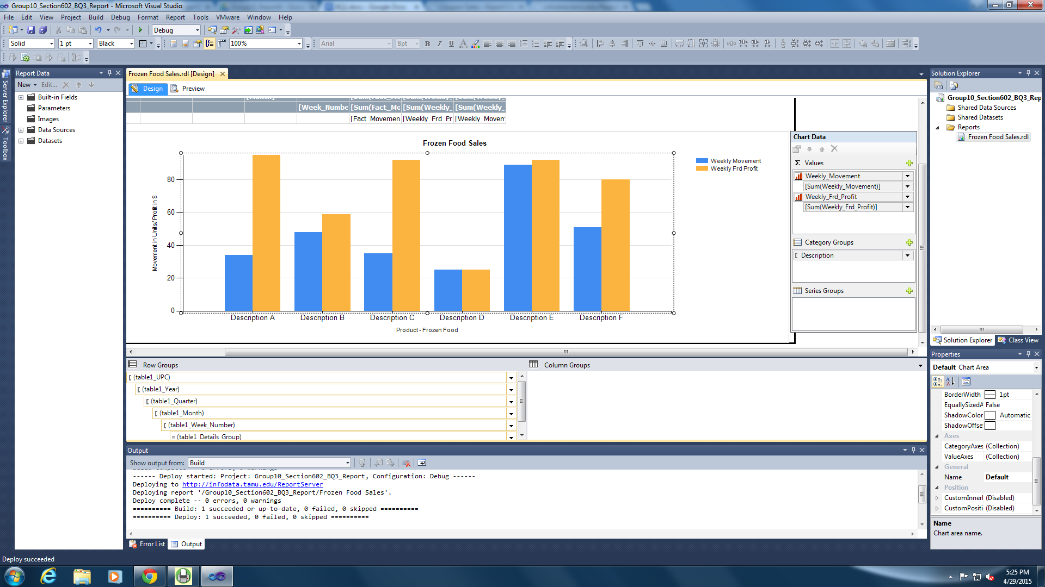

Figure 109: Designing the Chart to Display the Weekly Movement and Profit of Different Frozen Food Items

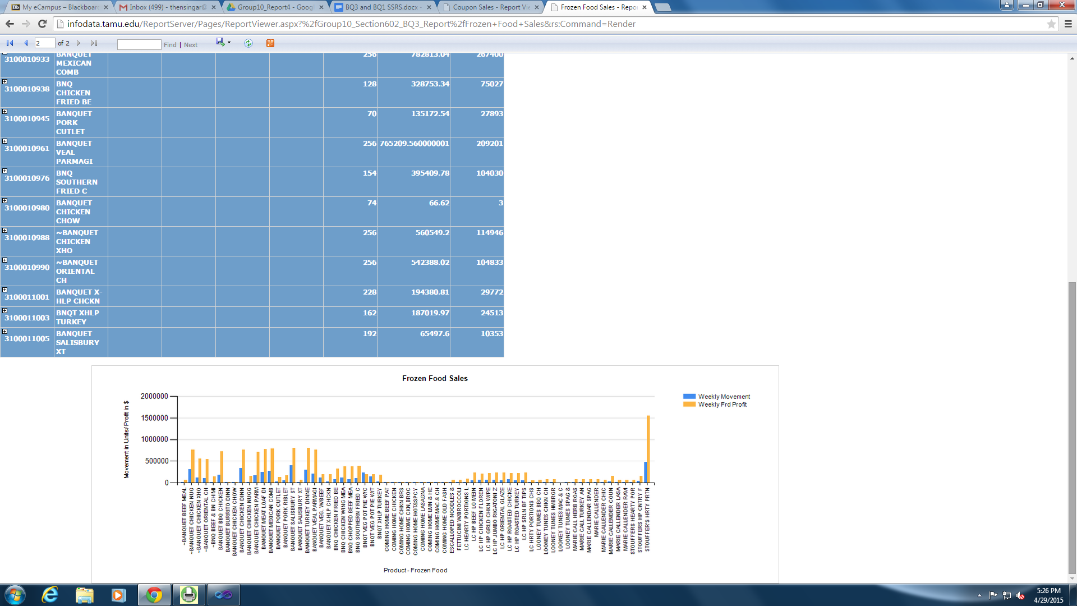

Figure 110: Deployed report with the chart accessed in the browser

|  |  |
| --- | --- |
| Question # | 4 |
| Business Question | How are beer sales in regions where single living population are high? Do these regions reflect higher profit for DFF?  Do beer sales result in higher profit in demographic distribution of single family? |
| Report Type and  Justification | Report Builder 3.0 |
| Report Title | Effect of Single Population on Beer Sales |
| Report Attributes Mapping | |  |  | | --- | --- | | Report Builder 3.0 | | | Data Mart Table | **Attribute** | | DimStore | Store Number | | DimStore | Single | | FactSales | Weekly Beer Profit | |
| Report Description | The report generated for this question has the weekly sales, profit and the data of the single population across the stores. The line chart depicts the single population and the beer sales in each store. The X-axis has the store numbers and the Y-axis has the population and sales data. From the chart, it can be determined if there are surges in beer sale with rise in single population |

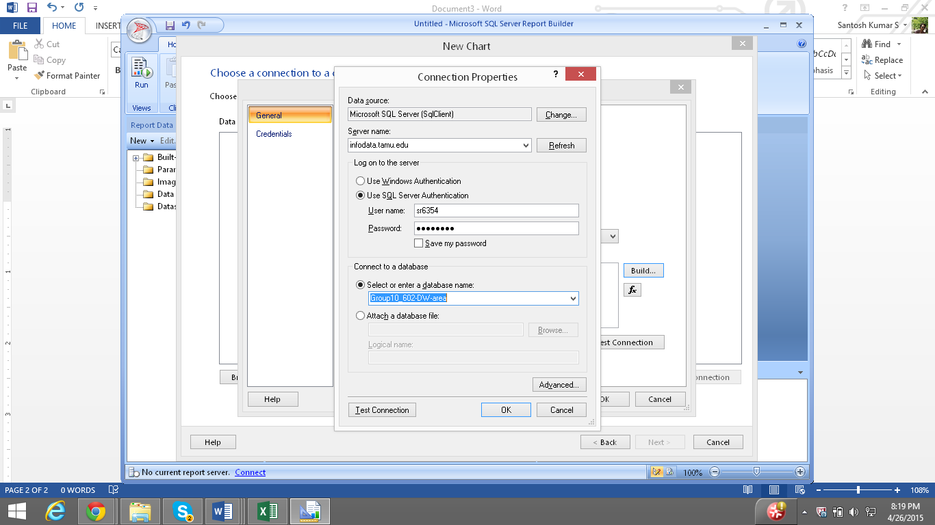

Figure 111: Connecting to a Data Source

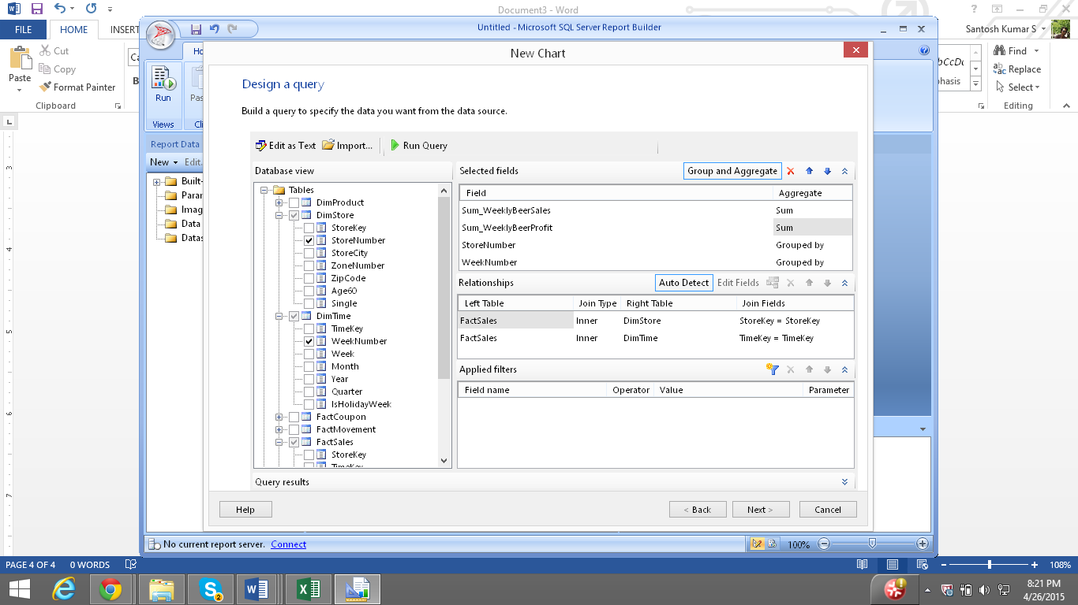

Figure 112: Designing a Query

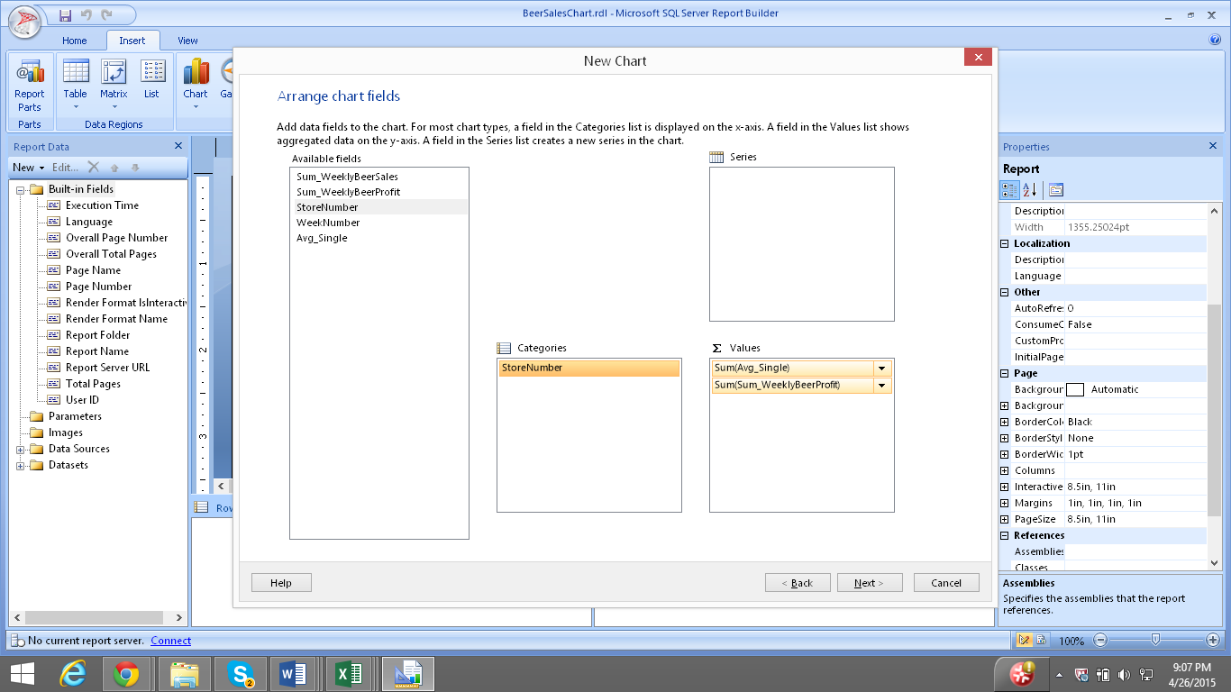

Figure 113: Choosing Chart Fields

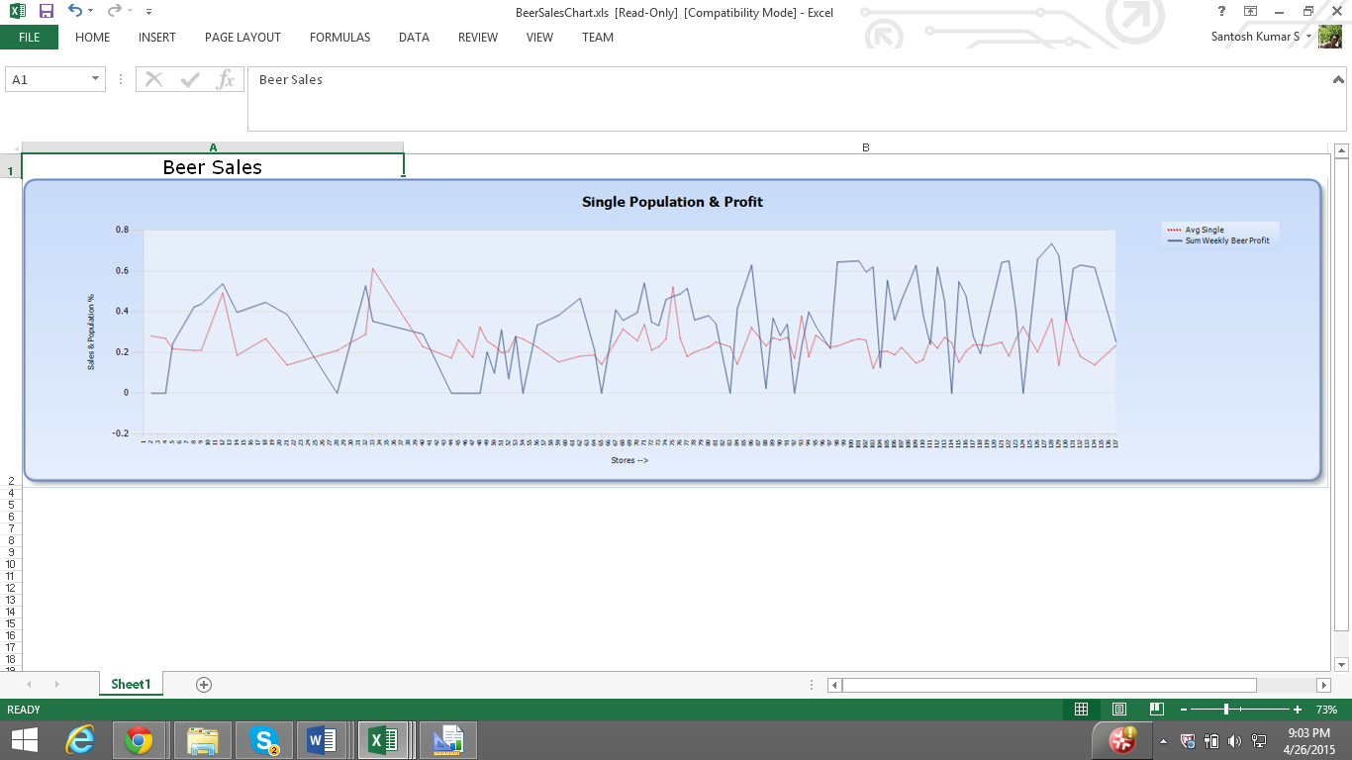

Figure 114: Displaying Chart for Beer Sales against the Average Single Population in Each Store

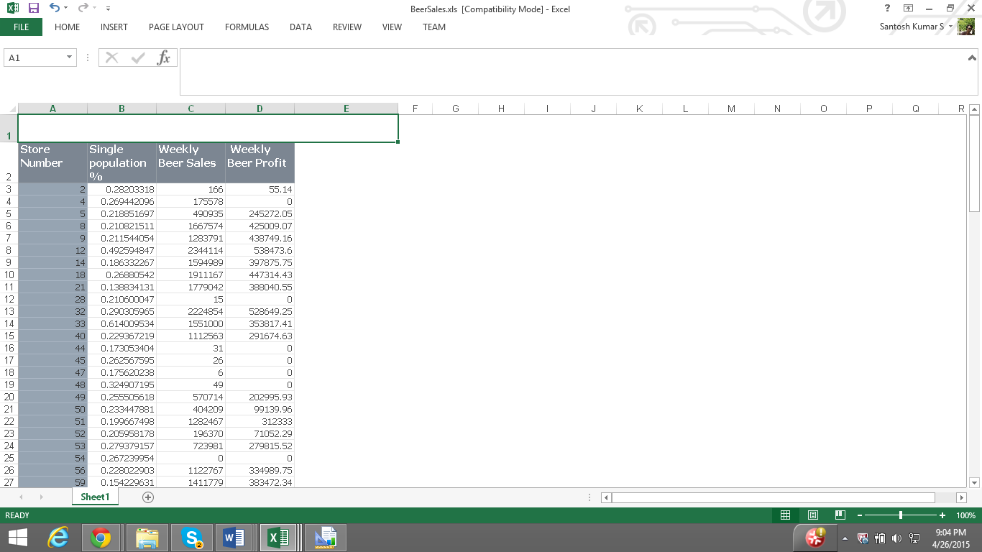

Figure 115: Displaying the table with data of Beer Sales, Profit and Single Population for Each Store

|  |  |
| --- | --- |
| Question # | 5 |
| Business Question | Which among Wine or Spirits is sold more during holiday season? Which is better gifted during Halloween, Thanksgiving or Christmas – Wine or Spirits? |
| Report Type and  Justification | SSAS  This question seeks to answer which among wine and spirits is bought more during holidays in DFF. This data may be needed for the holidays which fall in a month/ a quarter/ a year depending upon business requirements. Hence aggregating these values in prior and storing it in a cube facilitates immediate retrieval of this data along the hierarchy of time dimension. This data stored in the cube can be used by the business to compare the sales of these two categories of products during holiday weeks or non-holiday weeks and compare these values to decide on the best gifted category. This can enable the business to procure the best-selling category of products and plan the inventory for future accordingly. |
| Report Title | Effect of Holiday Season on Sales of Wine and Spirit |
| Report Attributes Mapping | |  |  | | --- | --- | | SSAS Cube | | | Data Mart Table | **Attribute** | | DimStore | StoreNumber | | DimTime | WeekNumber | | DimTime | Month | | DimTime | Week | | DimTime | Quarter | | DimTime | Year | | FactSales | WeeklySpiritSales | | FactSales | WeeklyWineSales | |
| Report Description | This report compares the weekly sales and profit for each store in the holiday season. This would help in determining if wine sales are higher than spirit sales in the holiday seasons. This report can be exported to Excel and charts can be prepared to see visual representation of the data. |

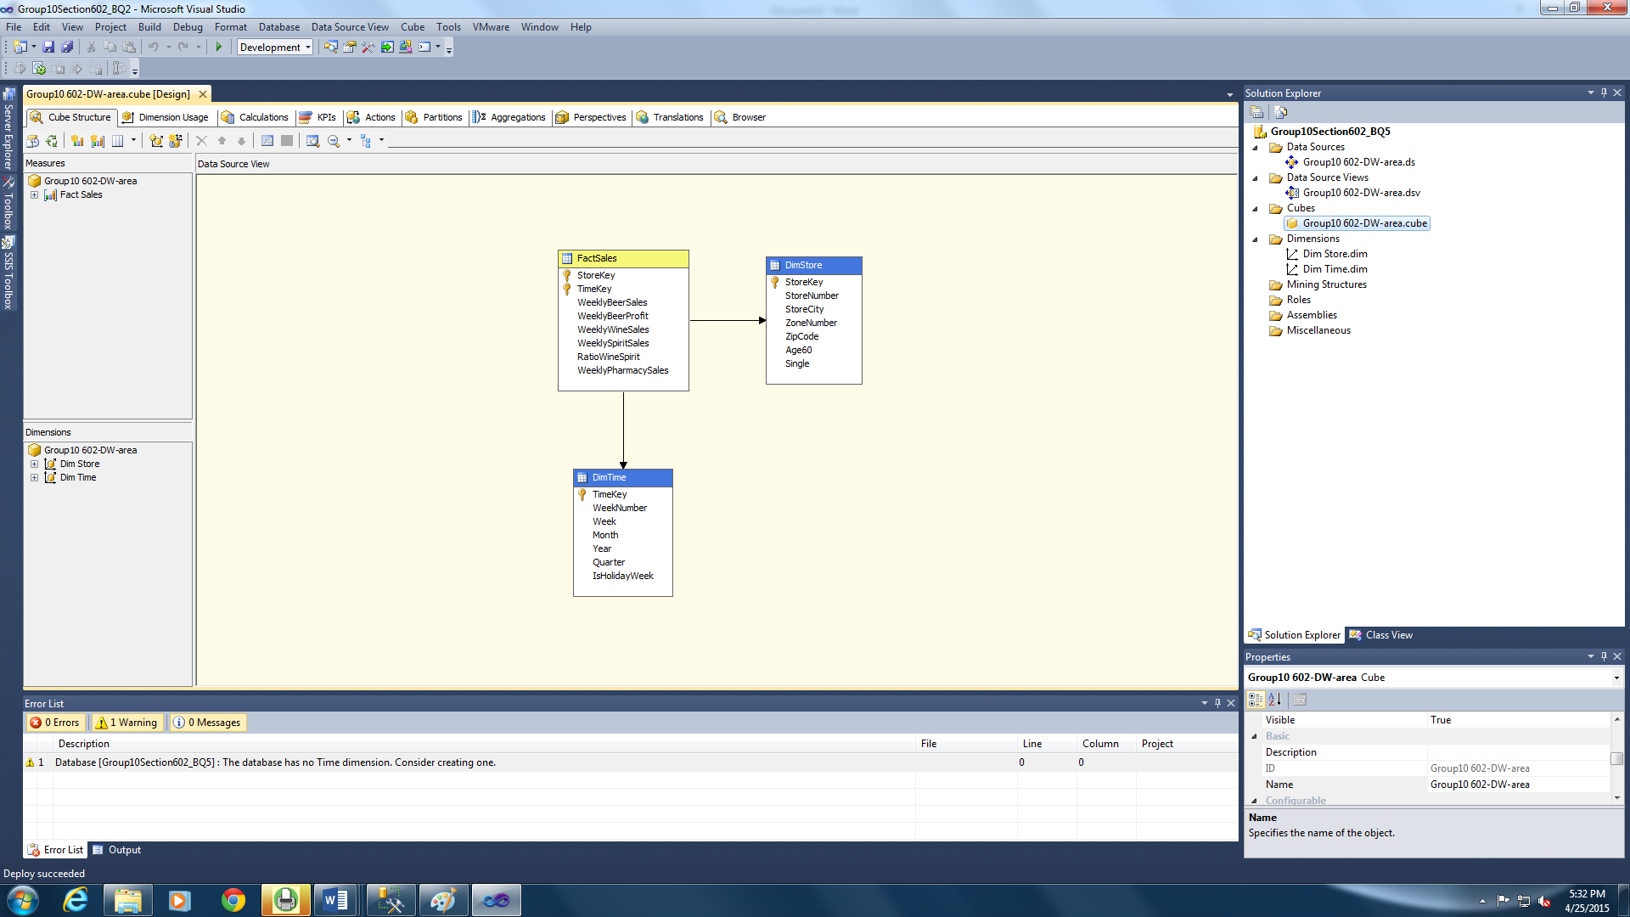

Figure 116: SSAS Cube

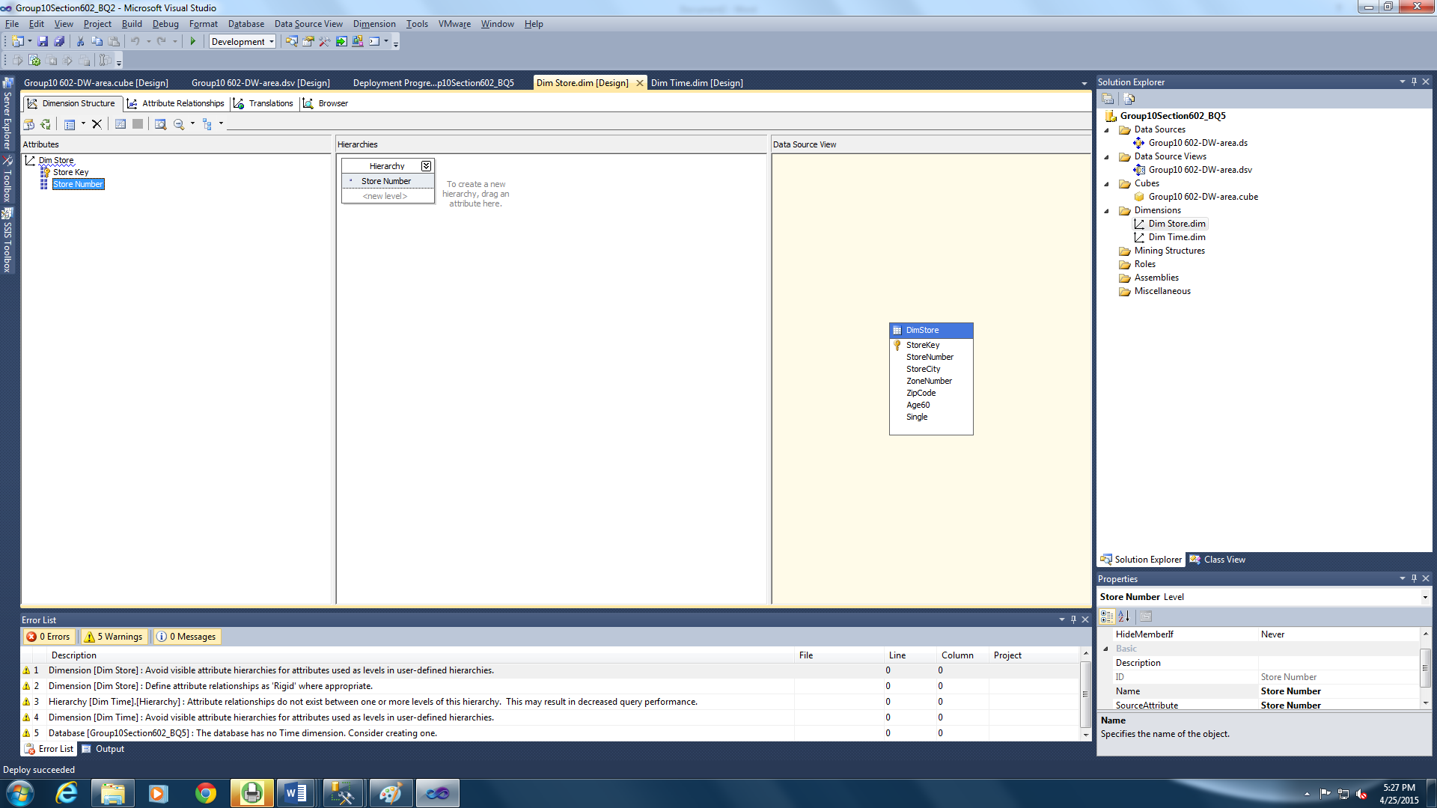

Figure 117: Adding the Attribute for Dim Store

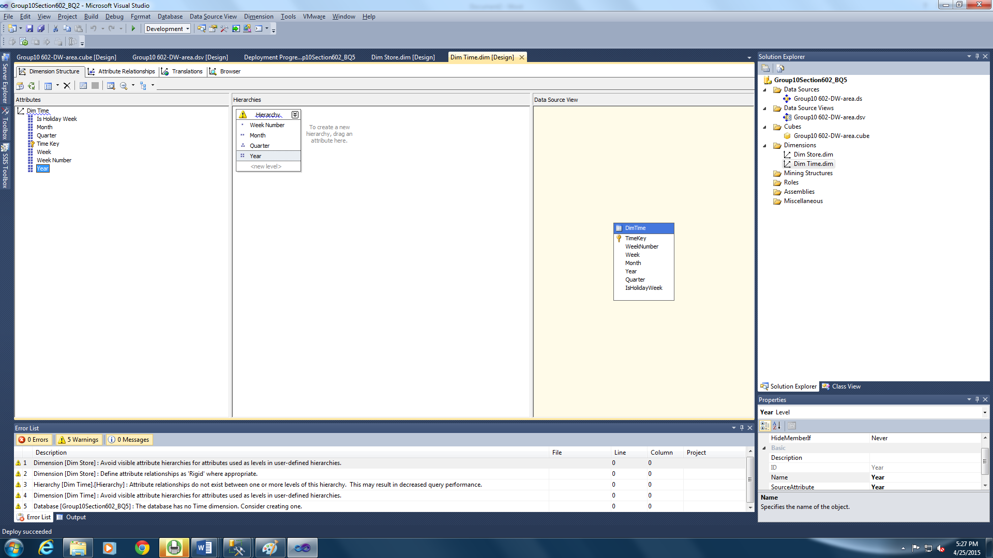

Figure 118: Creating Hierarchy for the Time Dimension

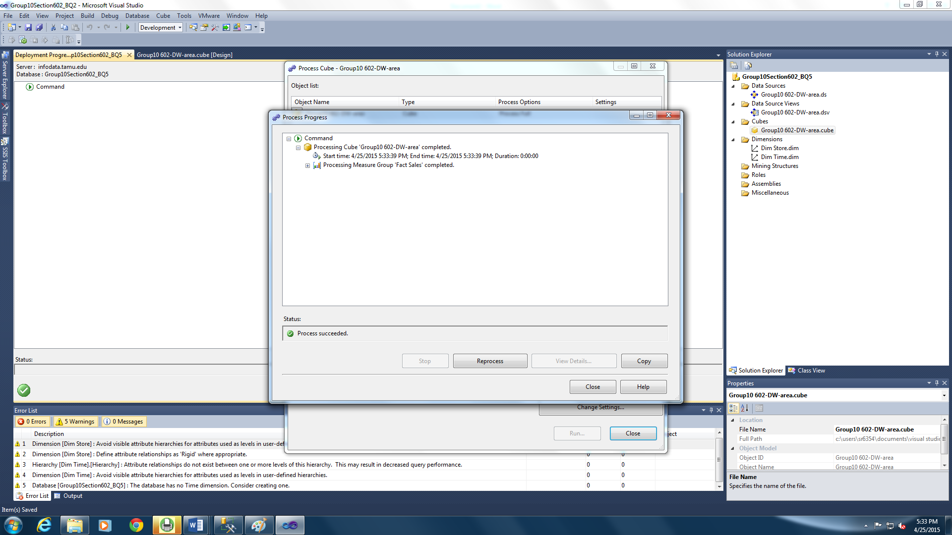

Figure 119: Processing the Cube

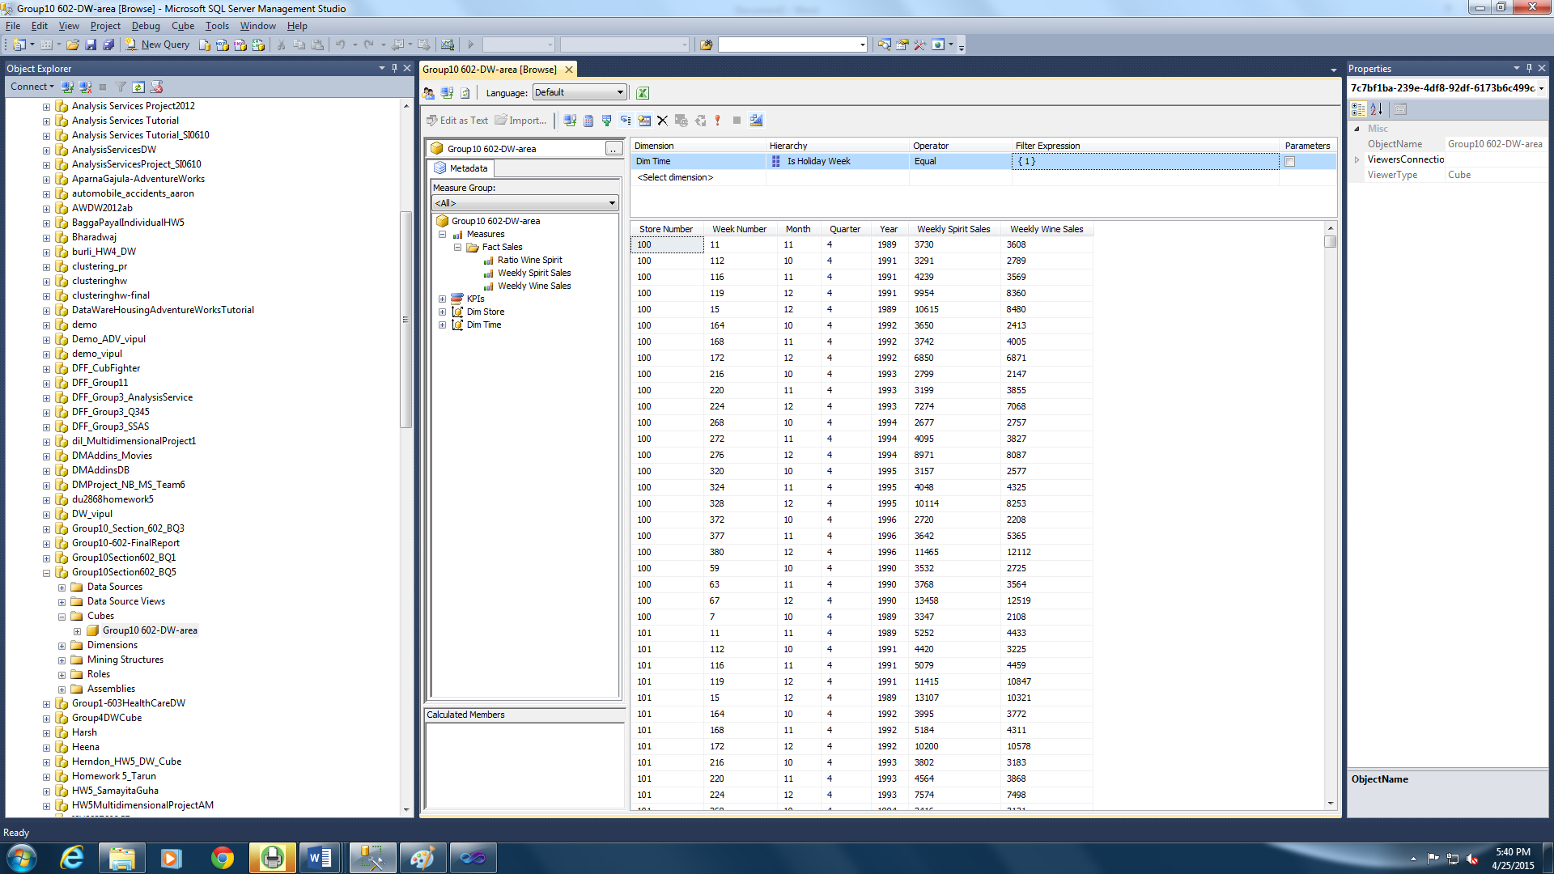

Figure 120: Displaying the Report in the Client Side (SQL Server Management Studio)

## **Data Warehouse Infrastructure Justification:**

The data warehouse infrastructure used in this project is Independent data marts developed using the Kimball’s approach. These data marts were developed to answer the chosen business questions. As the previous sections of this document substantiate the data warehouse design, these data marts have answered the selected business questions effectively.

BQ1 serves to compare the various coupon sales and the type of meat/fish/grocery coupon being redeemed the best in each DFF store. The Coupon Redemption data mart consisting the facts on weekly coupon sales for meat/grocery and fish coupons. This fact along the dimension store is used to identify the sales from each of these coupons in every store. This can also be analyzed along the time dimension to calculate the monthly/quarterly/yearly sales from these coupons in each store.

BQ2 seeks to analyze the effect of population over the age of 60 in a location on pharmacy sales. The Sales data mart consists the weekly pharmacy sales and the store dimension contains the percentage of population over the age of 60. This data is correlated to study the effect of this population on the pharmacy sales over all these years in every store. To know the effect of the population distribution of this age group on the pharmacy sales every month or quarter or year it, the data can be drilled down to the respective granularity.

BQ3 intends to identify the highest grossing frozen food in the whole of DFF. Using the Movement data mart which contains the movement of each type of frozen food and the profit it has grossed, we have analyzed and identified the frozen food that has grossed the maximum profit for DFF all these years.

BQ4 correlates the distribution of single population and the sales of beer in the stores. The Sales data mart is used to answer this question which has the weekly beer sales. On using this fact along the store dimension we have analysed the beer sales over these years in each store. This can be used to analyse the beer sales in each store every month/quarter/year by using the concept of drilling down along the time dimension.

BQ5 seeks to see the gifting pattern and which is best gifted between wine and spirits during holiday seasons. The Sales data mart has the weekly wine sales and weekly spirit sales which are used to answer this question. This data when analysed along the store dimension gives the result as to whether wine or spirits is sold more during holiday seasons and how does the holiday sales of these two compare with the non-holiday sales.

These data marts can also be used by the business to perform further analyses like comparing frozen food sales with pharmacy sales in various stores, identification of coupons which gross relatively less income, comparison of beer sales to wine and spirit sales in the various stores of the DFF chain.

## **References:**

[1] Mark R.Wilson, Stephen R. Porter, Janice L. Reiff, Dictionary of Leading Chicago Businesses (1820 – 2000)

[2] University of Chicago Booth, Kilts Center for Marketing Dominick’s data manual, July 2013